Community for Children: At the Border and Beyond is a signature program of the University of Texas Rio Grande Valley School of Medicine in South Texas. It is designed to prepare future physicians to provide compassionate, effective leadership within community collaborations. Application is open to upper level medical students and residents. There are no tuition fees.
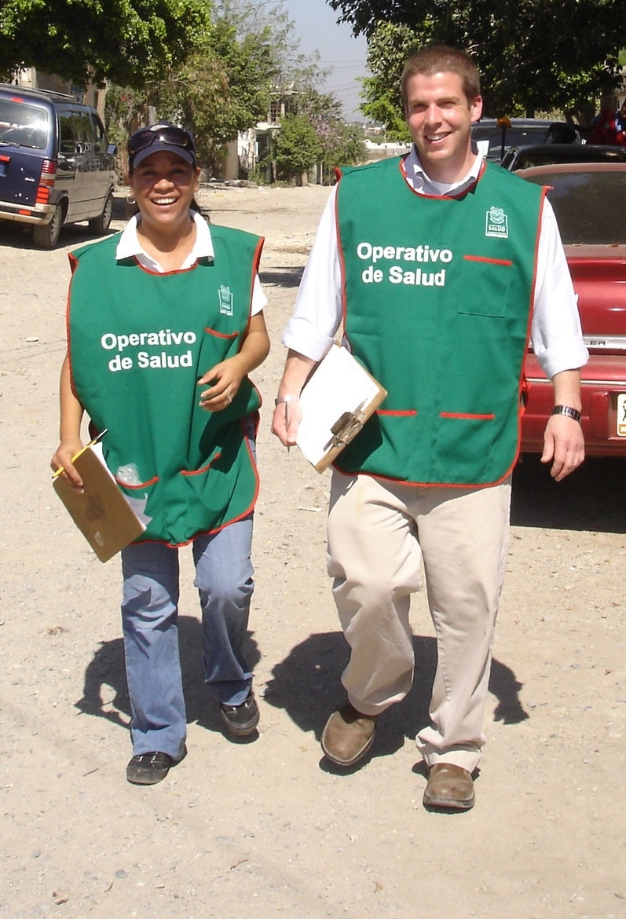
During this 4-week elective, participants explore the sources of health, disease and healing and
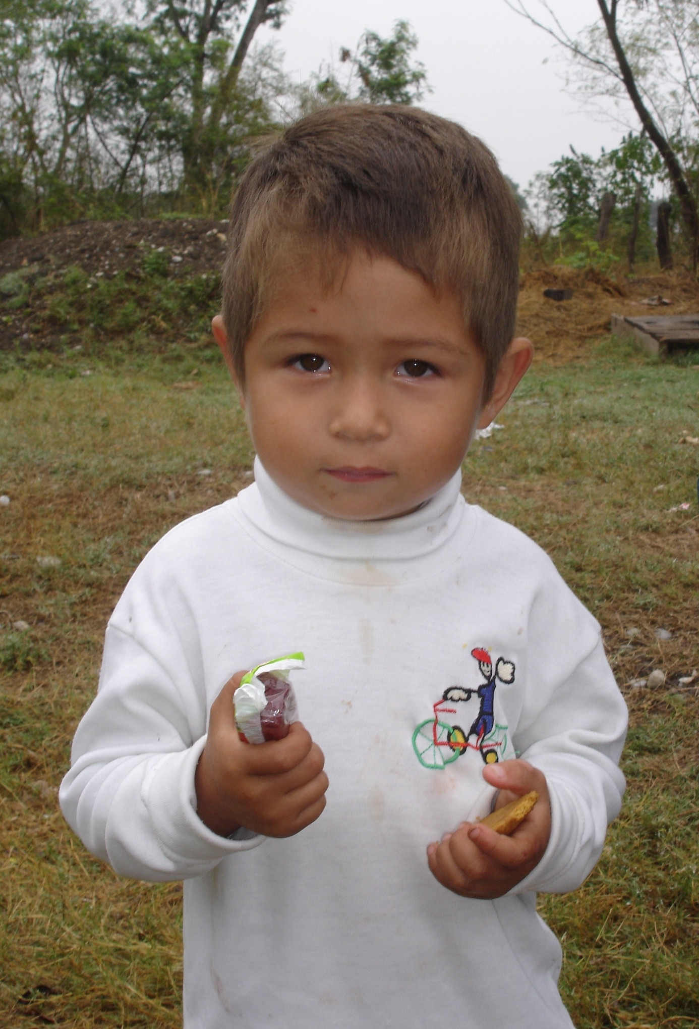
Community for Children: At the Border and Beyond
examine models of health delivery on the border. They study with international public health
experts, physicians, community leaders and activists, promotoras (community health workers),
migrant refugee health experts, and families. The CfC curriculum is addressed through didactics,
community outreach, advocacy projects, tailored Spanish-language classes, and
individual development counseling. CfC faculty mentor participants during the
rotation and beyond, providing tools and support for professional development.

Partners include UTHSCSA/RAHC and Department of Pediatrics, UTHSC Houston
School of Public Health–Brownsville, Brownsville Community Health Center, Harlingen
Pediatrics Associates, Hospital Infantil de Tamaulipas and Centro de Salud/Ciudad Victoria,
Tamaulipas, Mexico, and other community-based organizations in the Lower Rio Grande Valley.

Housing is provided at no cost to UTRGV students and approximately $600 for visiting residents/students for the month. For more details about the elective and applying, please visit our web site at http://www.communityforchildren.org.
Other Benefits
- Housing near the academic campus
- Individual development counseling
- Mentoring and membership in CfC alumni organization 90+members strong
- Tailored Spanish lessons
- Easy access to South Padre Island National Seashore

Block Rotation Schedule:

- September 26-October 21, 2016
- February 6-March 3, 2017

Apply ► Please email:
Marsha Griffin, MD
Director, Community for Children
CommunityforChildren@gmail.com
Facilities

Classes are held at the RAHC

Experiential learning is through:
- Community-based field work with community based organizations
- Pro bono legal offices providing services to immigrant children
- Office of Refugee Resettlement licensed care provider shelters for immigrant children
- Home visits
4-WEEK ELECTIVE CURRICULUM
1. Rights of the Child
- Workshops based on the UN Convention on the Rights of the Child
- Meetings with attorneys and judges working in children’s rights
- Interviews with child detainees and officials at U.S. federal detention centers
2. Social Determinants of Disease and Health
- Lectures on social determinants from an international public health perspective
- Meetings with migrant clinicians and promotoras
3. Ethics of Global Health
- Didactics and discussion on ethical issues of care in resource-poor regions
- Global health resources
4. The Impact of Poverty, Immigration and Violence
- Home visits with faculty and lay health educators
- Examination of roots of poverty and immigration issues through interaction with faculty, families, community leaders, organizations and literature review
- Reflections on observations and experiences
5. Preparing for Advocacy
- Community-based advocacy project
- Meetings with community activists and advocates
- Cultural Humility
- Review of current literature
- Daily opportunities to encounter people whose language, values, affect, economics, religion, norms and politics are personally foreign to participants
- Individualized Spanish classes
- Fostering a Culture of Compassion
- Guided reflection to explore how medical training supports or undermines compassion for self and others
- Reflection on the meaning, causes and repercussions of poverty and our own emotional responses to the poor among us
- Professional Development
  - Correspondence prior to attendance to encourage reflection on personal values, affinities, and the “heart” in medicine
  - Private time for reflection on personal meaning, call to action, sense of direction
  - Individual development counseling
  - Post-elective mentoring

