Improve patient safety. Reduce Falls up to 35% with the Otago Exercise Program.

Otago Exercise Program
Otago Exercise Program
Address: [Address]
Phone: [Phone number]
Fax: [Fax number]
http://www.med.unc.edu/aging/cgec/

For More Information:

Reduce Falls 35% with Otago:

An Evidenced-based Home Exercise Program

Over 1000 high risk older adults (65+) were enrolled in four independent randomized controlled trials in New Zealand. Those that completed the Otago Exercise Program reduced their risk of falls and related injuries by 35%.
Otago is a stand-alone intervention delivered by a licensed physical therapist.
- 6 – 8 visits over a year period
- Strength & balance & a walking program
- Follow up to increase patient compliance

Advantages:
Otago improves both strength and balance—two of the most readily modifiable risk factors for falls.
Otago Exercise Program can also be delivered as part of a multifactorial falls prevention program.

Why Should I Refer my Patients?
50% of all adults aged 80 and older fall each year.
Every 29 minutes, an older adult in the U.S. dies from a fall; 18,000+ seniors each year.
People who fall are 2 to 3 times more likely to fall.
Less than half of Medicare beneficiaries will tell you they’ve fallen.
Your patients will AVOID hip fracture, ER visits and Nursing Home Admissions
You: the primary care provider (MD, DO, PA, NP) are in the best position to provide information about the causes of falls and to refer an older adult patient to evidence-based programs that reduce falls.
.

Take Action!
Screen all patients 65 and over annually for falls!
Use American Geriatrics Society guidelines or the CDC’s STEADI toolkit
If your patient has poor balance or mobility, refer to physical therapy using the following language:
“Evaluation and treatment for balance and falls; consider Otago.”

Who to Refer…
- People who have fallen in the past year or
- People who have muscle weakness or balance problems
- Patients should live in the community and be able to walk with or without a walking aid

.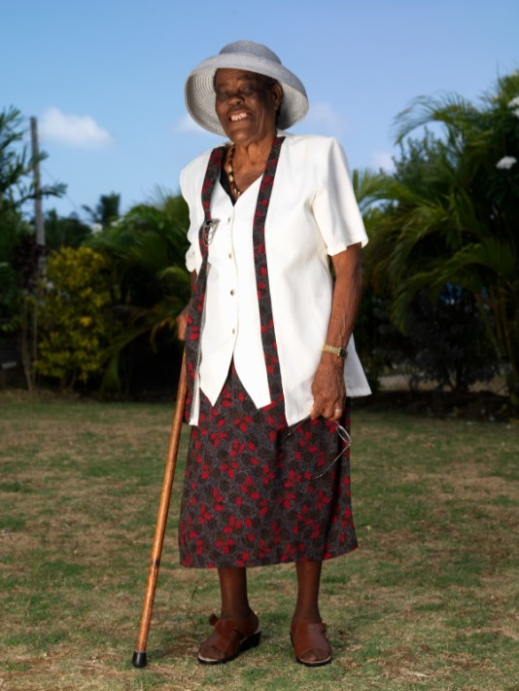

Is Otago Covered by Medicare or Other Insurance?
Otago may be covered by Medicare under Part A (Home Health) and under Part B (Outpatient Services delivered in the home or clinic. Medicare Advantage and supplemental insurance carriers typically follow what is covered by Medicare.

