Friday
5 Warm Up Exercises
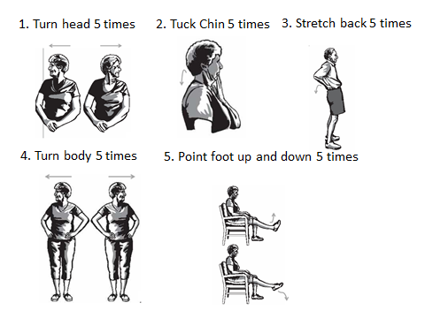
Mark every exercise you did today
Example | Week 1 | Week 2 | Week 3 | Week 4 | Week 5 | Week 6 | Week 7 | Week 8 | Week 9

Week 10 | Week 11 | Week12 | Week13 | Week 14 | Week 15 | Week 16 | Week 17

Friday
5 Strength Exercises: Advanced
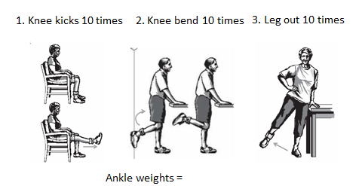
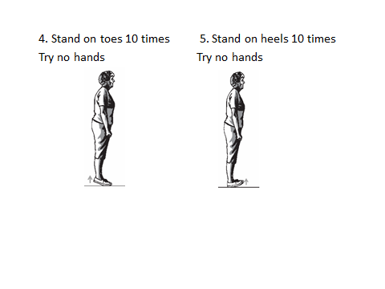
Mark every exercise you did today
Week 1 | Week 2 | Week 3 | Week 4 | Week 5 | Week 6

Week 7 | Week 8 | Week 9 | Week 10 | Week 11 | Week 12
Friday
8 Balance Exercises: Advanced Level
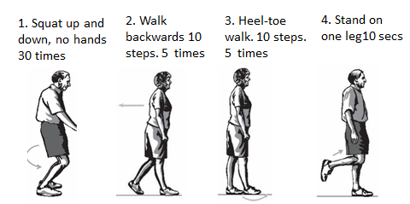
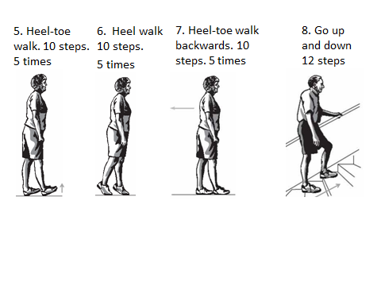
Mark every exercise you did today
Week 1 | Week 2 | Week 3 | Week 4 | Week 5 | Week 6

Week 7 | Week 8 | Week 9 | Week 10 | Week 11 | Week 12

