Wednesday
5 Warm Up Exercises
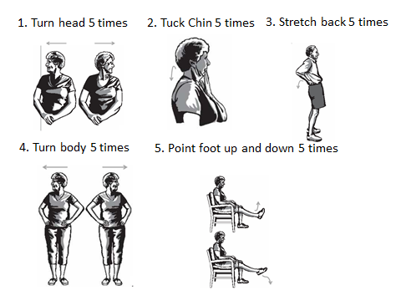
Mark if you did these exercises today (Yes/No)
Week 1 | Week 2 | Week 3 | Week 4 | Week 5 | Week 6

Week 7 | Week 8 | Week 9 | Week 10 | Week 11 | Week 12

Wednesday
5 Strength Exercises: Advanced
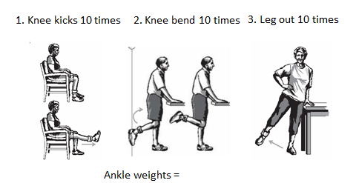
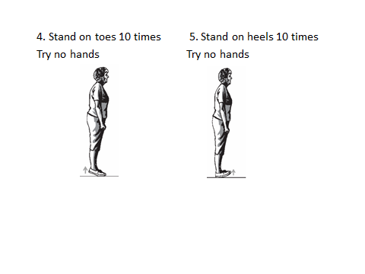
Mark if you did these exercises today (Yes/No)
Week 1 | Week 2 | Week 3 | Week 4 | Week 5 | Week 6

Week 7 | Week 8 | Week 9 | Week 10 | Week 11 | Week 12
Wednesday
8 Balance Exercises: Advanced Level
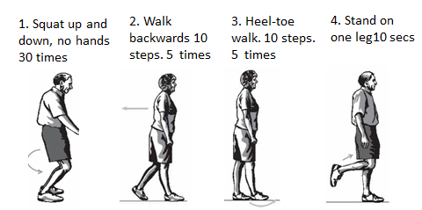
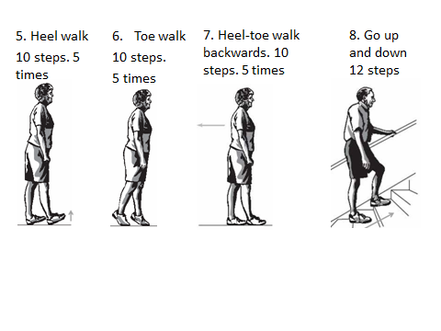
Mark if you did these exercises today (Yes/No)
Week 1 | Week 2 | Week 3 | Week 4 | Week 5 | Week 6

Week 7 | Week 8 | Week 9 | Week 10 | Week 11 | Week 12

