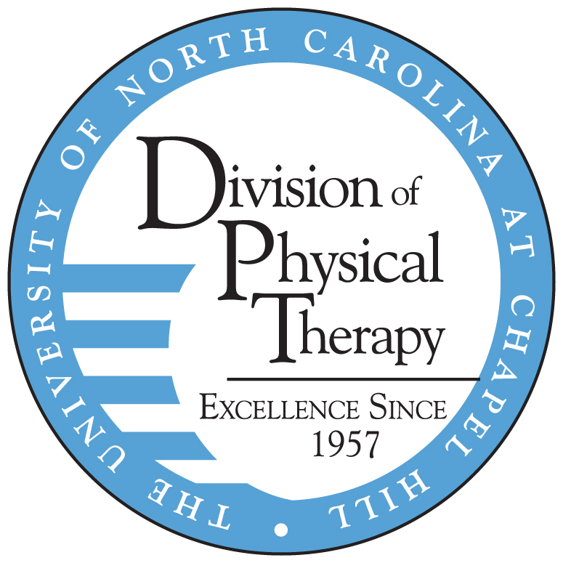

PEDIATRIC PHYSICAL THERAPY RESIDENCY
FACT SHEET

PROGRAM PURPOSE:
Our Mission
The mission of the Residency Programs in the Division of Physical Therapy and UNC Hospitals is to provide a superior, comprehensive specialist training to licensed physical therapists to meet the needs of North Carolina.
Resident Program Philosophy
The faculty and staff of the Division of Physical Therapy and UNC Hospitals are committed to developing residents who are recognized leaders within pediatric physical therapy. Residents will develop excellence in examination, diagnosis, intervention, consultation, teaching and the integration of best evidence into the patient care they provide. They will develop as a resource for the community in pediatrics and will contribute to the profession through teaching, writing, and leadership. Graduates of the residency program will be prepared to sit for the ABPTS Pediatric Certified Specialist (PCS) examination.

MENTORSHIP:
You will learn from mentors with exceptional experience and who are experts in their specific areas of interest. Mentored time provided is a minimum of 4 hours per week, but may increase to up to 12 hours per week depending on the module content. This one-on-one learning with real patients under the guidance of clinical experts is the foundation of the program. Feedback related to individual goals and module specific content is provided at each mentored session. The mentors include the following highly experienced individuals:

Kerry Blazek, PT, DPT, PCS, CNT
Cathy Howes, PT, DPT, MS, PCS
Dana McCarty, PT, DPT, PCS
Jennifer Newman, MSPT
Karen Tartick, PT
Laurie Ray, MPT, PhD
Kristen Montgomery, MS, PT
Kristel Maes, PT, DPT
Debbie Thorpe, PT, PhD
Randah Whitley, PT

CURRICULUM:
The program’s curriculum is designed in modules that address all areas of the pediatric Description of Residency Practice (DRP). The didactic-only modules include the topics of clinical reasoning (2-3 weeks), evidence-based practice (throughout program), and teaching and learning (2 weeks). Clinical modules include both didactic and clinical content and include acute care (10-14 weeks), school-based PT (8 weeks), Early Intervention (8 weeks), and outpatient care (10-14 weeks). During clinical modules, the resident will have 4-16 hours of clinical mentorship weekly. Weekly assignments and module-specific mentor assessments provide the resident with regular benchmarks to ensure learning progresses throughout the year. There are 2 written exams and 2 live patient exams administered at approximately the middle and end of the program.

The resident will also participate in the interdisciplinary Leadership in Neurodevelopmental Disabilities (LEND) fellowship at the Carolina Institute for Developmental Disabilities, which involves clinical consultation through RSI and weekly participation in AHSC 862/864: Developmental Disabilities Across the Lifespan I and II.
REQUIREMENTS:
The program has requirements for each resident in order to successfully complete the program. These core requirements include: 1000 hours of clinical practice, >200 hours of didactic learning and coursework, 150 hours of mentored clinical practice, and 12 hours of community service. In addition, residents must successfully complete each module, live patient cases, and written exams at a score of 70% or better.

RESIDENT WORK SCHEDULE:
Residents will be involved in scheduled clinic work, mentored clinical work, didactic work and focused clinic time totaling between 40-50 hours per week. Given the nature of didactic work and other clinical opportunities residents should expect to spend 50-60 hours per week completing activities related to the program. Residents are given a limited number of vacation days to be used during the year. The schedule below provides a sample of what a typical week might look like. *Please note that all schedules are subject to change based on clinic staffing needs and mentor availability.

 | MONDAY | TUESDAY | WEDNESDAY | THURSDAY | FRIDAY
8:00 AM | Work  (10 hours) | Focused Clinic  (4 hours) | Work  (10 hours) | Mentored Clinic  (6 hours) | Work  (10 hours)
9:00 AM
10:00 AM
11:00 AM
NOON | Work  (10 hours) |  | Work  (10 hours) | Mentored Clinic  (6 hours) | Work  (10 hours)
1:00 PM | Work  (10 hours) | Didactic learning  (4 hours) | Work  (10 hours) | Mentored Clinic  (6 hours) | Work  (10 hours)
2:00 PM
3:00 PM | Work  (10 hours) | Didactic learning  (4 hours) | Work  (10 hours) | Transit | Work  (10 hours)
4:00 PM | Work  (10 hours) | Didactic learning  (4 hours) | Work  (10 hours) | LEND Training  (2 hours) | Work  (10 hours)
5:00 PM | Work  (10 hours) |  | Work  (10 hours) | LEND Training  (2 hours) | Work  (10 hours)
6:00 PM

Didactic learning: This is academic learning time completed by the resident. They may include LEND courses, reading, self-study modules, mentor/resident discussions, laboratory and psychomotor learning activities. They may be completed via face-to-face, distance, or independent learning. Module mentors plan, administer, and evaluate didactic learning activities and their outcomes.
Mentored Clinic: This is clinical learning time in which the mentor and the resident are seeing patients together. The resident is typically leading the patient care with support and direction from the mentor. The mentor will be a licensed PT who is a residency program mentor.
Focused Clinic: This is clinical learning time in which the resident participates in activities related to the module topic which may include shadowing therapists in other disciplines, physicians, or observing surgery.

SALARY, TUITION AND BENEFITS:
Residents are paid $47,500, the equivalent of a new graduate salary for 3 clinic work day. Residents are eligible for full time benefits including health insurance, dental insurance, and paid time off. There is no tuition associated with the program.

ELIGIBILITY:
New graduates are eligible to apply and must have passed their licensure exam and hold a NC PT license by July 31st in order to be considered for admission. Completion of immunization requirements, HIPAA, OSHA, and CPR training prior to matriculation is required.

APPLICATION AND ENROLLMENT:
Application available via RF-PTCAS at http://www.abptrfe.org/RFPTCAS/
Application deadline: early-January each year (see RF-PTCAS application for exact date)
Program Start Date: early August each year, and lasting 12-13 months.

For more information contact: Dana McCarty at dana_mccarty@med.unc.edu

