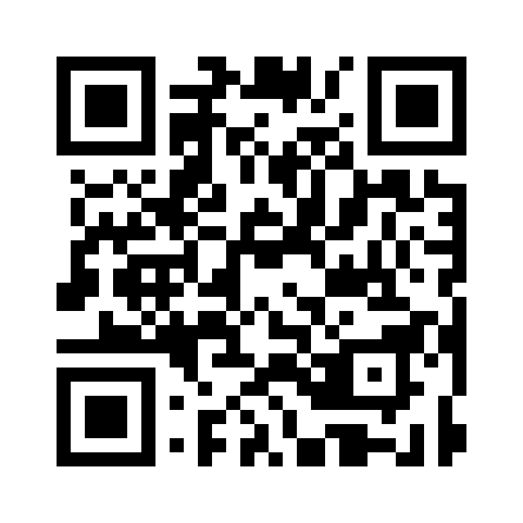
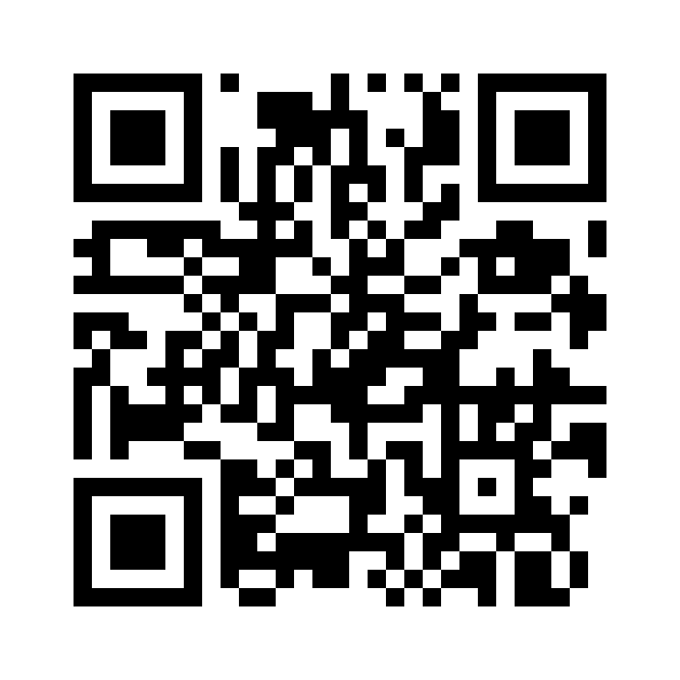
Teaching by Mistake(s): The Power of Errors in Trainee Education

OR Materials at www.go.unc.edu/mistakes OR

Case 1
Clinical vignette
Your approach
Outcome
Take-home Points

Case 2
Clinical vignette
Your approach
Outcome
Take-home Points

