UNC Health
University of North Carolina Medical Center
APP Handbook Table of Contents

1 | Prior to Employment

2-4 | Orientation

5-6 | PTO Clarification

7 | Directories, Daily Basics and Food/Beverages

8-12 | TimeTrex with Instructions

13 | Acknowledgments

Advanced Practice Provider Center UNC Health 101 Manning Drive Chapel Hill, NC 27514 12.4.2020

- Human Resources— will send you (1) an offer letter with your tentative start date and (2) forms to complete to initiate your background check and drug screening. These forms will need to be returned to the HR Recruiter as soon as possible to initiate the hiring process.
Prior to Employment
- Department Credentialing Coordinator — will contact you with instructions on completing your Collaborative Practice Agreement (CPA)
  - Collaborative Practice Agreement (CPA) — you will be responsible for completing the CPA template As part of your CPA, you will be expected to meet with your supervising physician to review your draft. You will need to contact your supervising physician via email to schedule a time to meet. **If you have any questions on how to fill out your CPA, please reach out to your Department Credentialing Coordinator.

- UNC Talent Requisition Department — will contact you to formally extend the offer of employment to you. If you
accept the position, they will go over the on-boarding process and start date information with you. There will be
five (5) on-boarding emails sent to you, which will include your offer letter, basic pre-employment paperwork,
employee health form and Federal I-9 work authorization form from "Hire Right." The fifth and final email is the
most time-sensitive from "noreply@mycrc.com." This is where you will sign the release form for the background
check and schedule your drug screen. Instructions on time limitations with these documents will be given to you
by the recruiter at the time of your acceptance. Three to five days prior to orientation, you will receive an
email with orientation information.
You will also need to bring two valid forms of identification to orientation:
(U.S. passport or U.S. Passport Card; Driver’s License or ID card issued by a state or outlying possession of the
U.S. provided it contains a photograph or information such as name, DOB, gender, height, eye color and ad
dress; Social Security Account Number card; School ID with photograph; U.S. Military card or draft record;
U.S. Citizen ID Card (Form I-197))
- APP Mentor — will be designated once you have a set start date. This is an informal relationship with another APP.
This will be someone to turn to with questions and for support. You should receive an email from the mentor intro-
ducing himself/herself.
- General Information:
EPIC Training—sign up/schedule training through LMS and ARC (Access Request Center) will be arranged with your manager. EPIC training occurs through several instructor-led courses at an off-site location. Training is specific to your role and privileges. Some of the available courses include:
  - Ambulatory Provider 100/200 (2 classes)
  - Ambulatory-Trained Inpatient Provider 100/200
  - Personalization Lab
  - Dragon Voice Recognition (to dictate notes)
  - Other specialty courses may include:
- Ambulatory Oncology Provider

- Orientation – (See next pages for orientation specifics)

First Day
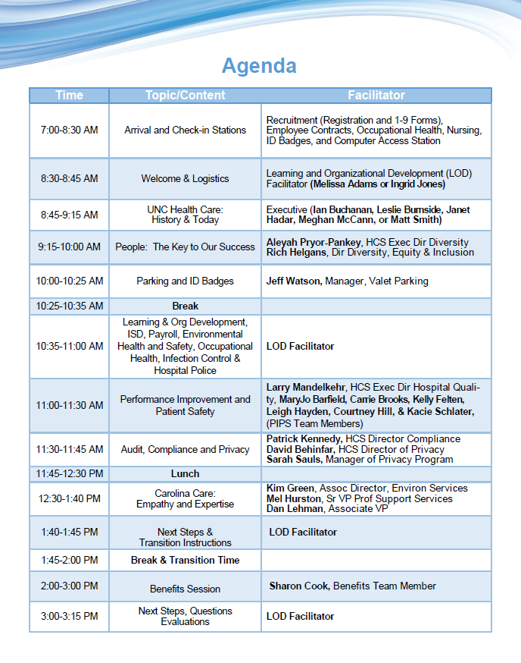
Second Day Onward

Department – specific Orientation (Day 2 onward)
  - Review basics with your Department/Division HR Coordinator
Details: Department/Division HR Coordinator will help orient and provide you with:
    - Physical mail box
    - Office location
    - Pager and pager instructions: http://intranet.unchealthcare.org/hospitaldepartments/telecom/pagers, pager batteries, labels, and support is located in the telecommunications office- Telecommunications: 984- 974-4357 or 919-962-4357 (SOM) – you will need to create a “ticket” to reach out to Telecommunications
    - Order/verify business cards
    - One Card (if applicable)
    - Lab Coat
    - Attending clinic schedules
    - Ongoing conference/meeting schedules
    - Freedom Pay: These cards are funded securely by your credit card or checking account, work like mini-
credit cards at our retail establishments and entitle you to 20% off every purchase you make in UNC’s retail venues. https://my.freedompay.com/MyFreedompay/faqs.aspx
    - Create an ONYEN (used for TimeTrex and University online resource access)
  - Tour: Hospital Map—http://www.uncmedicalcenter.org/uncmc/hospitals-locations/profile/?
id=38&searchId=9946d705-eb35-e511-a702-2c768a4e1b84&sort=11&page=1&pageSize=10 (copy and paste into a browser)
    - Details: You will be taken on a brief tour
    - Details: You will meet your team members
  - Clinic Unit Overview:
    - Orientation: You will be oriented to the clinics/units basic flow - your training and work schedule should be discussed with your coordinator/manager.
    - Introductions: Interdisciplinary team members, which may include:
      - Primary Supervising Physician
      - Nurse Manager
      - Advanced Practice Providers
      - Support Staff
  - Logistics: Technical/Computer
    - Clock In: **Check with your manager to see if this is different for your specific area**
- Do not need to clock in or out (unless otherwise designated by your specific
manager)
- Completed via phone
  - Dial: *25
  - Enter EID (employee identification number, which is given at orientation)
  - Enter 7 (exempt)

- MyTime: Check your clock-in time to be recorded—you do have to approve your time-card
online, but errors and missed clock-ins should be reported to your coordinator/manager
- Computer Access: You will be given assistance with accessing pertinent software

Shadowing, Required Education, Getting Comfortable
- Required Training: Your training schedule and work schedule should be discussed with your coordinator/manager
  - LMS (online education and course sign-up):
    - Off campus, you may access LMS at https://csg.unch.unc.edu/Citrix/XenApp/site/default.aspx - you
will need to enter your Citrix username and password.
    - On campus, you may access LMS via Intranet at Work at http://intranet.unchealthcare.org/ intranet
  - Verify Epic training has been scheduled
  - Complete TimeTrex module in LMS
  - Complete any other required modules that appear in your LMS home screen (eg. safety training, compliance code of conduct, etc.)
  - MyTime
  - Pay Stub (Pay Advice) – for viewing your paycheck
  - Health Sciences Library/online journals
  - UNC Healthcare Policy links
Computer/Technology Access Item
Employee ID numbers:
EID: Employee ID
Use: Internal identification of employee, clocking in
U number:
Use: Email, MyTime, CITRIX, LMS, and most online programs
Onyen: Additional identification # for the University
Use: UNC library access (university journal/resource access), TimeTrex Create through helpdesk/UNC library site
Basic Online Systems to know:
Citrix: Remote login program to UNC Healthcare intranet and applications https://csg.unch.unc.edu/Citrix/XenApp/auth/login.aspx
LMS: Shows you most of your required online training. Go to UNC Intranet where there is a link for LMS via Citrix
E-mail Account:
UNC HealthCare:
Access: Login:
Within Citrix: Outlook u# and password webmail.unch.unc.edu
Med.unc.edu account:

You already have a UNC Healthcare email address and now need to create @med.unc.edu aliases. Please sign in as stated and begin creating email.

UNC recently deployed a new self-service tool for creating email accounts and aliases, which can be found at http:// selfservice.unc.edu. To use this tool, please follow the steps below:

You already have a UNC Healthcare email address and now need to create @med.unc.edu aliases. Please sign in as stated and begin creating email.

UNC recently deployed a new self-service tool for creating email accounts and aliases, which can be found at http:// selfservice.unc.edu. To use this tool, please follow the steps below:

- Login with your Onyen at http://selfservice.unc.edu
- Click the Email Sign-Up link on the left
- Keep the check next to Update Listserv Subscriptions (Recommended)
- Click the SUBMIT button to request a new email account
- The School of Medicine’s standard is to add two email aliases 1) first_last@med.unc.edu and 2) onyen@med.unc.edu
- Click the My Aliases tab
- Select the radio button next to Add Alias, then click Next
- In the box under Alias, enter your name as firstname_lastname, then click the drop-down arrows to select @med.unc.edu. You can use either your formal or nickname for the firstname. Click the ADD ALIAS button.
- Repeat 6-8 add your onyen@med.unc.edu
- Click the My Aliases tab
- Select the radio button next to Set reply-To Address, then click Next
- Use the drop-down menu to select firstname_lastname@med.unc.edu
- Press the SET REPLY-TO ADDRESS button
These same instructions along with pictures can be found at http://help.unc.edu/help/email-self-service-tool

Emergency Procedures:
Emergency Preparedness: http://intranet.unchealthcare.org/hospitaldepartments/disaster

Paid Time Off ( PTO)
Paid Time Off (PTO):
HCS -The accrual rate is based upon years of service with UNC Health Care. See chart below
Requesting PTO: Coordinate with your manager
Taking PTO: Notify your manager of any days you take off/PTO and any missed clock-ins
Sale of PTO: To be eligible for the sell-back, employees must have more than 140 hours of PTO available— anything over the 140 can be sold back
Questions/Concerns: Contact HR manager
Reference for Time and Attendance:
http://www.aasa1.org/sites/default/files/Member-Toolkit/time_and_attendance.pdf

www.unchealthcare.org/site/humanresources/careers/benefits/pto/

HEALTH CARE EMPLOYEE EARNING FOR PTO

Table 1. PTO Leave credits for Full time employees (80-hour appointment) hired be-  fore December 31st 2016. Years of Service | Biweekly Accrual * | Total Annual Accrual*
< 5 | 11.539 hours | 300 hours
5 but less than 10 | 12.500 hours | 325 hours
10 but less than 15 | 13.462 hours | 350 hours
15 but less than 20 | 14.423 hours | 375 hours
20+ | 15.385 hours | 400 hours
*Accrual is pro-rated for Part-time employees (less than 80 hour appointment) Accrual rate will remain at rate for December 2016 years of service if greater than new accrual rates below, so long as the employee does not terminate employment with UNC Hospital or UNC Faculty Physicians.
PTO Leave credits for Full time employees (80-hour appointment) hired after January  1st, 2017. Years of Service | Biweekly Accrual * | Total Annual Accrual*
< 4 | 9.846 hours | 256 hours
4 but less than 9 | 10.769 hours | 320 hours
9 but less than 15 | 12.308 hours | 328 hours
15 but less than 20 | 12.165 hours | 328 hours
20+ | 13.538 hours | 352 hours
*Accrual is pro-rated for part-time employees (less than 80-hour appointment)

Table 2. PTO Balance Distributions at Termination to UNC Healthcare Service Date (EOD) or Reason
0-9 months | 0% of PTO Balance
9 months-2 years | 50% of PTO balance under 281 hours
2-5 years | 75% of PTO balance under 281 hours
>5 years | 100 % of PTO balance under 281 hours
Discharge | 0% of balance
Death While Employed | 100 % of PTO balance
Retirement | 100 % of PTO balance

School of Medicine PTO

UNIVERSITY EMPLOYEE- ONLY
The following summarizes annual leave, sick leave, and holiday leave guidelines for faculty employees.
For information on payout or transfer of faculty leave in the event of termination, change of position or to transfer to/from another State agency or UNC campus, see Guidelines on Faculty Leave Transfer or
Payout.

Annual (Vacation) Leave for Twelve-Month Faculty Members
- Twelve-month faculty members are entitled to 24 days of annual leave per calendar year.
- The amount of annual leave is adjusted proportionately for part-time employees in covered positions who work half-time (50% FTE) or more.
- Leave shall be earned on a monthly basis. The monthly earnings amount is equal to one-twelfth (1/12) of the annual leave accrual rate for each month the employee works or is on approved leave with pay at least half the working days of a month.
- The scheduling of an employee’s annual leave shall be subject to the approval of his or her Department Chair or other individual
designated by the Chair to authorize leave requests.
- The maximum number of unused days of annual leave that may be accrued and carried forward from one year to the next shall be 30 work days; however, unused annual leave in excess of thirty (30) days shall be converted to sick leave on December 31st of each year. In the event of a part-time faculty member, the thirty-day limit is pro-rated based on the faculty members part-time work schedule (FTE).

Sick Leave for Twelve-Month Faculty
- Twelve-month faculty earn 12 sick days per year accrued on a monthly basis. Unused sick leave may be accumulated and carried forward from year to year on an unlimited basis.
- Upon separation, unused sick leave is not paid out. Only members of TSERS are eligible to have sick leave credit converted to
creditable service upon retirement. For ORP participants, any unused sick leave balance at termination or retirement is forfeited.
- Sick leave is restored to an employee’s leave record when the employee returns from an approved period of leave without pay.
- Sick leave is restored to an employee’s leave record when the employee is reinstated to State service within five years of any type
of separation.
- Sick leave is reinstated when an employee returns to State service within five years after separating from EPA employment with a local government, public school, community college, or technical institute.
- Twelve-month faculty members are also eligible for paid serious illness and parental leave which when used does not require use of accumulated annual or sick leave. For more information on this policy, click here.

Annual (Vacation) and Sick Leave for Nine-Month Faculty
Nine-month faculty do not earn either annual or sick leave. They are eligible for paid serious illness and parental leave. For more infor- mation on this policy, click here.
Holidays
Both nine- and twelve-month faculty generally observe the same holidays as other University employees except that when classes are scheduled during a normal university holiday, faculty are expected to work when assigned teaching duties.

Please refer to https://hr.unc.edu/benefits/leave-holidays/ for the most current holiday schedule. Please note that certain clinical departments of the School of Medicine have a modified holiday schedule for their employees. Clinical departments will communicate any such modified holiday schedule directly to their employees.

Basic information
Directory:
Entry: Once you have your pager you will need to update your profile in the WebXchange directory. Check
with your manager or team lead on how to access this site.
Updates:Your Division HR or Administrative Coordinator is responsible for adding your contact
information in the Division’s contact list, and then you are responsible for any future adjustments. If
you have questions on this process, again, please reach out to your manager or team lead.

Phone Directory/Voice Mail/Long-Distance Phone Access:
Telecommunications: 984-974-4357 for HCS
919-962-4357 for SOM
Daily Basics:

  - ATMs/Banking/Money: ATMs:
Cash Points
SECU (State Employees Credit Union)
Main lobby, N.C. Memorial Hospital opposite pay phones
N.C. Women's Hospital lobby near the escalator Ambulatory Care Center, 1st floor

Banking:
CCB (Main lobby, N.C. Memorial Hospital, opposite pay phones)
Bank of America (Ground floor, N.C. Memorial Hospital, near coffee shop)
Wachovia (Main lobby, N.C. Memorial Hospital, opposite registration desk)

Food and Beverages: **Due to COVID-19, most of the cafes are closed. You can utilize the following for “grab and go” and grocery items pick-up:

  - Terrace Café: Located on the first floor terrace of the Children’s Hospital—Open 24 Hours

  - Corner Grocery Store: Offering “essential grocery packages” for you and your family. There are four packages being offered – use this link to see the packages offered https://uncmedicalcenter.intranet.unchealthcare.org/Pages/2020/04-April/Essential-Grocery-Packages.aspx. Located on the ground floor of the Children’s Hospital. To place an order, call 984-974-7929 Monday – Thursday between the hours of 9:00 am – 3:00 pm. **Please make sure to call 24 hours in advance of pickup. **only credit cards and white Freedom Pay tags will be used as payment. NO CASH will be accepted.

  - Courtyard Café: Located near the ACC Building for “grab and go”—Open 7:00 am – 4:00 pm **only for employees with UNC badge.

  - The Beach: Located behind the hospital on the first floor of the Brinkhous-Bullitt Building next to the
School of Medicine (Bondurant Hall) - Open Mondays —Thursdays from 7:00 am to 4:00 pm; Fridays—7:00 am –3:00 pm; closed on Saturdays and Sundays.

- TimeTrex is a time-keeping system developed and used by UNC Health to accurately calculate UNC Hospital’s reimbursement for Part A activities (hospital related services) on the hospital cost report. All Other activities are related to Part B (direct patient care) or other School of Medicine activities (not for hospital benefit).
TimeTrex
- Complete mandatory training at LMS site: https://unchcs.sumtotal.host/Core/search
Search for UNCHTIMETREX20 and the module will appear if not already auto-assigned to you.
- You will be sent a monthly email with instructions on how to access the site to enter your time. You will be instructed to enter time during one (1) selected week per month. Your TimeTrex monthly entry is REALTIME. 100% of your time should be reported.

**Please see an example of the timetrex entry page and category lines with explanations on the following pages. If you have questions, please review LMS or contact Roberta Byrd at Roberta.Byrd@unchealth.unc.edu.

Time Trex

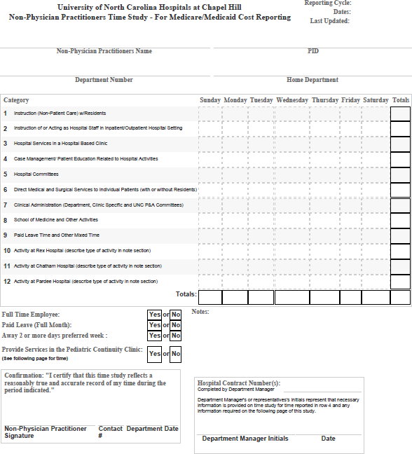

Line 1 - Instruction (Non-Patient Care) w/Residents
TimeTrex– Category Lines and Explanations
- Training of Physician Residents
Line 2 - Instruction of or Acting as Hospital Staff in Inpatient/Outpatient Hospital Setting
- Training of RNs, NAs, etc
- Routine RN Activities on Hospital Unit or Department- Not Hospital Based Clinic
- Administrative duties on Hospital Unit or Department- Not Hospital Based Clinics (Such as Clinic Manager)
- Instruction of or Acting as Hospital Staff in Inpatient/Outpatient Hospital Setting
Line 3 - Hospital Services in a Hospital Based Clinic
- Routine RN Activities in Hospital Based Clinics
- Administrative duties in Hospital Based Clinics (Such as Clinic Manager)
Line 4 - Inpatient care coordination and patient education related to hospital activities that does not require an
advanced license (i.e. could be provided by Case management or a Registered Nurse)
- Active implementation of post discharge care and transitions of care
- Patient and patient family education as it relates to care (not part of the Professional (APP or Physician) explanation of the patient's diagnosis or plan of care)
- Examples of case management such as:
  - Arrange home health infusions
  - Arrange local transportation to/from UNC
  - Arrange home health nursing, wound vac, outpatient OT/PT
  - Make changes as needed to post hospitalization care transition arrangements
- Example of education such as:
  - Actively arrange. Facilitate patient/family discussions re: care continuum needs
  - Review understanding of discharge plan/meds/wound care
  - Educate patients/family on G-tubes, etc. before discharge
Line 5 – Hospital Committees and inpatient quality/performance improvement and patient safety activities
- Committees served on which benefit the hospital
- Quality improvement/performance improvement/patient safety
- Examples such as:
  - Green belt project (inpatient) or Kaizen event in hospital unit
  - Review of patient satisfaction data
  - Patient safety root-cause analysis
Line 6 - Direct Medical and Surgical Services to Individual Patients (with or without Residents)
- Information and education to the patient and their families that are part of the initial explanation of the patient’s diagnosis or plan of care
- Additional education and information provided to the patient or their families in the physician clinic
- Education provided to the physician clinic staff
- Taking the patient history
- Physical examination
- Medical diagnosis or judgment
- Ordering tests or treatments
- Coordinating medical care
- Counseling patients regarding prognosis, test results, diagnosis, treatment options, and risk factors
- Nursing care provided in a FP clinic
- Providing services in the Pediatric Continuity Clinic
- Billable Services

Line 7 – Clinical Administration (Department, Clinic Specific and UNC FP Committees)
TimeTrex– Category Lines and Explanations
- Procedural issues in the physician clinics
- Quality control activities in the physician clinics
- Documentation review in the physician clinics
- Work on policies and protocols in the physician clinics
- Other management issues in the physician clinics

Line 8 – School of Medicine/Nursing and Other Activities
- Medical School Activities
- Research activities (excluding direct patient care)
- School of Medicine Department Committees
- Contract services to outside parties
- Teaching any students including: Nursing, NP, PA, Medical, etc.
- Other non-patient care activities

Line 9 – Paid Leave Time and Other Mixed Time
- Continuing education
- Administrative time not otherwise allocated
- Health Care System administrative activities
- Completing TimeTrex monthly time studies
- PTO or vacation and sick time
  - Paid Administrative Leave
  - Paid FMLA
  - Paid Holiday
  - Paid Parental Leave
  - Paid PTO
  - Paid Sabbatical Leave
  - Paid Sick Leave
  - Paid Vacation

Line 10 – Activity at Rex Hospital (describe type of activity in note section)
- Patient care activities for which UNC FP WILL NOT bill
- Patient care activities performed in a Rex Hospital clinic
- Patient care activities performed incident to a Rex Hospital physician

Line 11 – Activity at Chatham Hospital (describe type of activity in note section)
- Patient care activities for which UNC FP WILL NOT bill
- Patient care activities performed in a Chatham Hospital clinic
- Patient care activities performed incident to a Chatham Hospital physician

Line 12 – Activity at Pardee Hospital (describe type of activity in note section)
- Patient care activities for which UNC FP WILL NOT bill
- Patient care activities performed in a Pardee Hospital clinic
- Patient care activities performed incident to a Pardee Hospital physician

Special thanks to Kate Pepin, NP, Dell Strayhorn, NP, Kimberly Smith and the Department of Medicine, Division of Hematology/Oncology for allowing the APP Center to adapt this onboarding document from their original work.

