2018 proposal from the UNC Chapel Hill department of Biochemistry and biophysics for a unc CENTer For MacroMoLecular Design
Over the last 20 years there has been tremendous progress in the field of macromolecular design and engineering. Advanced methods in molecular modeling and directed evolution can now be used to create proteins with user-defined structures and functions. The exciting task before the field is to use these technologies to create molecules that have valuable applications in research and medicine. Here, we propose to create a center that places UNC at the cutting edge of macromolecular design and allows UNC investigators to target a broad range of diseases with engineered proteins, peptides and nucleic acids.
Why macromolecules? (frequently referred to as Biologics)
Macromolecules or Biologics, i.e., proteins, peptides, and nucleic acids for therapeutics, diagnostics or bio-detection, are a rapidly growing sector of the pharmaceutical industry and are now used to treat a variety of diseases including cancer, arthritis, diabetes and multiple sclerosis. Unlike small molecules, proteins and nucleic acids are naturally well suited to inhibiting macromolecular interactions and therefore can activate or suppress pathways that are difficult to control with traditional small molecule drugs. Additionally, protein therapeutics are generally very specific for their target, limiting side effects. In addition to their usefulness as therapeutics, engineered macromolecules can be used to develop a better understanding of processes important to health and disease.
UNC already has world-class expertise in macromolecular design.
Recent developments in directed evolution and computational protein design have revolutionized the field of protein design. UNC has expertise in both areas. Brian Kuhlman’s laboratory in the Department of Biochemistry and Biophysics are co-developers are of the leading software for protein design, Rosetta. Rihe Liu’s and Albert Bowers’ lab in the UNC School of Pharmacy are using directed evolution to discover macromolecules that inhibit pathways important in cancer.
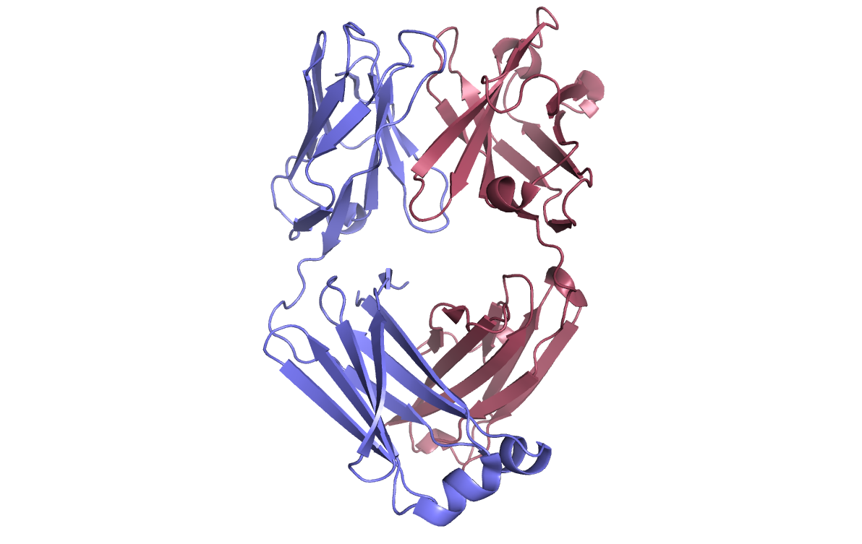
Bispecific antibody engineered at UNC in collaboration with Eli Lilly for treating cancer.
Why will a Center for Macromolecular Design be transformative?
A critical bottleneck for the development of biologics is the identification of new cellular processes and pathways to target. Because most biotechnology companies are not involved in basic research, they must rely on outside sources for identifying new targets. In contrast, UNC has hundreds of independent laboratories probing a wide variety of processes central to many diseases, including inflammation, cancer, cardiovascular disease and neurodegeneration. A major goal of the Center for Macromolecule Design will be to collaborate with these laboratories to engineer molecules that allow them to better understand and treat diseases. Ongoing biologic-related research at UNC that could benefit from a team-based approach for rapidly progressing lead biologics through development are the DeSilva lab’s effort to create subunit vaccines for dengue virus, the Margolis’s lab use of bispecific antibodies to neutralize HIV, the Tisch lab’s use of monoclonal antibodies to treat diabetes, and the Ting’s lab use of antibodies to control immunologic disorders.
What do we need to do to make the center successful?
Recruiting a scientist from industry who has experience in taking engineered proteins from the bench to the clinic would help jump-start the center, and hiring additional expertise in directed evolution, antibody discovery, and high throughput screening would help create critical mass for the center. Development of a core facility for the directed evolution techniques phage display and yeast display would allow the center to support the broader research community at UNC and provide a source of lead molecules with therapeutic potential. To stay at the leading edge of molecular engineering, an important focus of the center will be the development of new methods for structure-based design, and strategies for combining these approaches with directed evolution.

