Research Retreat
Department of Biochemistry & Biophysics
Event Schedule
2019

Friday, October 11, 2019
8:30 - 9:15 AM | Arrival and Breakfast ǀ Carolina Inn, Chancellors Ballroom  pick up welcome packets
9:15 - 9:20 AM | Welcome comments from Chair ǀ Leslie Parise, PHD
9:20 - 10:20 AM | 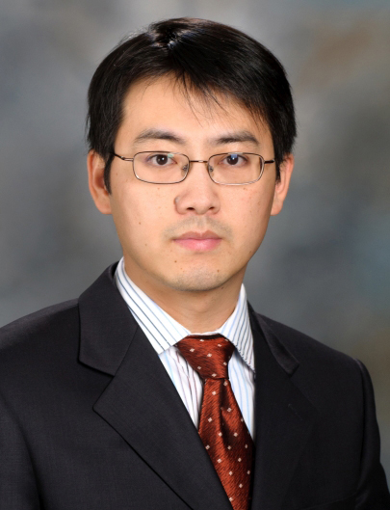 | ALUMNI KEYNOTE TALK ǀ Jian Hu, PHD (UNC 2007)  MD Anderson Cancer Center  “Lipid metabolism in gliomagenesis and myelin maintenance”  Introduction from Yue Xiong, PhD
10:25 - 10:45 AM | Short Talk ǀ Graduate student: Jared Baisden (Zhang Lab)  “Visualizing a transient RNA protonation state that modulates oncogenic microRNA-21 maturation”
10:50 – 11:10 AM | Short Talk ǀ Graduate student: Benjamin Roberts (Neher Lab)  “ The Molecular Regulation of Lipoprotein Lipase”
11:10 - 11:25 AM | Break for poster set-up for session 1
11:25 - 12:15 PM | Poster session 1 (odd number posters)
12:20 - 1:20 PM | Lunch with mentorship tables
1:20 - 1:40 PM | Short Talk ǀ Graduate student: Cathy Anderson (McGinty Lab)  “Cryo-EM structure of Dot1L-H2BK120ub nucleosome complex illustrates trans-histone epigenetic crosstalk”
1:40 - 2:00 PM | Short Talk ǀ Postdoctoral fellow: Dajiang Li, PhD (Jiang Lab)  “Protein crotonylation sensitizes SMACm-induced disruption of latent HIV by enhancing p100 cleavage”
2:00 - 2:20 PM | Short Talk ǀ Graduate student: Stephan Kudlacek (Kuhlman Lab)  “ Targeting Dengue Envelope Protein Instability Regions using computational design to develop improved Dengue Subunit Vaccines”
2:20 - 2:30 PM | Break for poster set-up for session 2
2:30 - 3:20 PM | Poster session 2 (even number posters)
3:30 - 4:30 PM | 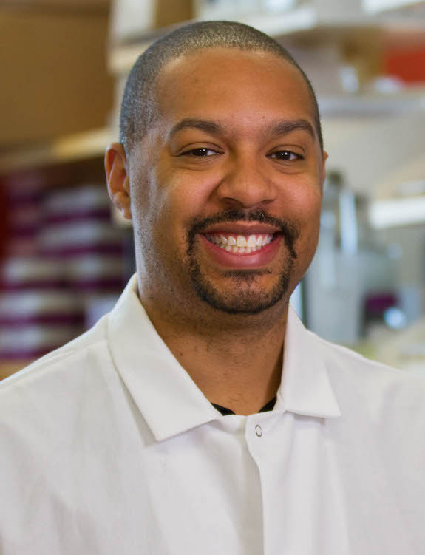 | ALUMNI KEYNOTE TALK ǀ Michael Johnson, PHD (UNC 2011)  University of Arizona  “Something Old, Something New, Something Borrowed, Copper II”  Introduction from graduate student Gabrielle Budziszewski
4:40 - 4:45 PM | Closing remarks and student and postdoctoral fellow awards

