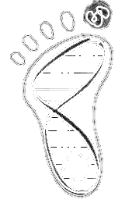
BIOCHEMISTRY & BIOPHYSICS FACULTY RECRUITMENT PRESENTATIONS

All RESEARCH SEMINARS WILL BE AT 12PM AND ALL CHALK TALKS AT 230PM

MARCH 1, 2021
Aakash Basu, Ph.D.
Johns Hopkins University School of Medicine
MARCH 2, 2021
John R. Jimah, Ph.D.
NIDDK, NIH
MARCH 5, 2021
Kate L. White, Ph.D.
The University of Southern California
MARCH 9, 2021
Rebecca B. Berlow, Ph.D.
Scripps Research Institute
MARCH 11, 2021
Melinda M. Diver,
University of California, San Fransisco

