Department of Biochemistry and Biophysics Suggestion Box
The suggestion box is for providing feedback to the department, including suggestions for areas of improvement, ideas for new initiatives, changes to existing procedures, etc. All submissions will be confidential.
This box is NOT for reports about mistreatment, crimes, or ethics violations. Reporting mechanisms for those concerns are accessed below.
UNC Reporting Information
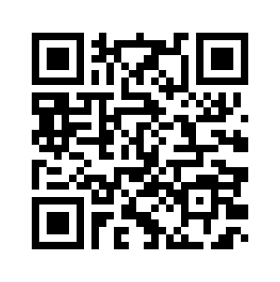
Reporting issues of discrimination, harassment, mistreatment, threats, etc. should be submitted to the appropriate UNC office outlined below.

Guidelines for reporting resources across campus and links to reporting forms.
Equal Opportunity and Compliance Office Reporting
Discrimination and harassment based on age, color, disability, genetic information, national origin, race, religion, sex, sexual orientation, veteran status, sexual misconduct, relationship violence, and stalking.
SOM Student Mistreatment and Learning Concern Reporting
Mistreatment ranging from subtle belittlement or discrimination to blatant hostility or harassment.
LGBTQ Center Reporting
Threats, discrimination, or harassment due to sexual orientation, gender identity, or gender expression.
University Ombuds Office
Safe place where all individuals can schedule an appointment to talk in confidence about any campus issue, concern, problem, or dispute.
Human Resources Violence Reporting
Workplace violence should be reported either to UNC Public Safety or to Employee & Management Relations

