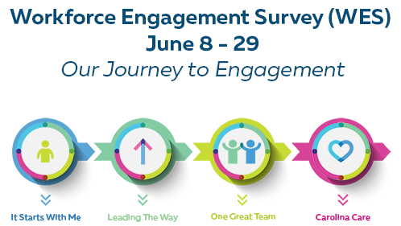
2021 WES FAQ

Why is the Workforce Engagement Survey important?
- Our most valuable resource is our people, and it’s very important to get your feedback.
- It is the single best collective approach for staff to tell management what is working well and what needs improvement.
- To achieve UNC Health’s vision, to be the nation’s leading public academic health care system, we must have our most valuable resources – our co-workers committed to living our mission of caring for the people of North Carolina which is the foundation of all we do.
- We know that engaged co-workers provide great care which in turn creates satisfied patients.
- It is important to create a culture that aligns with UNC Health’s values. You can find the values here.

What does “Engagement” mean?
Engagement is the extent to which co-workers are committed to an organization.
Engaged co-workers are:
- Willing to go above and beyond
- Energetic and enthusiastic
- Loyal to the organization – more likely to stay
- Proud of the organization
- Willing to recommend as a place to and to receive care
- More satisfied co-workers overall
Ultimately, having engaged co-workers leads to greater job satisfaction and patient satisfaction.

What can I expect in the 2021 full survey?
- There are five-point scale standard items on the survey and some open-ended questions. You may receive a set of additional items based on whether you are a nurse receiving the Nursing Excellence Magnet items or if your affiliate has elected to ask additional items.
  - Nursing Excellence Magnet items will be embedded into the survey. Only nurses will see these items.
  - Each employee will receive an e-mail from Press Ganey, the 3rd party survey administrator, with a unique link that provides access to the survey.

How long will the survey run?
The survey will run for three weeks. It will be active from June 8th – June 29th, 2021.

How do I know my responses are confidential?
No one working for UNC Health has access to data that can identify specific individuals. An external vendor, Press Ganey, administers the survey and all responses go directly to Press Ganey. Because all information goes directly to Press Ganey, UNC Health leaders will only see combined data and will have no way to identify individual co-workers.

When fewer than five respondents from a work unit or demographic complete the survey, results will roll into overall entity results.

I’m the only one in my work unit with less than six months seniority who works regular part time. How do I know Press Ganey can’t identify me?
- Online responses are seen only by Press Ganey.
- Press Ganey has committed to never creating a report that reflects input of fewer than five co-workers. Doing so assures that each individual’s identity remains confidential.
- Demographic information is compiled and shared only at the overall or facility level.

Is the survey mandatory?
- No. Participation is not mandatory.
- Participating in the survey is optional/voluntary. While everyone is encouraged to complete it, no employee should be told or given the impression that it is mandatory.
- The higher our participation rate the more valid the survey results.

Who can take the survey?
“Active” co-workers employed by April 5th, 2021 are encouraged to take the survey.

Do Per Diem co-workers participate in WES?
Yes. Per Diem co-workers will take the survey. Per Diem co-workers may also be referred to as Casual, Temporary or PRN.

Who does NOT take the survey?
- Contractors
- Vendors
- Students
- Interns
- Physicians
- APPs** (special notification will be provided for APPs who will receive the survey)
- Others vary by entity

How will co-workers access the survey?
Press Ganey will send each employee a unique link by email and when the link is clicked on, the employee will be taken directly to the survey introduction.

What if I cannot complete the survey in one sitting?
The survey takes about 15 minutes to complete so it is recommended that co-workers try to complete it in one sitting.

Participants are able to stop the survey at any point prior to completing it, and later using their unique link, click back into the survey page, in which they left off. This rule applies to both personal and shared computers. Once submit is clicked on, the survey cannot be retrieved.

If it’s necessary to exit the survey, co-workers should close out the browser and later click on the survey link within the email invitation to be taken back to the point of the survey where they left off. This rule applies if the survey takers are using a shared computer or a personal computer

Once the survey is completed and the “submit” button is clicked on the responses are received by Press Ganey and cannot be retrieved

How do I know the e-mail with the unique link is not SPAM? Who will it come from?
You will receive an e-mail from the e-mail address noreply@surveys.pressganey.com and it will have “Press Ganey on behalf of UNC Health” in the “From” field. The subject will be “UNC Health Workforce Engagement Survey”. The e-mail will contain the unique link for you to take the survey.

Can I forward my survey access link to another co-worker?
No. The link is unique to you and can only be used by you.

Can I complete the survey from another location or a non-work issued computer?
The survey is accessible by any computer that has internet access. You will need to access your e-mail to retrieve the e-mail sent to you from Press Ganey with your unique access link. You may also access your e-mail by using webmail or forwarding the email with the link to your personal email account. For more information about webmail or how to access your work email, click here.

What is the role of the Engagement Champion (formerly known as WES Coordinators)?
- Encourage work units to be 100% participatory in taking the survey.
- Collaborate with manager/supervisor on how to communicate about the survey.
- Inspire and educate others to take the survey. Be positive in all aspects of survey conversations and education.
- Talk about it (staff meetings, huddles, emails, bulletin boards, etc.).
- Explain that the survey will take place from June 8th – June 29th and how co-workers will be able to access it.

What is a Co-Worker Catalyst?
Co-Worker Catalysts have a different role than Engagement Champions.
Catalysts will be active year round and focused on strengthening culture and engagement across the system. They will proactively bring ideas and challenges about engagement and culture forward. They will communicate key messages, provide feedback on enterprise initiatives. They will also promote participation in WES.

If I have questions about the survey, who should I contact?
If you have general questions about the survey or employee engagement, in general, you can submit a question through the myHR Portal.

If you would like resources about Employee Engagement, please go here:

For technical questions related to the survey, contact Press Ganey at hdesk@pressganey.com

What if I work at more than one hospital network or practice? Do I take the survey for each network hospital and/or practice?
Co-workers complete the survey with the work unit in which they spend most of their time. Your manager can clarify which group your responses should represent.
The Press Ganey platform will allow participants to be tied to only ONE work unit within either an affiliate hospital or practice.

Is the survey in Spanish?
Yes, the survey can be taken in Spanish.

What will happen with survey results?
Survey results will be available in the WES portal. Once results are shared with senior leaders, they will be shared with managers. Managers/supervisors will share the results with co-workers. Units will have opportunities to act on the results by making positive changes through the creation of Action Plans.

What if I want to give feedback on my previous supervisor?
You may make comments in the open-ended question.

What if an employee has a new interim or acting supervisor/manager who does the employee’s annual performance appraisal?
Co-workers should answer for the person who is their current manager/supervisor. If co-workers do not feel that they have enough information to respond to an item in the manager domain, they should use the response, N/A.

If a work unit has four staff members and one manager would that unit be identified?
Work units with fewer than five co-workers, not including managers, will not receive a unit-specific report, however the responses will roll-up to the next level.

What are the key terms to understand?
This organization: consider the primary network hospital and/or practice that you work for; UNC Medical Center, UNC Faculty Physicians, UNC REX Healthcare, Johnston Health, UNC Physicians Network, Pardee Hospital, Caldwell Memorial, Nash UNC Health Care, Chatham Hospital, Wayne UNC Health Care, UNC Rockingham Health Care, UNC Lenoir Health Care, UNC School of Medicine, Onslow Memorial Hospital, Southeastern, Shared Services.

Items in the Organization Domain measure performance on issues associated with senior management – issues such as organizational support for safety, quality, communication, pay and benefits, corporate ethics, and workplace climate.
The person I report to: the person who signs off on my performance evaluation.
Work unit: consider the group of co-workers you work with on a regular basis, usually reporting to one manager.
Employees: consider all the people who work for your affiliate organization within UNC Health.
Senior Management: consider associate vice president, associate chair for administration (ACA), executive director and above
Work unit managers are encouraged to complete the Work Unit Reference Sheet to provide information specific to the department. Click here

What is new with the 2021 survey?
There is new terminology with this full survey.

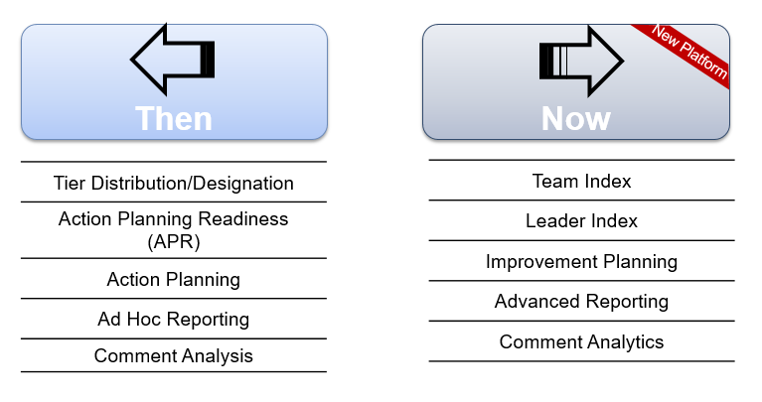

What is the difference between the answer choices “Neutral” and “N/A”?
Use "N/A" if you do not have enough information to rate your level of agreement with a statement or if you do not think the statement applies to you. For example, you might choose N/A for the statement "physicians and staff work well together" if you don't interact with physicians.

Use "Neutral" when you have enough information to rate your level of agreement, and the statement applies to you, but your level of agreement with that statement is midway between 1 and 5. This is the response you should use when you somewhat agree and somewhat disagree with the statement.

I am a manager, how do I log-in to my Press Ganey Portal?
To access your results, please go to the WES Results Portal and enter your password, using this link.
(https://reportal.us.confirmit.com/reportal/login.aspx?PortalId=3387)

If you need your password, please click “Forgot your Password?”

If you need assistance with access to the portal and/or navigation, please contact the Press Ganey Help Desk at hdesk@pressganey.com

Are WES scores used to determine raises?
The WES is used to understand colleagues’ perception of the organization, leadership, teams and engagement with and meaningfulness of their work.
The WES is not used to determine annual raises. Responses to WES are confidential and no one at UNC Health receives any information that allows any individual to be identified, and therefore it wouldn’t be able to be used to determine raises. Merit Increases (raises) are determined by individual performance.
The participation rate is one of three items to achieve the organizational goal for team mates to “engage in activities that enhance and promote the One UNC health values and culture.” This does not factor into raises, but is one of many measures that plays a part in determining incentives—which occur when organizational goals are met.
The data from WES provides actionable information to guide maximization of what is working well and improving what could be done better. For this reason, honest and candid responses are encouraged.

