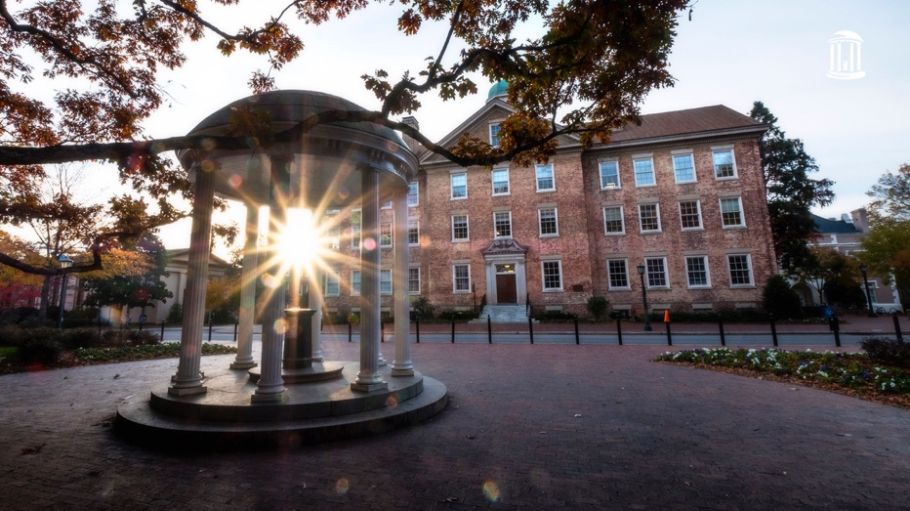

**New Student Talks**

**May 19th, 2:45pm-4:30pm**

**Bioinformatics 1131**

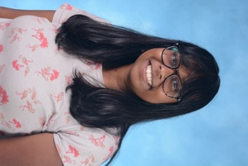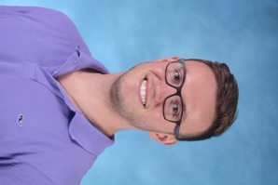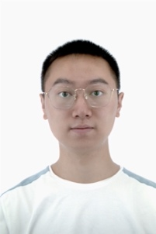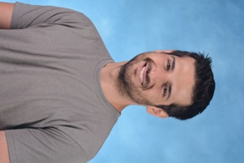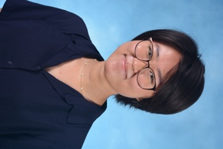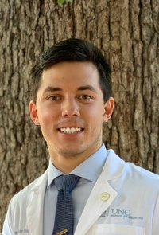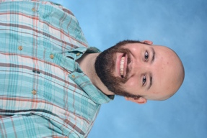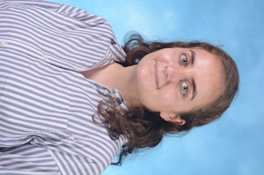

**Amrita Nallathambi,** Biophysics

*“Optimizing a PD-1 autoinhibitory domain using AlphaFold2”*

Lab: Brian Kuhlman

**Alex Neary,** Biophysics

*"3D RNA structure prediction with post transcriptional modifications using Rosetta/FARFAR2"*

Lab: Qi Zhang

**Jingting Chen,** Biochemistry

*“Imaging identification of oncogenic ecDNAs (extrachromosomal DNAs) in cancer cell lines”*

Lab: Elizabeth Brunk

**Matthew Hvasta,** Biophysics

*"A conserved set of mutations for stabilizing soluble E protein dimers from Dengue and Zika viruses"*

Lab: Brian Kuhlman

**Chelsea Yang,** Biophysics

*“Using super-resolution microscopy to study effects of Nup98-HoxA9 condensates on the nuclear environment”*

Lab: Wesley Legant

**Matthew Vander Ploeg,** Biochemistry (MD-PhD)

*Research interest: biochemistry, molecular biology, coagulation hemostasis*

Lab: Wolfgang Bergmeier

**Maria Al Haddad,** Biochemistry

*Research interest: spatiotemporal allosteric activation of PI3K by Ras*

Lab: Sharon Campbell

**Gabriel Arias,** Biochemistry

*"Alternative purification strategy of extracellular vesicles"*

Lab: Dirk Dittmer