8:30 – 9:00 AM Check-in and Breakfast

**Research Retreat**

9:00 – 10:00 AM Session 1 (moderated by Darex Vera-Rodríguez)

Welcome from BCBP Chair Jean Cook, Ph.D.

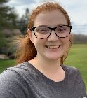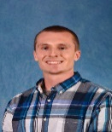Sarah Harris Rodney Park Aleksandra Skrajna, Ph.D.

(Dominguez lab) (Kuhlman lab) (McGinty lab)

‘Evolution of RNA ‘Design of substrate ‘KDM2A/B paralog-specific

Binding and Regulation’ recruitment domains recognition of the nucleosome

in enzymes” acidic patch’

10:00 – 10:15 AM Break

10:15 – 11:00 AM Poster Session A (#1-15)

11:00 – 11:45 AM Session 2 (moderated by Jean Marie Mwiza)

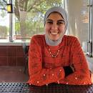Dalia Fleifel Adam Luthman Jun Wang, Ph.D.

(Cook lab) (Ramsden lab) (Wang lab), ‘Cryptic trans-

‘The role of the c-Myc ‘High-resolution activation domain of EZH2

oncoprotein in ensuring mapping of double binds AR & AR’s splice variant

complete DNA replication’ strand break repair promoting oncogene activation

outcomes’ and tumorous transformation’

11:45 – 1:15 PM Museum Exploration & Lunch under tent beside the Butterfly House

1:15 – 2:00 PM Poster Session B (#16-30)

2:00 – 3:00 PM Career and DEI Panel (Introduced by Kanishk Jain, Ph.D.)

Moderated by Qi Zhang, Ph.D., BCBP Diversity Committee Chair

and Silvia Ramos, Ph.D., BCBP Diversity Liaison

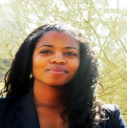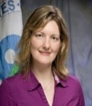

Stephanie Page, Ph.D. Brooke Heidenfelder, Ph.D. Mary Munson, Ph.D

BCBP alumna, Director of BCBP alumna, Clinical Professor & Vice Chair,

Strategic Initiatives WEPAN, Trials Project Manager, Dept. of Biochemistry &

DEI Practitioner, Duke Translational Medicine Molec. Biotechnology,

#BLACKandSTEM creator Institute UMass Chan Med. School

3:00 – 3:15 PM Break

3:15 – 4:00 PM Poster Session C (#31-45)

4:00 – 5:00 PM Keynote Presentation (Introduced by Rick Baker, Ph.D.)

Mary Munson, Ph.D.

Seminar Title: Activation of the Exocyst Tethering Complex for SNARE Complex

Regulation and Membrane Fusion

5:00 – 5:15 PM Closing Remarks and Awards Presentation (Laura Lindsey-Boltz, Ph.D.)

5:30 – 6:30 PM Happy Hour in the Butterfly House



**Retreat Sponsors:**

**Retreat Planning Committee: Laura Lindsey-Boltz, Ph.D; Rick Baker, Ph.D.; Kanishk Jain, Ph.D.; Darex**

**Vera-Rodríguez;** **Jean Marie Mwiza; Rhonda Strickland; Marsha Lynn Ray.**