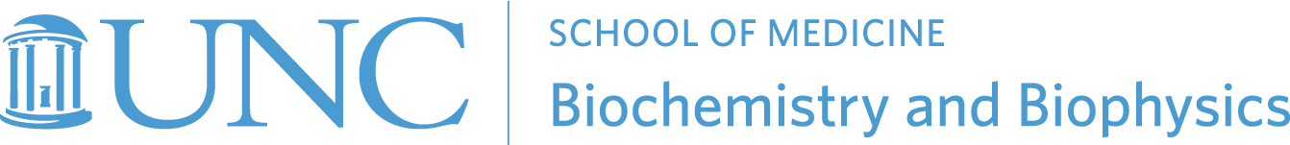

2022 Fall Seminar Series
Tuesdays at 11:00 AM in 1131 Bioinformatics

August 23
Christopher Ackerson, Ph.D., Professor, Chemistry
Colorado State University-----------------------------------------------------------Host: Saskia Neher
Title: “Contrast Problems and Solutions in Biological Electron Microscopy”

September 6
Wellness day- no seminar

September 13
Vacant

September 20
Lindsay Case, Ph.D., Assistant Professor, Biology
Massachusetts Institute of Technology (MIT)-----------------------------------Host: Rebecca Berlow
Title: “Phase separation regulates integrin clustering and downstream signaling”

September 27
Anthony-Samuel LaMantia, Ph.D., Professor and Director, Center for Neurobiology Research
Fralin Biomedical Research Institute at VTC-----------------------------------Host: Patricia Maness
Title: TBD

October 4
Ahmad Jomaa, Ph.D., Assistant Professor, Molecular Physiology and Biological Physics
University of Virginia----------------------------------------------------------------Host: Student Invitation
Title: “Mechanisms of co-translational protein sorting and targeting to the endoplasmic reticulum”

October 11
Nan Yan, Ph.D., Professor and Vice Chair, Immunology and Microbiology
University of Texas-Southwestern---------------------------------------------------Host: Pengda Liu
Title: “Innate immune STING signaling in healthy and disease”

October 18
Morgan Desantis, Ph.D., Assistant Professor, Molecular, Cellular, and Development Biology
University of Michigan------------------------------------------------------------------Host: Rick Baker
Title: "Mechanisms of dynein regulation"

October 25
Sarah Keane, Ph.D., Assistant Professor, Chemistry and Biophysics
University of Michigan--------------------------------------------------------------------Host: Qi Zhang
Title: "Structural determinants of microRNA biogenesis"

November 1
Nick Rhind, Ph.D., Professor, Biochemistry and Molecular Biotechnology
University of Massachusetts Medical School-------------------------------------Host: Jean Cook
Title: TBD

November 8
Stephen Hughes, Ph.D., Chief of the Retroviral Replication Laboratory
National Cancer Institute----------------------------------------------------------Host: Ron Swanstrom
Title: “Clonal Expansion of Infected Cells in People Living with HIV”

November 15
UNC Postdocs

Theresa Simermeyer, Ph.D. (Research in Progress)
Title: TBD

Tomoaki Kinjo, Ph.D. (Research in Progress)
Title: TBD

November 22
Holiday week – no seminar

December 6
Franziska Bleichert, Ph.D., Assistant Professor,
Yale School of Medicine-----------------------------------------------------------Host: Student Invitation
Title: "Mechanisms for initiating DNA replication in eukaryotes"

December 13
UNC Postdoc

Aleksandra Skrajna, Ph.D. (Research in Progress)
Title: TBD

