**BIOC/GNET/BIOL 631: Advanced Molecular Biology**

**Gene expression and genome stability**

**Who should take it?**

* **Any student with an interest in understanding the molecular mechanisms required for life.** It is a core course for students in the department of Biochemistry (Biochemistry track) and the curriculum in Genetics and Molecular Biology. It serves as an elective for almost all other departments.

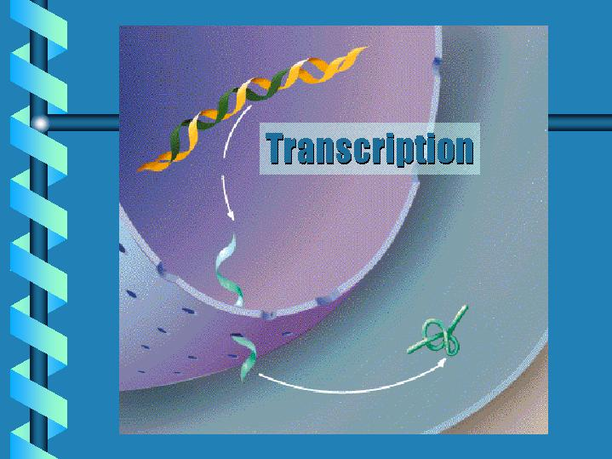

* We will help you understand how genes and genomes are organized, packaged into chromatin, replicated, damaged, and repaired.
* We will address how genes are expressed, as well as the impact of RNA stability on gene expression.
* Two units will emphasize the biology and mechanisms of CRISPR and RNAi, as well as their application to genome engineering.

**When is it?**

* Spring semester, 4 credit hours. Monday, Wednesday, and Friday for 1 hour in the morning, 9:00 to 9:50. An additional 1 hour small group section/recitation will be held 2 pm, either Wednesday or Thursday (with some flexibility to fit your schedule).

**Who teaches it?**

* Albert Baldwin
* Jack Griffith
* Dale Ramsden (course director)
* Aziz Sancar
* Brian Strahl
* Bill Marzluff