BCBP Spring 2024 Seminar Series Presents
“New Frontiers in the cGAS-STING DNA sensing pathway”

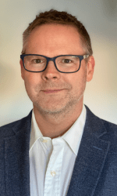
Daniel Stetson, Ph.D.
Professor, Departments of Immunology and Medicine
University of Washington
Dr. Daniel Stetson received a B.S. in Biology from Duke University and a Ph.D. in Biomedical Sciences from the University of California, San Francisco. After completing postdoctoral work at Yale University, he joined the University of Washington Department of Immunology. He currently is Full Professor in the Departments of Immunology and Medicine. Dr. Stetson’s research focuses on mechanisms by which cells detect and respond to viral infection with particular interest in recently described pathway that detects cytosolic DNA within mammalian cells.
To read more about Dr. Stetson, please follow this link: Daniel Stetson

Host: Pengda Liu
Tuesday, March 19, 2024 - 11:00 am – 12:00 pm
1131 Bioinformatics

