THE UNIVERSITY OF NORTH CAROLINA
AT CHAPEL HILL
UNC BLOOD RESEARCH CENTER - Seminar Series

Seminar by
Alan Tall, MD
Columbia University

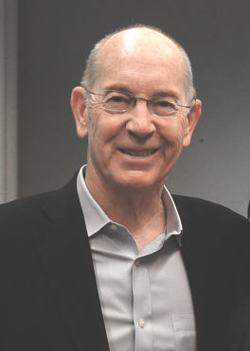

‘Clonal hematopoiesis, inflammation and atherosclerosis’

FRIDAY, April 1, 2022
11:00AM – 12:00pm

ZOOM Details:
Dial: 646-558-8656
Meeting ID: 969 8436 2705; Passcode: 736233

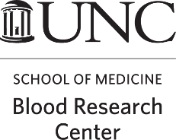

For more information contact: amy_spence@med.unc.edu Host: Brandi Reeves, MD

