**Sending an Imaging Request using iLab Solutions**

**Overview**

iLab is designed to help core facilities with the process of scheduling and billing for services offered at the facility.

Once you have an iLab account, you will be able to either schedule a study for user-operated imaging experiments, or send an imaging request for staff-operated imaging experiments. The following is the step-by-step instructions of using ilab to request an imaging study. Please contact the SAI facility if you have any questions [bricsai@med.unc.edu](mailto:bricsai@med.unc.edu) .

1. **Log into the iLab webpage**

**Website:** <https://my.ilabsolutions.com/>

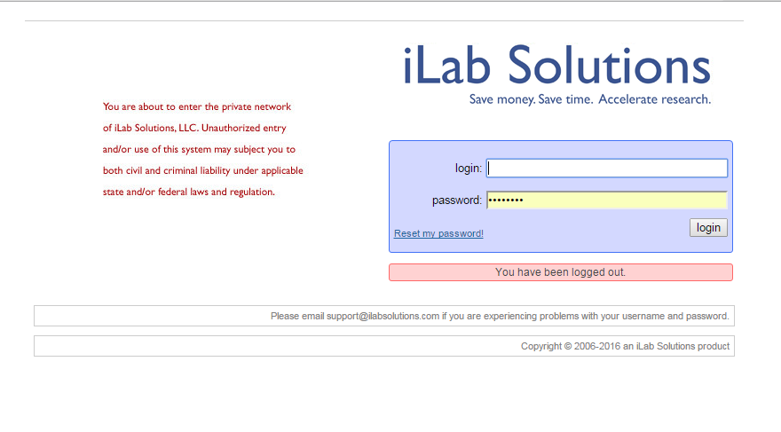

You should already have your account information. Contact [bricsai@med.unc.edu](mailto:bricsai@med.unc.edu) with any problems logging in.

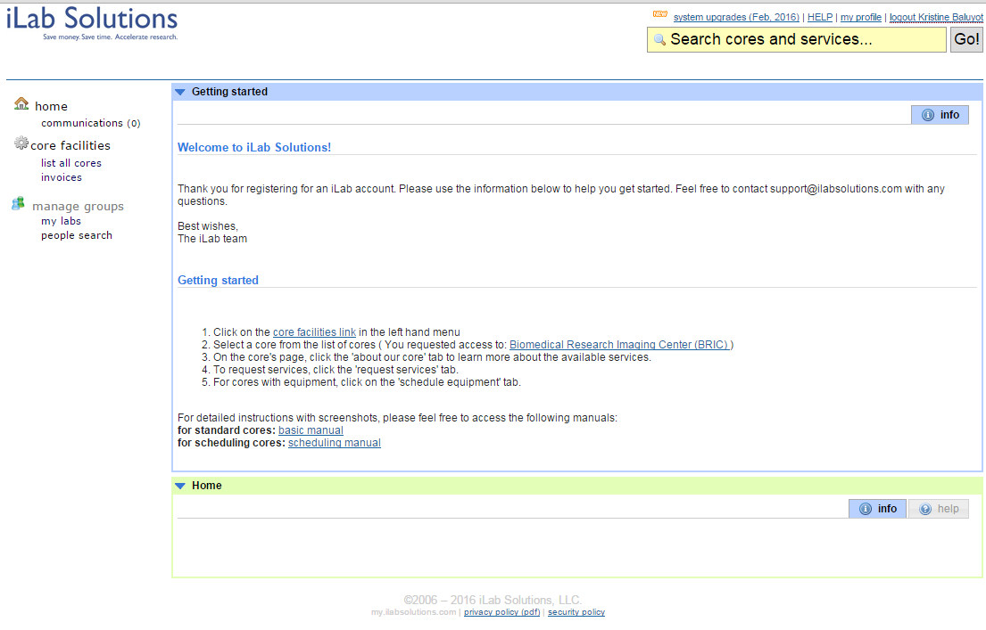

Choose “List all Cores”

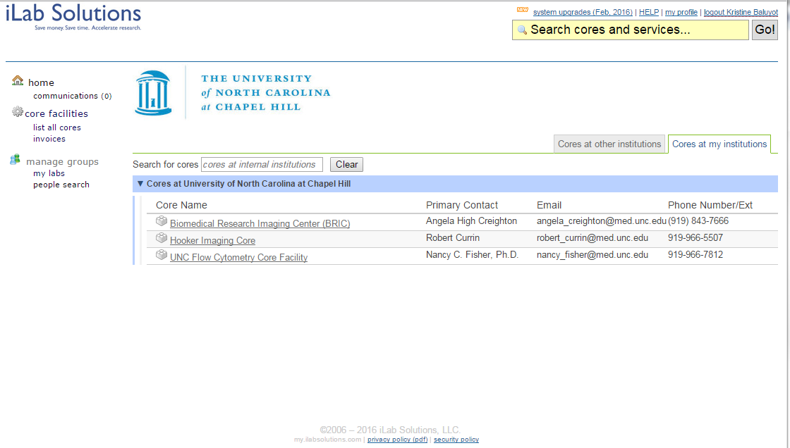

Select BRIC from the options available

1. **Send Imaging Request. This is for requesting staff-supported imaging study.**

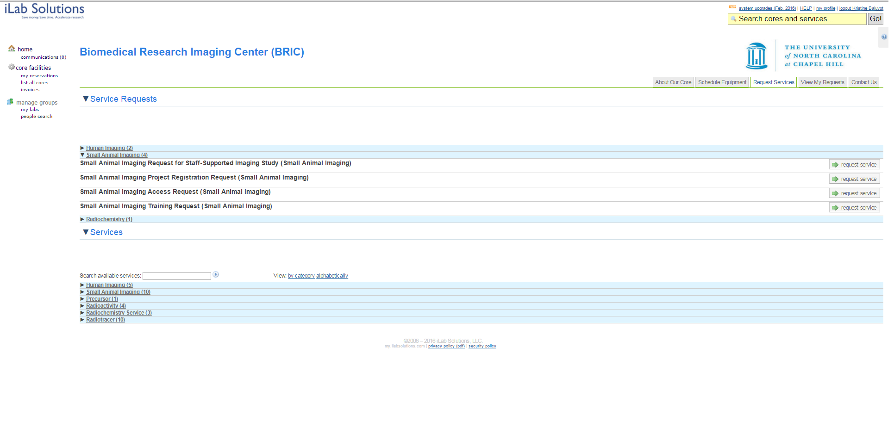

Click this button to send imaging request

Choose the “Request Service” tab, and Small Animal Imaging (4) to display the requests under the SAI core

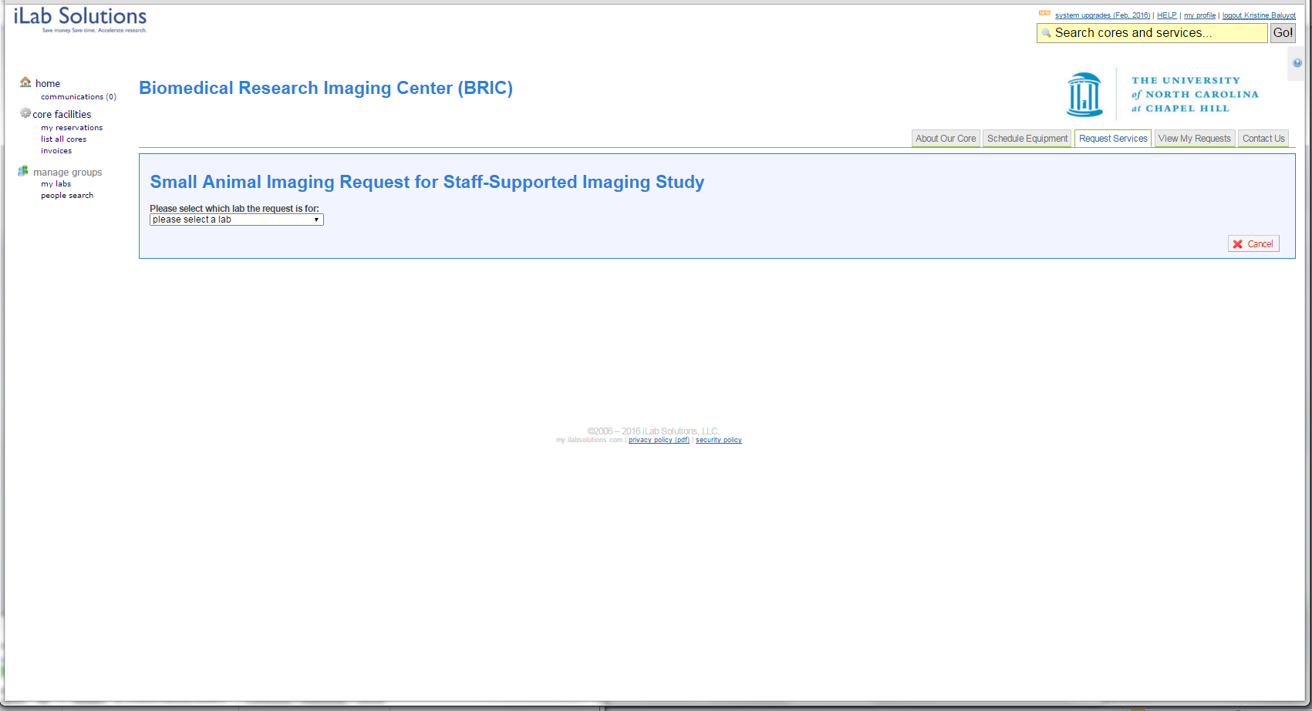

Start a Imaging Request by choosing the PI.

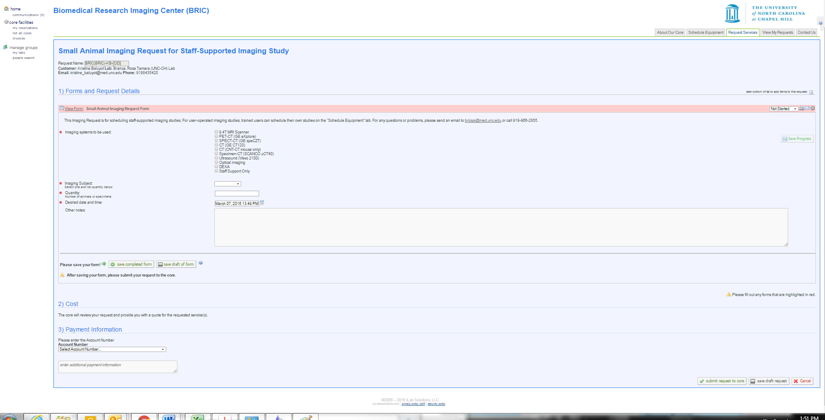

Choose the modality you need for imaging, and fill out the rest of the form and send the request