Scheduling on Calendars using iLab Solutions

Overview
iLab is designed to help core facilities with the process of scheduling and billing for services offered at the facility.

Once you have an iLab account, you will be able to either schedule a study for user-operated imaging experiments, or send an imaging request for staff-operated imaging experiments. The following is the step-by-step instructions of using ilab to schedule an imaging study. Please contact the SAI facility if you have any questions bricsai@med.unc.edu .

- Log into the iLab webpage
Website: https://my.ilabsolutions.com/

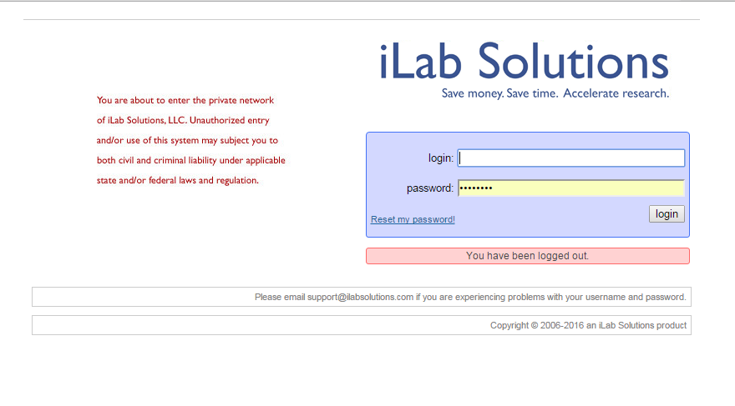
You should already have your account information. Contact bricsai@med.unc.edu with any problems logging in.

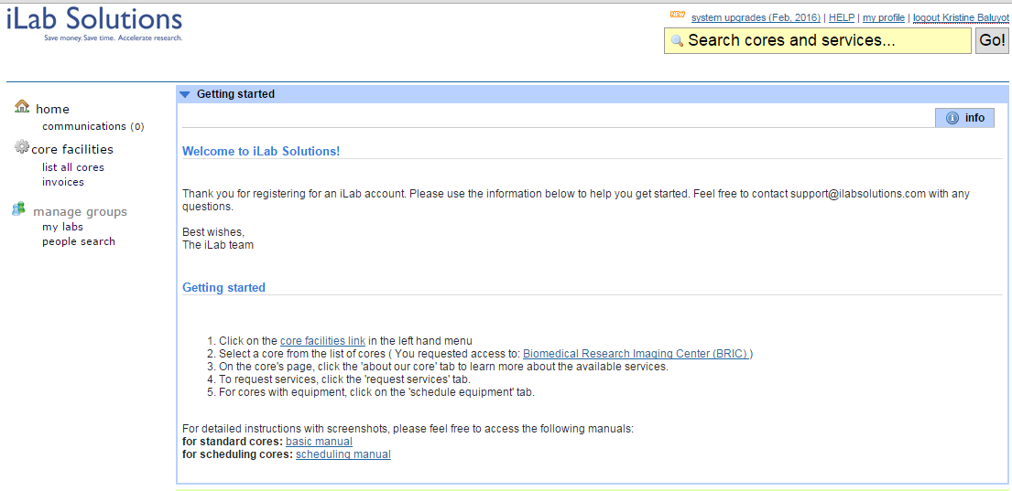
Choose “List all Cores”
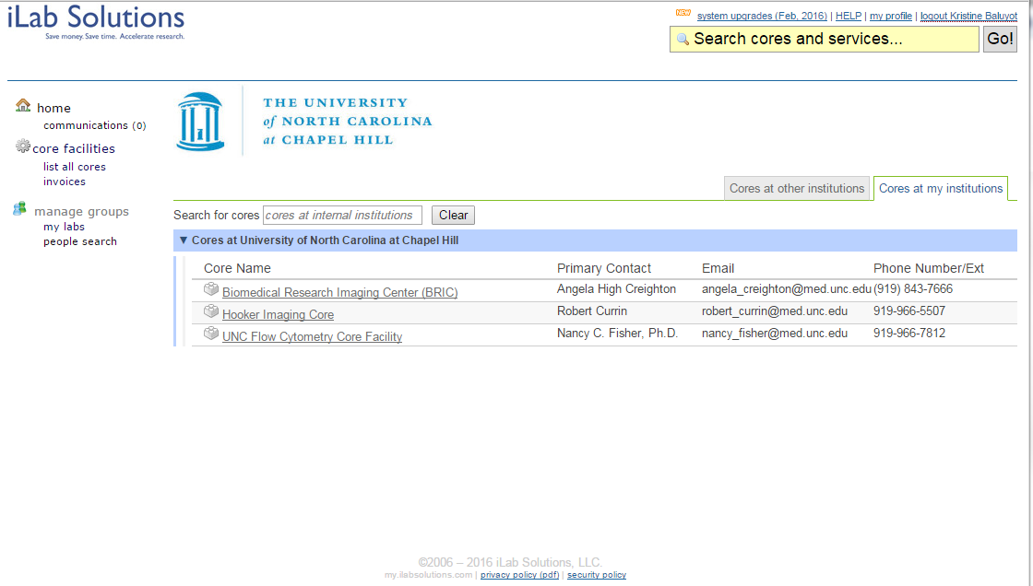
Select BRIC from the options available

- Schedule your study on equipment calendar. This is for user-operated imaging study; for requesting staff-operated study, please download those instructions at this link:

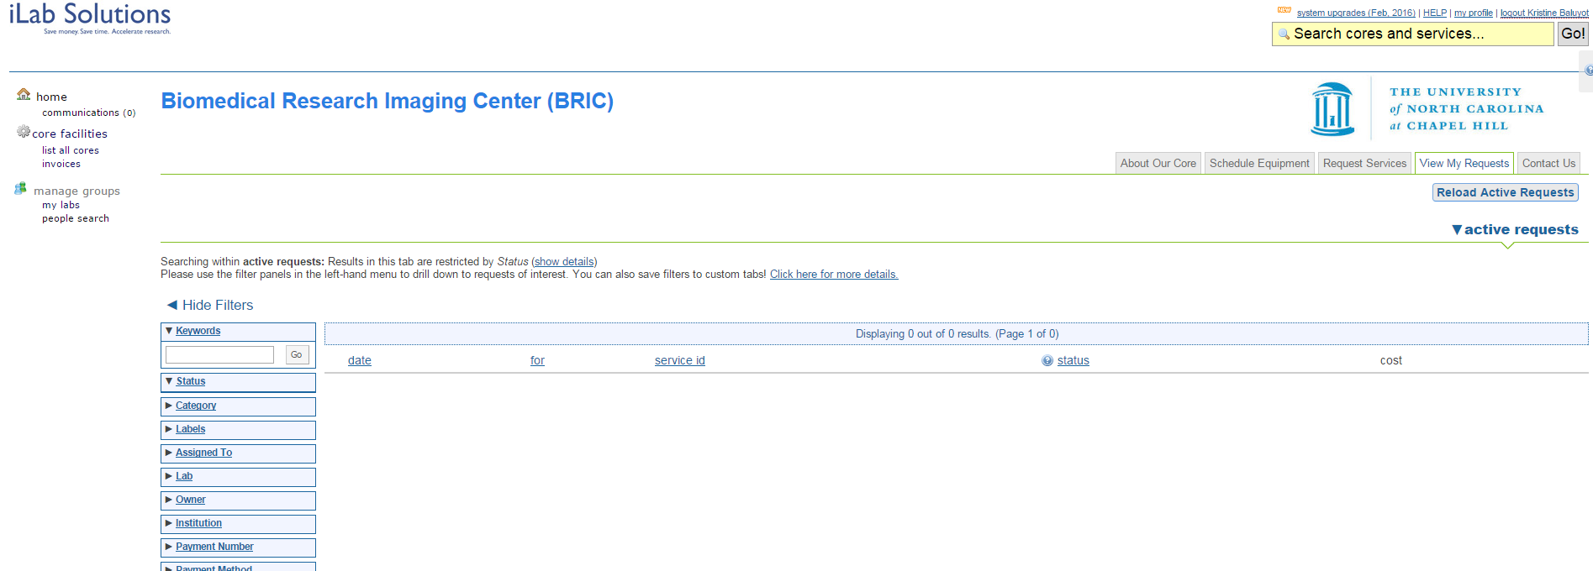
Choose the “Schedule Equipment” tab
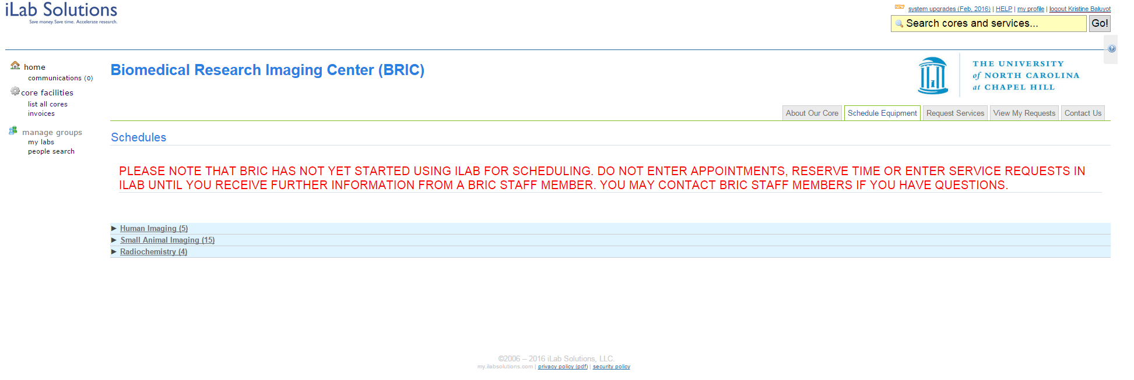
Choose the “Small Animal Imaging” schedules

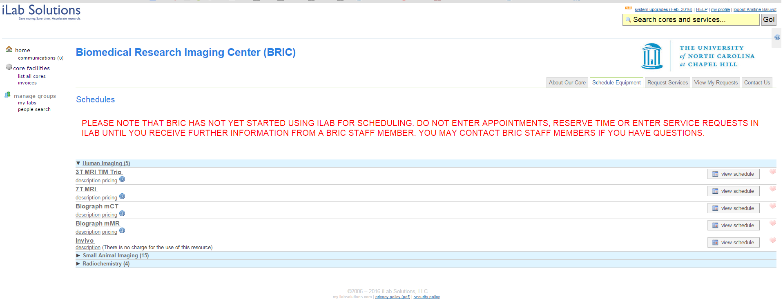
Select the calendar you wish to open. Either the Equipment Name or “view schedule” button will open up the calendar.

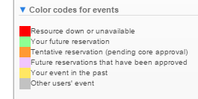
Please note:

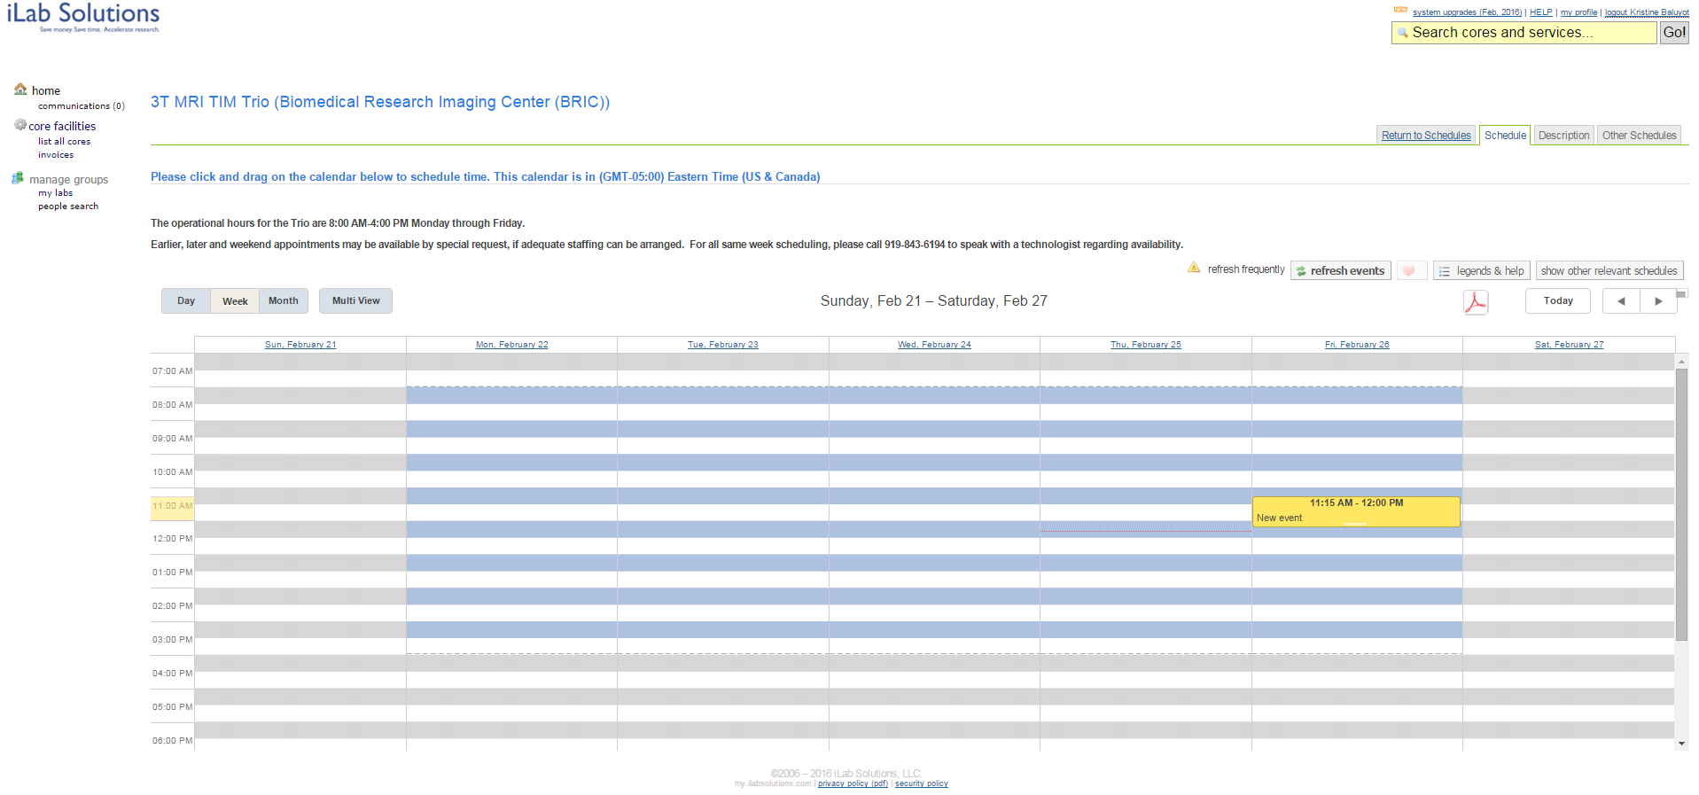
IVIS Kinetic
To reserve a time on the calendar, click and drag to create an event for the time frame you are requesting. When you release, a reservation form will automatically be created. If you are not able to click and drag the exact appointment time you are trying to schedule, this time frame can be changed in the reservation form

Blank Reservation Form Example:

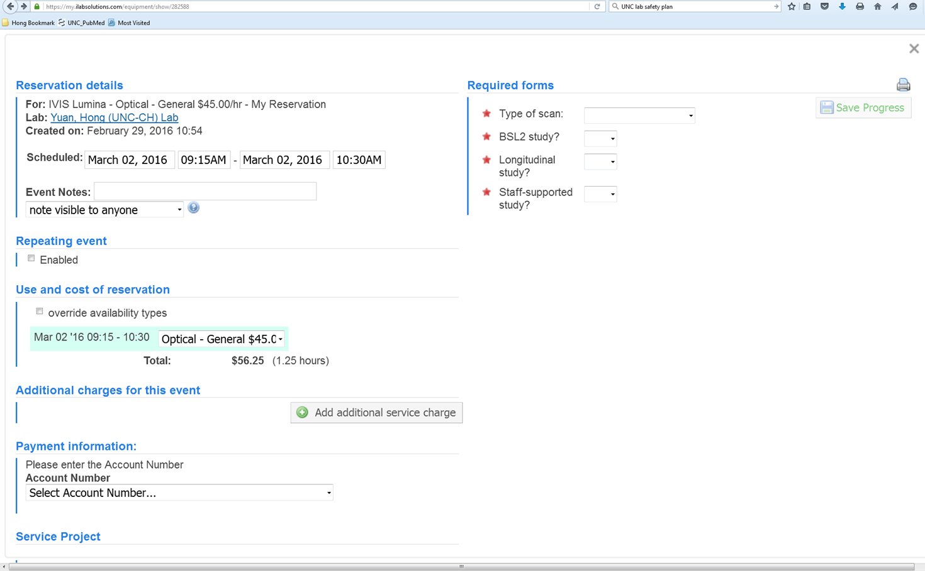
Make sure the correct chart string is linked to the study. This information is automatically linked to billing, please confirm the chart strings with your lab manager PRIOR to scheduling.
Make sure these items being filled out.

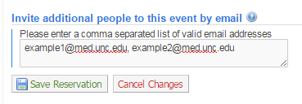

Once you have confirmed all reservation information is correct, click “Save Reservation” to submit your request to BRIC. You will receive an email once the appointment is requested.

