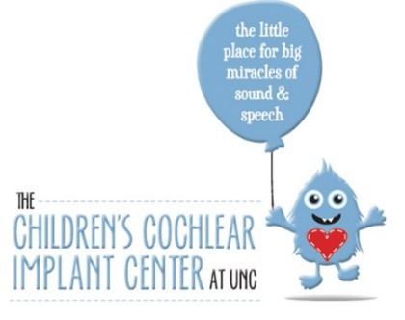**LSL JUNCtion Fall 2023**

**Listening and Spoken Language for Children with Hearing Loss**

An online educational opportunity presented by:

The Children’s Cochlear Implant Center at UNC

**September 1, 2023 to November 15, 2023**

LSL Junction consists of online coursework in Listening and Spoken Language therapy with LSLS certified coaches. This training is for audiologists, speech-language pathologists, and teachers of the deaf who wish to develop skills in Listening and Spoken Language Therapy for children who are deaf or hard of hearing.

Course Specifics:

* Eight week, online course designed to provide the basic knowledge, tools and resources in LSL therapy.
* Participants will explore LSL topics through readings, videos and application assignments.
* Weekly live online meetings with instructors to review the learning from that specific week.
* Topics Addressed:
  + What is a Listening and Spoken Language Specialist?
  + Audiology 101
  + Auditory Brain Development, Function and Strategies
  + Auditory Memory & Auditory Learning (this is covered in 2 parts over 2 weeks)
  + Language Development & Strategies
* Speech Development
* Parent Participation Sessions & Strengths Based Coaching

Cost: The cost of this training is $400. If you are employed by the state of North Carolina there is no charge.

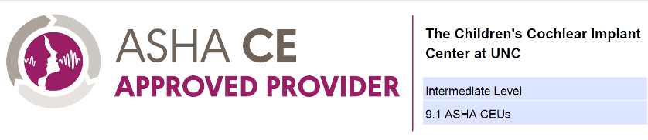

*ASHA CE Provider approval does not imply endorsement of course content,*

*specific products or clinical procedure.*

**Coaches:** *   
Sandra Hancock, MS, LSLS Cert AVT  
Lillian Henderson, MSP, LSLS Cert AVT  
Christine Kramer, MS, LSLS Cert AV Ed

Virginia Madorin, MA, LSLS Cert AV Ed  
Erin Thompson, MS, LSLS Cert AVT

*\*All coaches and presenters are employees of The University of North Carolina at Chapel Hill (UNC-CH) and will not receive additional compensation. The speakers do not have any nonfinancial relationships to disclose.*

,

For further information please contact Lillian Henderson: [Lillian.henderson@unchealth.unc.edu](mailto:Lillian.henderson@unchealth.unc.edu)