***FAMILY MEDICINE***

***CAREER ADVISING***

***CLASS OF 2019***

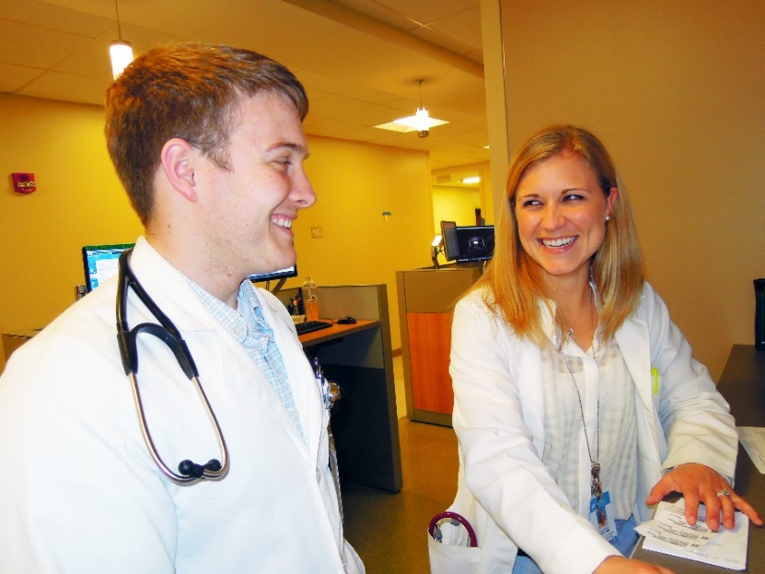**Kelly Bossenbroek-Fedoriw, MD**

**Medical Student Programs**

[kelly_fedoriw@med.unc.edu](mailto:kelly_fedoriw@med.unc.edu)

**Beat Steiner, MD, MPH**

**Medical Student Programs**

[Beat_steiner@med.unc.edu](mailto:Beat_steiner@med.unc.edu)

**Dawn Morriston, MPH**

**Associate Director of Educational**

**Programs & Director of Medical Student Advising**

[Dawn_morriston@med.unc.edu](mailto:Dawn_morriston@med.unc.edu)

**Student Resources:**

**Virtual Family Medicine Interest Group: National**<http://fmignet.aafp.org/>   
The Academy of Family Physicians at the national level has a great resource page for students to help with residency selection process.

**Virtual Family Medicine Interest Group: State**<http://www.ncafp.com/students>   
The North Carolina Academy has another web page that is great for students choosing careers in Family Medicine.

**AAFP Directory of Family Practice Residency Programs**

<http://www.aafp.org/residencies/>   
Online Directory of Family Practice Residency Programs. Contains links to programs on the Web.

**Electronic Residency Application Service (ERAS)**<http://www.aamc.org/eras>   
Home page for information about the new electronic application service

**National Resident Matching Program (NRMP)**<http://www.nrmp.org>   
Online information from the AAMC about the match

**TABLE OF CONTENTS**

1. **Timeline for Residency Selection Activities**
2. **Career Advisors for the Class of 2019**
3. **Advisor Profiles**
4. **Guidelines for Ranking Residency Programs**
5. **Guidelines for Fourth-Year Electives**

**A group of people sitting at a table

Description generated with very high confidence**

**I. Timeline for Residency Selection Activities**

**January-April of your third year**

* *Attend Class meeting*
* Seriously considering family medicine? ***Schedule an initial meeting with Dawn Morriston, Director of Medical Student Advising, phone 984-974-4987 (***[dawn_morriston@med.unc.edu](mailto:dawn_morriston@med.unc.edu)***).*** She will review the residency interview process in light of your personal needs and issues; discuss the Kansas City meeting and assign you an MD advisor based on your needs and interests. Please bring and/or have thought about the following:
  + CV (please email this to Dawn)
  + know your grades and Step 1 score
  + have in mind 3 faculty who might write letters of recommendation
  + decide when to schedule Step 2 CK & CS
* ***Attend Match Celebration dinner* (March 21, 2018)** with 4th year students who matched in Family Medicine. They will share their experiences and we will also have a panel of residency directors discussing what they look for in candidates. Your spouse or significant other is also welcome to attend the dinner.
* *Make appointments for your* ***Medical Student Performance Evaluation*** *with Maureen Rosen, Staff Writer in Student Affairs*. Turn in your CV to Maureen if you haven’t already done so and schedule a meeting with her to review a draft of your ***Medical Student Performance Evaluation***.
* *Meet with your assigned MD advisor* to:
  + Review electives and have advisor sign off on forms, forms are due **in March, 2018**.
  + Consider whether an “audition” elective in a certain geographic area is needed/desired.
  + Decide your interview months (students usually interview between November and January).
  + Discuss the type of residency program you are considering
* *NC Family Medicine Day Residency Recruitment Conference:* March 10, 2018 at Hilton Durham.

**May – August of your third year**

* Review web resources on cover page of this handout
* Begin working on your Personal Statement
* *Kansas City Meeting*: The National Conference of Family Medicine Residents and Medical Students (Kansas City Meeting) will be held on August 2-4, 2018, Kansas City, MO. Please contact Dawn Morriston at 984-974-4987 or [dawn_morriston@med.unc.edu](mailto:dawn_morriston@med.unc.edu) or Tracie Hazelett 919-980-5357 or [Thazelett@ncafp.com](mailto:Thazelett@ncafp.com) if you plan to attend. The department has limited resources to support students.

**In your fourth year**

**August**

* Attend the AAFP National Conference of Family Medicine Residents and Medical Students in Kansas City August 2-4, 2018. Contact Dawn Morriston and Tracie Hazelett for more information. Some financial support is available to support travel.
* *Meet (1-3 times) with your advisor*, as needed, to review your Personal Statement.
* Get your application and letters of recommendation into these programs **AS SOON AS YOU CAN** to ensure that you will be interviewed.
* *Letters of recommendation*: Contact these individuals and confirm timeline with them. Supply ERAS forms to those faculty members who will write letters.

**Summer, 2018**

* *ERAS Opens:* Begin filling out this application

**August – October**

* Consider doing a practice interview with your advisor before hitting the interview trail.
* Consider doing an early interview with the UNC Family Medicine Program, which has agreed to offer an interview to any UNC student interested in Family Medicine.
* Schedule interviews. Do not schedule your most desired program first. Rather, schedule one or two interviews to become familiar with the process
* Letters of Recommendation: following up with those who have not sent them in! Make sure that programs have received the letters, too.
* Meet with advisor to review your list of programs to be interviewed

**September 15, 2018**

* Submit completed application materials to ERAS.
* Submit ERAS applications to residency programs.
* Register with National Residency Matching Program (NRMP)

**October 1, 2018**

* Dean's Letters mailed/Uploaded to ERAS

**October, 2018 - January, 2019**

* Interview with programs.

**January, 2019**

* Contact advisor to discuss program rankings

**February, 2019**

* Turn in Rank List to Dean's Office

**March 11, 2019**

* *If you have not matched*, you will be notified by e-mail by ERAS on Monday of Match Week. They will also contact the Dean's Office. Don't panic. Contact Dr. Dent, your advisor and Dr. Beat Steiner, and they will work with you to identify unfilled family medicine residency programs. Unmatched students will be able to submit supplementary applications for unfilled programs.

**March 15, 2019**

* Match Day

**April, 2019**

* Participate in Advising Dinner for students from the Class of 2020 who are interested in Family Medicine.

**II. Career Advisors for the Class of 2019**

You should plan on at least **FOUR** meetings with your career advisor: (1) in April to review fourth year electives and materials you prepare for your Dean’s letter; (2) in July/August to discuss residency programs, personal statements, and letters of recommendation; (3) in September to finalize residency program selection; (4) in December/January to review ranking of programs for your Match list.

The following Family Medicine faculty members will serve as career advisors for your class.

Dr. Kelly Bossenbroek: Reid Johnson, (984-974-4898) (e-mail: [Kelly_Bossenbroek@med.unc.edu](mailto:Kelly_Bossenbroek@med.unc.edu) **or** [Reid_Johnson@med.unc.edu](mailto:Reid_Johnson@med.unc.edu))

Dr. Narges Farahi: contact direct by e-mail: [Narges_Farahi@med.unc.edu](mailto:Narges_Farahi@med.unc.edu)

Dr. Tommy Koonce: Amanda Harvey, (984-974-4881) (e-mail: [Thomas_Koonce@med.unc.edu](mailto:Thomas_Koonce@med.unc.edu) **or** [adharvey@email.unc.edu](mailto:adharvey@email.unc.edu))

Dr. Anne Mounsey: Reid Johnson, (984-974-4898) (e-mail: [Anne_Mounsey@med.unc.edu](mailto:Anne_Mounsey@med.unc.edu) **or** [Reid_Johnson@med.unc.edu](mailto:Reid_Johnson@med.unc.edu))

Dr. Beat Steiner: Reid Johnson, (984-974-4898) (e-mail: [Beat_Steiner@med.unc.edu](mailto:Beat_Steiner@med.unc.edu) **or** [reid_johnson@med.unc.edu](mailto:reid_johnson@med.unc.edu))

Dr. Morgan McEachern: (984) 974-5106 or [morgan_mceachern@med.unc.edu](mailto:morgan_mceachern@med.unc.edu)

Dr. Yee Lam: (984) 974-4897 or [yee_lam@med.unc.edu](mailto:yee_lam@med.unc.edu)

Dr. Kelly Evans: (984) 974-0210 or [Kelly_Evans@med.unc.edu](mailto:Kelly_Evans@med.unc.edu)

**Asheville Program** students should contact Dr. Robyn Latessa at [Robyn.Latessa@mahec.net](mailto:Robyn.Latessa@mahec.net).

**Charlotte Program** students should contact Dr. Michele Birch at [Michele.Birch@carolinashealthcare.org](mailto:Michele.Birch@carolinashealthcare.org).

**Wilmington Campus** students may contact Dr. Catherine Sotir at [Catherine.Sotir@seahec.net](mailto:Catherine.Sotir@seahec.net)

**III. Advisor Profiles**

**Kelly Bossenbroek Fedoriw, MD**

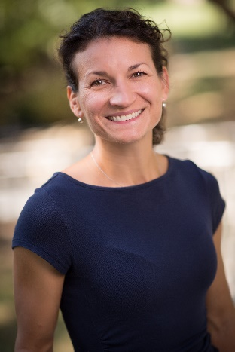

Dr. Bossenbroek Fedoriw attended the Medical College of Ohio and received her MD in 2003. She completed her Family Medicine Residency at Brown Family Medicine Residency program in Providence, RI and graduated in 2006. She is board-certified in Family Medicine. Prior to coming to UNC she worked in a Community Health Center and speaks Spanish fluently.

Dr. Bossenbroek Fedoriw is most knowledgeable about residency programs in the Midwest and Northeast areas.

Her areas of interest include: women’s health and procedures, lactation, child development, addiction, and chronic pain.

To make an appointment with Dr. Bossenbroek Fedoriw, e-mail [Kelly_Bossenbroek@med.unc.edu](mailto:Kelly_Bossenbroek@med.unc.edu) **or** [Reid_Johnson@med.unc.edu](mailto:Reid_Johnson@med.unc.edu), or call Reid Johnson at 984-974-4898.

**Kelly Evans, MD**

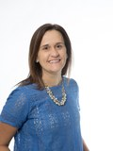

I grew up in the small town of Rustburg, Virginia outside of Lynchburg.  I was the first person in my family to go to college, attending the University of Virginia and graduated with a degree in Spanish.  I took time off and worked as a scribe in the UVA Emergency Department before attending the Medical College of Virginia (Virginia Commonwealth University) in Richmond for medical school.  I loved all my third-year rotations and quickly realized that Family Medicine would offer me long-term relationships with my patients and I would be able to practice a variety of medicine. I completed Family Medicine residency at the University of North Carolina then stayed on for fourth-year Chief Residency Fellowship. Currently, I work within the Department of Family Medicine. I continue to practice inpatient medicine by working on the Family Medicine Inpatient Service, working on the rural Chatham hospitalist service, and working in the new Observation unit. In addition, I see patients in Family Medicine Center and on our Maternal-Child Health service. I am interested in teaching both medical students and residents; now I am part of the Patient-Centered Care (PCC) course for first- and second-year medical students. I would like to be involved in developing medical school curriculum especially around rural populations.

To make an appointment with Dr. Evans, please contact her at [Kelly_Evans@med.unc.edu](mailto:Kelly_Evans@med.unc.edu)

**Narges Farahi, MD**

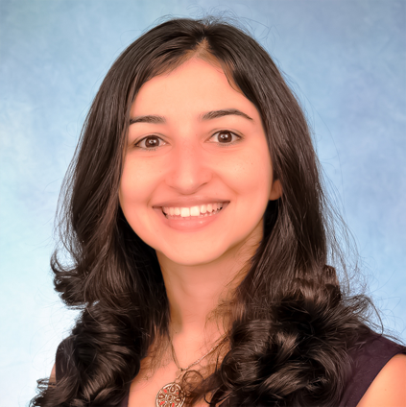Dr. Farahi attended the University of Pittsburgh, School of Medicine and received her MD in 2007. She completed a Family and Community Medicine Residency at the University of California, San Francisco at San Francisco General Hospital in 2010 and is board certified in Family Medicine.

Dr. Farahi is most knowledgeable about residency programs on the West Coast and particularly Northern California.

Dr. Farahi’s areas of interest include: maternal and child health, reproductive health, care of the underserved, full-scope family medicine, and team-based care.

To make an appointment with Dr. Farahi, please contact her at [narges_farahi@med.unc.edu](mailto:narges_farahi@med.unc.edu).

**Tommy Koonce, MD, MPH**

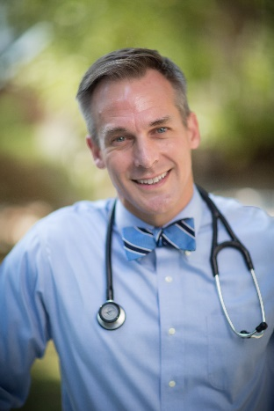

Dr. Koonce attended the UNC School of Medicine and received his MD in 1999.  He completed his Family Medicine Residency at East Carolina University in Greenville, NC in 2002.  He then completed a fellowship in academic medicine at UNC and earned his MPH. He is board certified in Family Medicine.

Dr. Koonce is most knowledgeable about residency programs in North Carolina and the Southeast.

Dr. Koonce’s areas of interest include:  inpatient medicine, quality improvement, and medical student teaching.

To make an appointment with Dr. Koonce, please e-mail [Thomas_Koonce@med.unc.edu](mailto:Thomas_Koonce@med.unc.edu) **or** Amanda Harvey [adharvey@email.unc.edu](mailto:adharvey@email.unc.edu).

**Yee Lam, MD, PhD**

I'm excited to hear that you're interested in a career in family medicine. I came to family medicine through a love of women's health that grew into care for the whole family from birth to passing. I have a background in engineering that helps me approach patient care from a unique perspective. I take care of patients in clinic and in the hospital, and work with medical students and residents at many points during training.

In my time outside of medicine, my husband, our 2 children and I enjoy traveling, hiking and camping. We also enjoy cooking together and tasting the abundant supply of local fresh produce.

*Interests: women's health, preventive medicine, care for the underserved, health equity and healthcare reform, medical student education, academic medicine*

To make an appointment with Dr. Lam, contact Jenny Jones (984) 974-4463, [jnjones@email.unc.edu](mailto:jnjones@email.unc.edu).

**Morgan McEachern, MD**

I’m originally from Phoenix, Arizona but moved to North Carolina as a teenager and over the years it has really grown to become my home. I completed both my undergraduate and medical school degrees from Wake Forest University, but took a brief hiatus between degrees to join AmeriCorps. There I worked to establish HIV/AIDS prevention educations programs with inner city youth, offered free HIV and STD screenings to a variety of high-risk populations, and provided medical and support services to patients living with HIV. This experience was incredibly formative and set me on a path of wanting to care for vulnerable populations and underserved communities. In medical school, I was quickly drawn to family medicine and the breadth and depth of care provided to entire families through the specialty. I became particularly interested in caring for women and children as a way of improving the overall health of communities. I completed my residency training and career development fellowship in Maternal Child Health here at UNC and during that time developed a passion for teaching. My clinical interests within Family Medicine include maternal and child health, women’s health and reproductive access, vulnerable populations, and social determinants of health. I continue to practice full scope family medicine including outpatient, inpatient, and maternity care for entire families. Outside of medicine, I enjoy spending time with my partner, daughter, and dog. I also enjoy traveling, hiking, practicing yoga, and trying new restaurants.

To make an appointment with Dr. McEachern, e-mail [morgan_mceachern@med.unc.edu](mailto:morgan_mceachern@med.unc.edu) **or** [Dionne_Apple@med.unc.edu](mailto:Dionne_Apple@med.unc.edu) (984) 974-4990

**Anne Mounsey, MD**

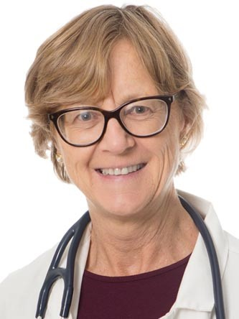Dr. Mounsey attended the University of London for her undergraduate education and St. Thomas’ Hospital Medical School, receiving her MD in 1982. She did her internship year at St. Thomas’ Hospital in London and completed her Family Medicine Residency at Barnet Hospital in London in 1987. She served as a Fourth Year Family Medicine Resident at John Radcliffe Hospital in Oxford, UK in 1987-88. After completing her medical training, Dr. Mounsey worked in medical centers in Oxford, Ashington, and Birmingham, UK from 1989-1996. During that time, she spent the year of 1993-94 working at the Thomas Jefferson Institute in Charlottesville, VA and later moved to the Charlottesville area and worked at UVA Dept. of Family Medicine from 1997-2007. In August of 2007, Dr. Mounsey moved to Chapel Hill to begin work in the Dept. of Family Medicine.

Dr. Mounsey is most knowledgeable about the Virginia area residency programs, and her research interests include: evidence-based teaching, and, medical student teaching and management of chronic problems, such as headache, asthma, low back pain.

To make an appointment with Dr. Mounsey, e-mail [Anne_Mounsey@med.unc.edu](mailto:Anne_Mounsey@med.unc.edu) **or** [Reid_Johnson@med.unc.edu](mailto:Reid_Johnson@med.unc.edu), or call Reid Johnson at (984) 974-4898.

**Beat Steiner, MD, MPH**

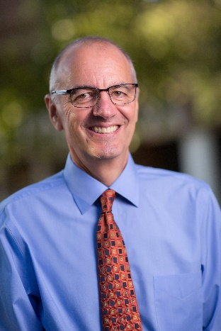Dr. Steiner is a graduate of the UNC School of Medicine and completed his residency at the University of Rochester in New York State. His residency clinic was located in an urban community health center which helped affirm his commitment to improving the health of the underserved. As part of his training he also completed a residency in Preventive Medicine and obtained an MPH. Since returning to Chapel Hill as a faculty member in 1996, he has worked closely with medical students, teaching in all four years of the curriculum and acting as an advisor to a number of student groups focused on service to underserved populations.  He is currently the Program Director for Medical Student programs in the Department of Family Medicine.

His interests include the intersection of medicine and public health and the integration of physical health and mental health.  He is the medical director for the local Community Care of North Carolina network. His clinical practice is located in a psychiatric campus where he provides primary care to patients with severe mental illness.

He has a particular interest in working with students who share his interest in serving the underserved, who are interested in integrating mental and physical health care, who want to know more about how physicians can become involved in areas of public health, or who want to learn more about exciting innovations in family medicine.

To make an appointment with Dr. Steiner, please e-mail him directly at [beat_steiner@med.unc.edu](mailto:beat_steiner@med.unc.edu), or contact [reid_johnson@med.unc.edu](mailto:reid_johnson@med.unc.edu)

**AHEC Campus Career Goal Advisors**

Students also have the option of discussing career goals with their Campus Career Goal Advisors as well:

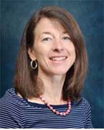**Charlotte: Michele Birch, MD**

[**Michele.Birch@carolinashealthcare.org**](mailto:Michele.Birch@carolinashealthcare.org)

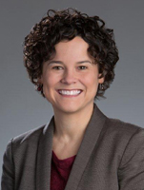**MAHEC – Robyn Latessa, MD**

[**Robyn.Latessa@mahec.net**](mailto:Robyn.Latessa@mahec.net)

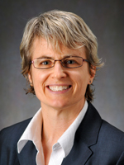**SEAHEC – Catherine Sotir, MD**

[**Catherine.Sotir@seahec.net**](mailto:Catherine.Sotir@seahec.net)

1. **Guidelines for Ranking Residency Programs**

The NRMP matches applicants and programs in favor of the students. Students get their highest ranked programs when the programs rank them highly; residency programs do not get their highest choices when students have ranked other programs higher. Given that mechanism, it follows that:

1. Rank your first choice first, even if you feel your chances of matching are low.

1. List seven to ten programs, even if you are confident of your top three. If your academic record is uneven, you may want to list more than ten.
2. Consider having a "safety" program ranked at the bottom. Not matching is problematic, even though there are usually good programs which do not fill.
3. DO NOT rank a program that you really **do not** want to go to. You break a legal contract if you do not attend a program you matched, and it is foolish to go where you would be unhappy. You are better off NOT matching, and going through the SOAP (Supplemental Offer and Acceptance Program) process for a spot.
4. Couples Matching can be tricky! Visit the NRMP website <http://www.nrmp.org/couples-in-the-match/> for tips or talk to Dr. Sarah Nickolich ([sarah_nickolich@med.unc.edu](mailto:sarah_nickolich@med.unc.edu)) in Family Medicine who successfully navigated it!

**V. Guidelines for Fourth-Year Electives for Students Considering Family Medicine Residency Programs**

Use fourth year rotations to your educational advantage! The new Individualization Phase is longer and gives you more **opportunities to shine while filling in gaps** in your clinical education. While it might be tempting to register for the minimum number of electives you need to graduate, remember this is your last opportunity to choose from a broad range of clinical rotations and **garner letters of recommendation**.

A group of people standing in a room

Description generated with very high confidence**Required Selectives**: Use these required courses to prepare for family medicine. Here are some options to consider:

* **UNC Acting Internship & AHEC Acting Internship:**

Use this time to check out NC residency programs. The programs in Greensboro, Asheville, Charlotte, Cabarrus, and Wilmington take AI students, but slots are limited. The AI in Chapel Hill **DOES NOT** fulfill your AHEC AI requirement unless you are a student from one of the Regional campuses. You are not expected to do more than one AI in family medicine. The AI in Family Medicine in Asheville will give you a feel of what an (mostly) unopposed program is like.

* **Critical care:** Consider the Medical ICU or the Emergency Medicine placements.