SOM School Reports

Faculty Productivity 2017
  - General Notes

Data
- Data refresh, at a minimum, will take place shortly after the month-end close
- The data is for Fiscal Year 2017 and going forward only, as this is when the SOM started utilizing program code for Faculty Productivity purposes.
- The data sources for this report include HR/Payroll, Revenue Cycle, AAMC, FPSC, and MGMA.
- Data nuances: there have been occurrences where the degree data is not in ConnectCarolina; therefore it is not pulled into this report.
- Additional charts and data continue to be refined, which makes this report ever evolving

  - Report Navigation

Navigate to Infoporte > Home > School Reports > HR/Funding > Faculty Productivity 2017

  - 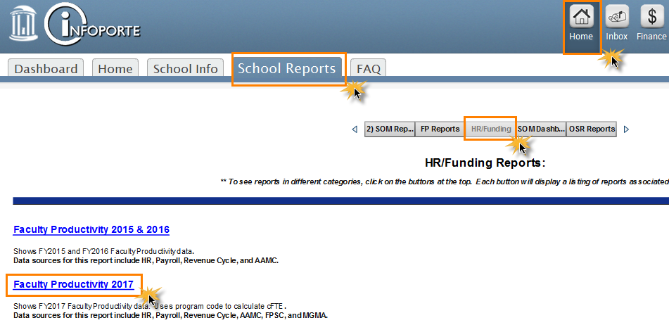

  - Default Filters

These filters apply to all tabs in this report. For example when you make a certain selection for the “Detail Data” tab it will carry over to the “Dashboard AAMC and FPSC” tab.
- Rank: this filter includes the ranks that can be queried (i.e. Associate Professor, Professor, etc.)
- A: this filter shows the payroll status. It is automatically set to Active (A) employees, but the following are additional payroll statuses:

  - A – Active
  - D – Deceased
  - L – Leave of Absence
  - P – Leave with Pay
  - Q – Retired with Pay
  - R – Retired
  - S – Suspended
  - T – Terminated
  - U – Terminated with Pay
  - V – Terminated Pension Pay Out
  - W – Short Work Break
  - X – Retired-Pension Administration

- Clinical: this filter shows the type of Faculty. It’s currently defaulted to Clinical, but can be changed to Adjunct, Other, Research, or the filter can be cleared.
- Degree_Type: this filter shows you all degree types possible
- MD or PHD: this filters is preselected to MD or PHD, but “Other” can be selected as well
- Dept and Description: this is where you can select your four-digit department ID.
- Department and Description: this is where you can select your six-digit division ID

