SOM School Reports

Program Code on Faculty Funding
This report is used to see which program codes have been applied to your Faculty’s funding lines. It can also be utilized to see which funding lines do not have a program code so that one can be assigned. Follow the below instructions to run the report.

General Notes
  - Data Refresh
Data refresh occurs soon after the monthly payroll runs. This is not an automatic refresh and is handled manually.

  - Source of Data
The data source for this report is payroll.

Report Navigation
Navigate to Infoporte > Home > School Reports > HR/Funding > SOM Program Code on Faculty Funding

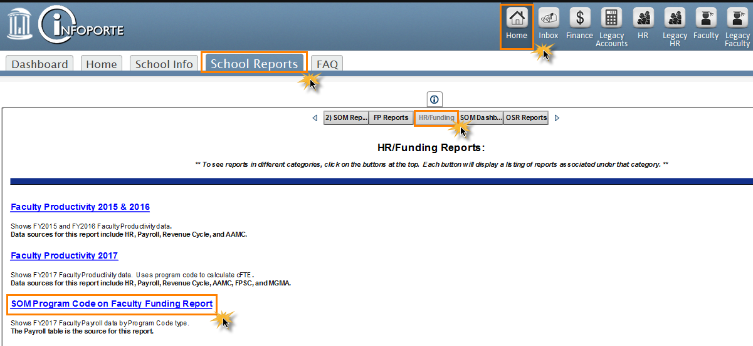

SOM Payroll for 2017 Program Code Checking tab
- Select your department from the drop down list at the top right of the screen OR select a person or PID
- To see payroll data for a specific FY select the same “Fiscal Year” and “Payroll Run ID Control” (by selecting the “Payroll Run ID Control” this will eliminate PAATs that were processed in this FY, but for a different FY)

See next page for screenshot.
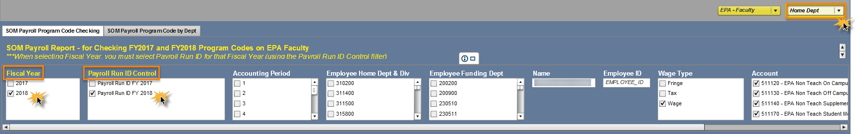

Payroll Summary By Employee Result: the report displays the amount in each program code grouping (i.e. Admin, Clinical, etc.) by employee. The “XX Not Coded XX” column shows the amount of funds not coded by person if applicable.

Payroll Detail For Export Result: the report displays the detail for the program code grouping; including the individual program codes, payroll run ID, and full chartfield string.
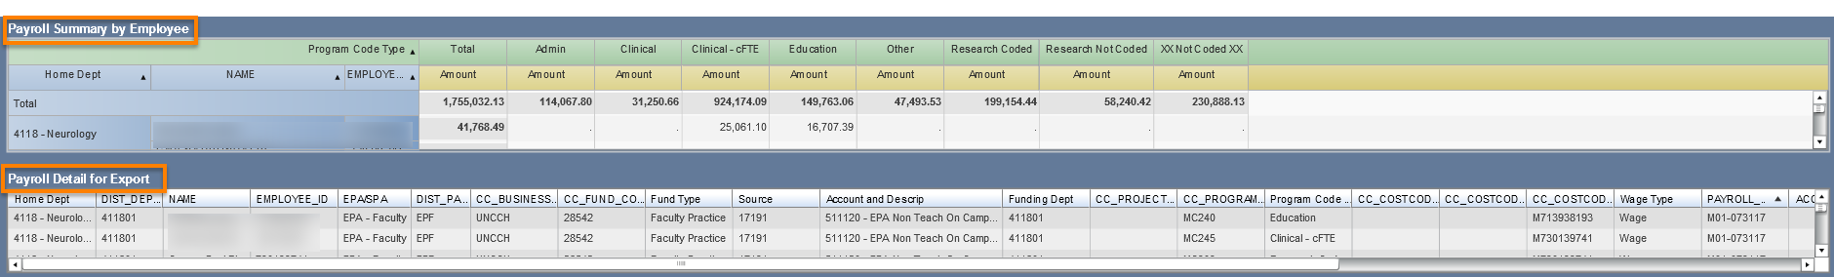
* For Clinical Departments: there is a column labeled “Clinical – cFTE” which identifies the program codes that count towards cFTE. For reference these program codes are as follows:
- MC205 – Hospital Contracts RVU’s
- MC231 – Inpatient
- MC232 – Outpatient
- MC245 – Clinical
- MC310 – Off Site RVU’s

SOM Payroll for 2017 Program Code by Dept tab
This tab is used as a high-level summary to view the amounts in the program code types, including the “XX Not Coded XX” column. The same search parameters can be used from the first report.

