Faculty Roster Budgeting for FY21 Budget Entry

Overview
Faculty Roster Budgeting (FRB) is the first phase of the FY21 ALL funds budget for clinical departments. FRB is the process to budget our faculty funding (current and/or new faculty), which Strata refers to as “Roster Budgeting”.

Timeframe & Due Date (subject to change)

Steps
- Navigate to our website: www.med.unc.edu/fbo. Click on the “FY21 Budget Process” tab, then click on the “FRB Database” link.
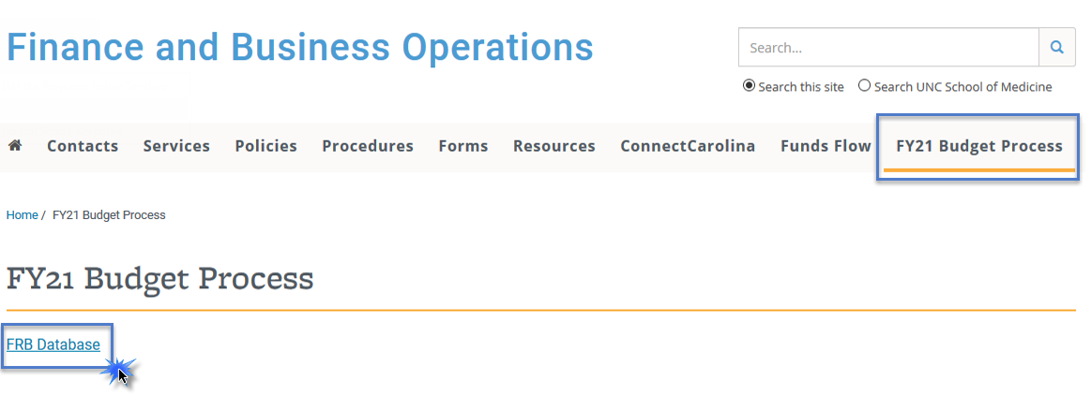
- Once on the FRB site, login with your ONYEN and password. Note: if you do not have access, please contact Lauren Gardner (lauren_gardner@med.unc.edu).
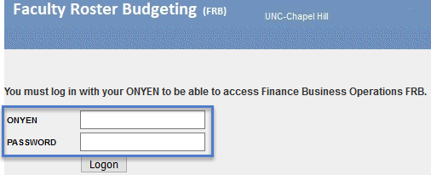
- Select the department/division you would like to begin with and click “Submit”.
  - Please Note: access is based on the HOME department of the faculty member; not funding department.
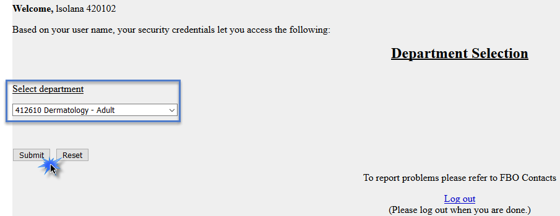

CURRENT FACULTY
- This will pull up the list of faculty housed in the given department/division. Select the faculty member you want to adjust.
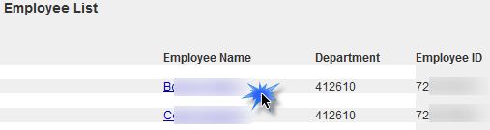
- This will pull up the data for this specific faculty member. The following header will display and cannot be changed.
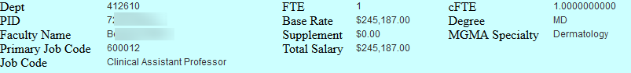

Funding
- Below the header is the faculty member’s current funding grid as of November 2019.
- Click the “Add” button to populate any of the funding rows from the “FRB Current Funding” grid to the “2021 Budget Funding” grid. This will populate a FY21 Budget Funding grid.
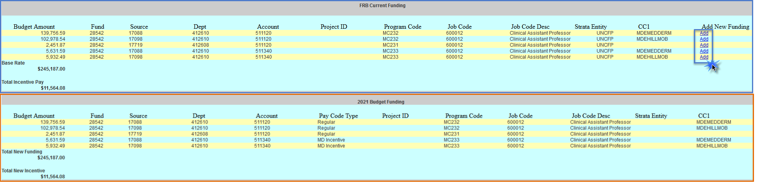
- To add a new funding line, click the button at the bottom of the page.
- At a minimum enter the required fields noted by the asterisk. Note: you can add multiple new funding lines by clicking “Add Another”.
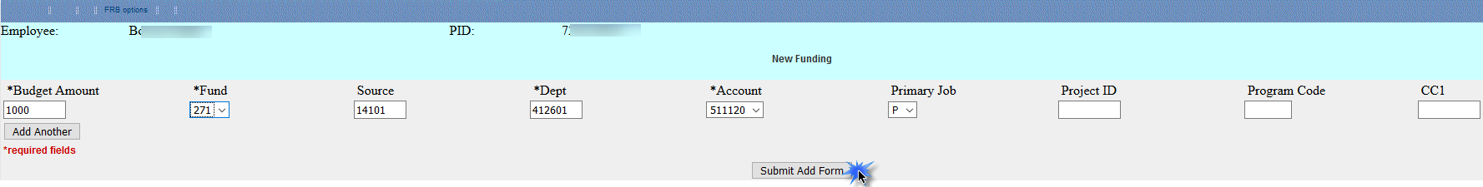
- To make edits to the FY21 grid click the button at the bottom of the page.
- The amounts and chartfield string information can be adjusted here.
- This is also where you can delete a funding row that was inadvertently added.
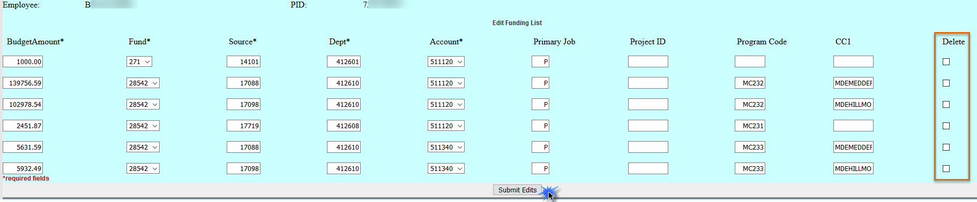

Funds Flow Variables
- Make necessary adjustments to cFTE and FTE fields for FY21 budgeting purposes under the “Funds Flow Variables” section.
- Changing these variables will not impact the dollar amounts under the funding section. You will still need to do this manually.
- If you are changing the FTE, please leave an explanation in the Comments section. Note: you cannot adjust the degree, start date, or MGMA Specialty for current employees. This is only to be completed for new employees.
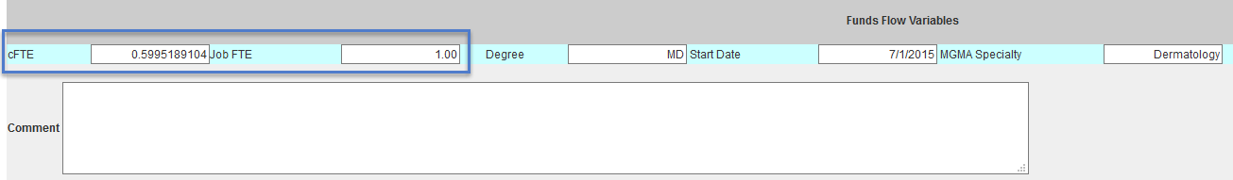
- Once you are finished with the “Funds Flow Variables” section, click the button at the bottom of the page. If you do not click this button the data entered will not save.
- Click the link to return to the list of Faculty members in the department ID you selected.
- A checkmark on the “Employee List” page indicates NEW funding has been entered for that faculty member. Note: this may not always mean that the faculty member funding is complete, only that new funding has been entered.
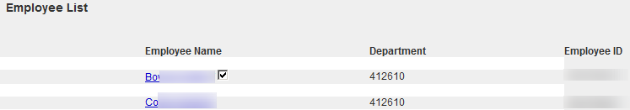
PLEASE NOTE: even if a faculty member’s funding may not change or an increase will not be given, you will still need to go into each faculty member’s page and input a FY21 budget grid for it to be included in Strata Roster Budgeting.
NEW FACULTY
- Each department/division will have 5 blank PID’s in order to add new faculty funding.
- To add a new faculty member, click “ZZ New Employee” at the bottom of your employee list.
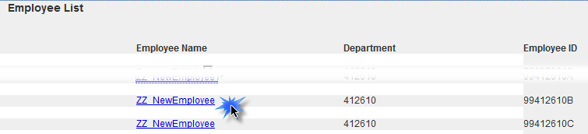
- Input is required in the following fields:
  - New Funding: input the expected funding grid. Note, you can copy down from “FRB Current Funding” line
  - cFTE: input the expected cFTE
  - FTE: input the expected FTE
  - Degree: select “MD”, and if anything else other than “MD”, input “Non-MD”.
  - Start Date: input the anticipated start date
  - MGMA Specialty: select the MGMA specialty
  - New or Replace: select “new” for new faculty, or “replace” if this is a vacancy to be filled
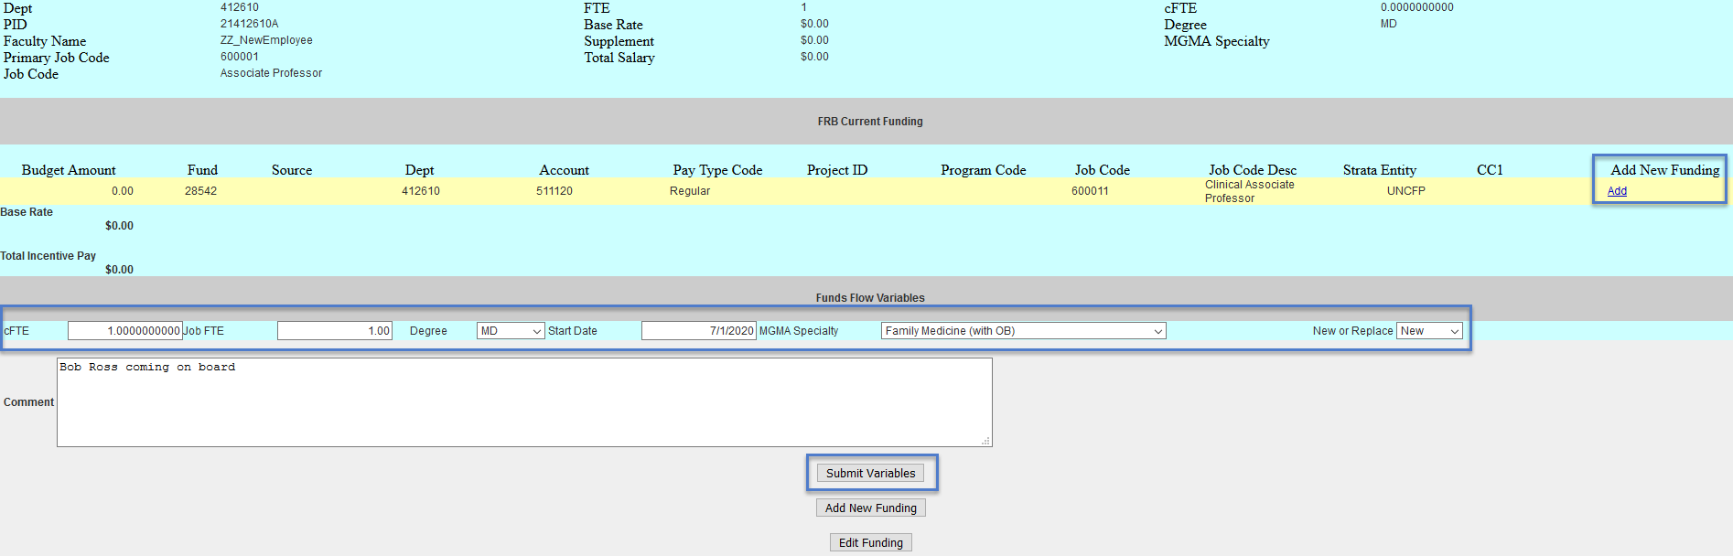

FAQ’s
Q: What if I don’t know the new project ID/source/etc. for FY21 yet?
A: Budget to the best of your ability. For example, if you know the faculty member will be funded from a new project ID but do not have that project ID yet, enter fund 252, the department, and account and leave project field blank.

Q: I will need to create new divisions within my department, and I know there will be faculty in this new division. How should I enter the data?
A: Please contact your FP Analyst.

Q: Will I have the opportunity to change what I’ve submitted in FRB?
A: Yes, there will be multiple opportunities throughout the budget process to make changes to FRB.
- Initial: Now thru January 13th
- Ongoing: January 21st – February 13th FRB will be open each week until Thursday at 2 pm. After 2 pm on Thursdays we will take the changes made in FRB and will upload them into Strata. FRB will then reopen on Friday mornings at 8 am for additional changes.
- After departmental meetings. Date for this is still to be determined and will be communicated.

Q: There are faculty members I fund but who are housed in a Basic Science department? How will I budget for them if the Basic Science departments aren’t going through this process as well?
A: We will give you access to the Basic Science departments where faculty are housed where your department funds a portion of their salary. You will then be able to go in and update the lines where your department’s funds are being utilized. We have a list of these and will provide this list to each affected department.

Q: In my department list, it shows “OS” after the department ID. What does this mean?
A: These are faculty members your department funds but who are housed outside of the School of Medicine (i.e. College of Arts & Sciences, Pharmacy, etc.). This indicates this type of Faculty member. You will only need to update the funding line(s) your department funds.

Q: I have a faculty member in my list who will be leaving in FY21, how should I handle this?
A: Enter one new funding line in the FY21 Budget Funding grid and enter the amount as zero. Then zero out the cFTE and FTE. Lastly enter an explanation in the comments box (i.e. retiring, leaving, etc.).

Q: If an employee starts in December 2020, do I budget as if they are there for the full year?
A: You will budget for the 6 months that you will be funding them. For example, if the annual salary for the employee is $120,000, you will budget for $60,000.

Q: What is the employment status of the SOM Faculty you are pulling?
A: We are pulling all “Active” and “Leave with Pay” Faculty housed in the SOM. This includes temporary and part-time Faculty who have a funding grid.

Q: How would I input NEW funding for Faculty who are either outside of the SOM or in a Basic Science department who I have not yet paid this FY (i.e. they are not pulling up in my current list)?
A: For either Basic Science Faculty or Faculty outside of the SOM click “New Employee” in one of your departments/divisions and add the funding here for the portion your department will be covering. If you’re funding multiple Faculty members who are in a Basic Science department or outside of the SOM then lump these amounts together on one “New Employee” FY21 Budget funding grid. That way you won’t have to create multiple new employees.

Q: Should incentives be budgeted by Faculty member? Should I budget for the clinical Chair incentives?
A: Yes, budget the incentive for each Faculty member. Yes, budget for full chair incentive – the departmental and Dean’s office portions. Please consider $50k as a budgeting guideline to enter for the clinical Chair incentive (generally paid out in November).
Q: What does “New or Replace” mean under the Funds Flow Variables section?
A: This will indicate to us if the faculty member is a brand-new faculty member, or if this is a replacement value for a vacant position.
Q: What are the different job codes?
A: The job codes that start with “6” are SOM faculty job codes. The job codes that start with “4” are secondary jobs. See following list.

Job Code | Job Code Description |  | Job Code | Job Code Description
400009 | Associate Dean |  | 600000 | Professor
400010 | Assistant Dean |  | 600001 | Associate Professor
400012 | Director |  | 600002 | Assistant Professor
400013 | Associate Director |  | 600004 | Distinguished Professor
400014 | Assistant Director |  | 600005 | Scholar
400016 | Department Chair |  | 600007 | Research Professor
400017 | Associate Department Chair |  | 600008 | Research Associate Professor
400027 | Vice Department Chair |  | 600009 | Research Assistant Professor
400031 | Academic Advisor |  | 600010 | Clinical Professor
400035 | Administrative Coordinator |  | 600011 | Clinical Associate Professor
400065 | Information Tech Professional |  | 600012 | Clinical Assistant Professor
400071 | Nursing Professional |  | 600013 | Adjunct Professor
400078 | Research Facility Manager |  | 600014 | Adjunct Associate Professor
400079 | Research Investigator |  | 600015 | Adjunct Assistant Professor
400081 | Research Program Director |  | 600017 | Clinical Instructor
400105 | Faculty Coordinator |  | 600018 | Research Instructor
400107 | Program Coordinator |  | 600025 | Distinguished Term Professor
400109 | Division Chief |  | 600026 | Term Scholar
 |  |  | 600027 | Adjunct Instructor
 |  |  | 600030 | Distinguished Trm Rsrch Prof
 |  |  | 600035 | Distinguished Clinical Prof
 |  |  | 600037 | Distinguished Clinical Scholar
 |  |  | 600049 | Teaching Assistant Professor

