  - How does this report help me?
A SAS report was created to view the historic SOM funds (FY14 – December 31, 2019). The data in this report includes source, project ID, account, fund code type, etc. for your SOM funds (Trusts, State, F&A, and Contracts & Grants). It’s suggested to pivot the data by fund type and/or source for Trusts to review the historic data. This will help with the projections and FY21 budget input within Strata.

  - Steps
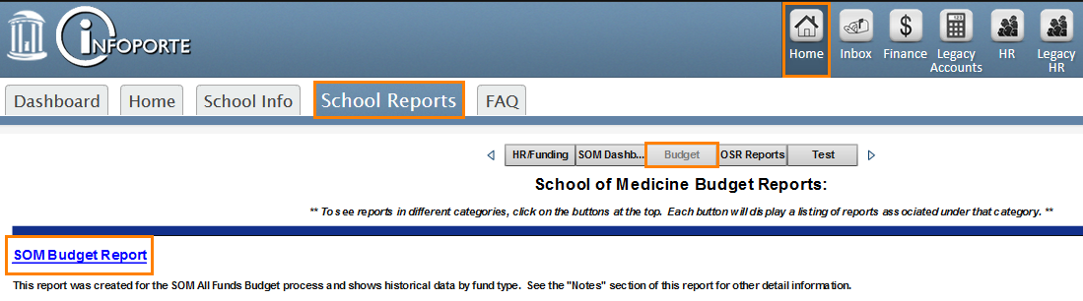
This report can be accessed via Infoporte School Reports (Infoporte > Home > School Reports > Budget > SOM Budget Report). If you are having issues accessing and/or need access to School Reports, please contact Shane Alexander at shane_alexander@med.unc.edu.

- Navigate to Infoporte > Home > School Reports > Budget > SOM Budget Report > Alternate Summary tab.
- Clear the Fiscal Year filter so that all FY’s are selected.
- Select your Department.
- Export the data from the detailed table at the bottom of the report.
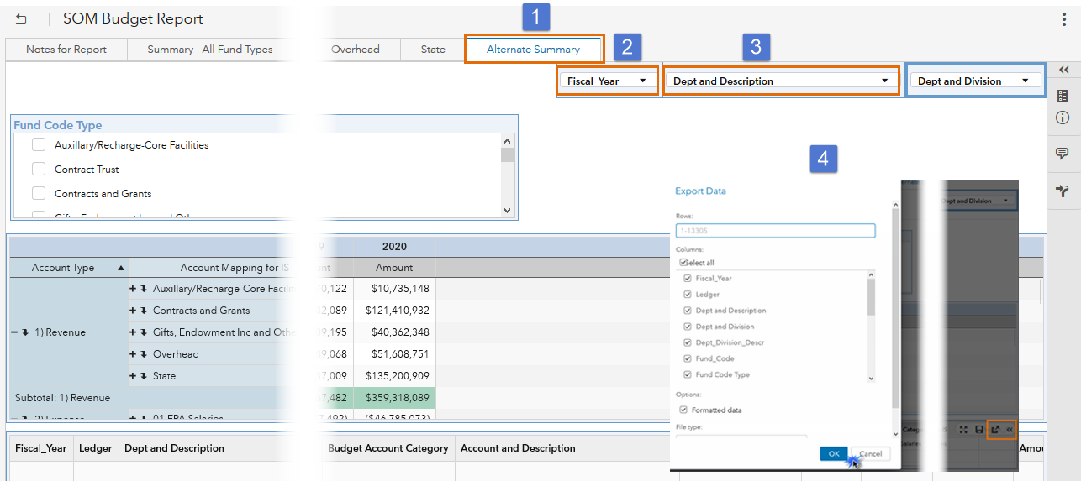
- Insert the exported data into a pivot (see FY21 Budget Process_SOM Funds Pivot Example document on the FY21 Budget Process website).

- Select the fund code type you want to review from the filter. Your options will be:
  - Gifts, Endowment Inc and Other
  - State
  - Overhead
  - Contracts and Grants
  - Aux/Recharge-Core Facilities
Please note: it may be necessary to also select a fund code and/or source range

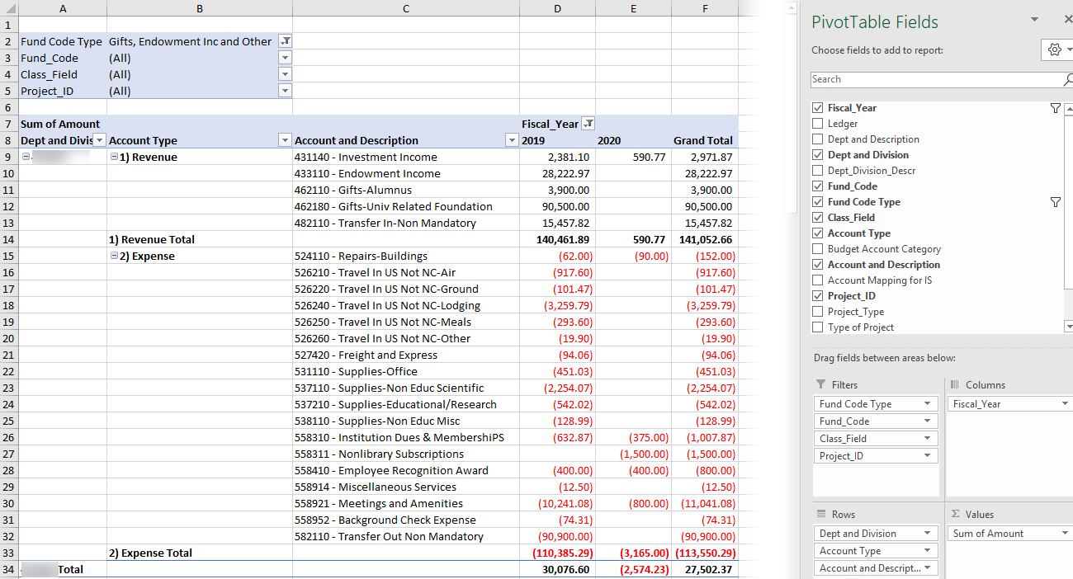
- You can utilize this pivot to review actuals and to project out by selecting the appropriate fund type and sources that tie to your Strata entities. See table below for fund type and Strata entity crosswalk.
PS Fund | Strata "Entity"
285 | UNCFP
201 | SOM - State AA
211 | SOM - State HA
221 | SOM - State AHEC
241 | SOM - Residuals
252 | SOM - Contracts and Grants
271 | SOM - Overhead
281 | SOM - Endowment Inc Unrestr
282 | SOM - Endowment Inc Restr
291 | SOM - Gifts-Endowment Inc and Other Unrestr
292 | SOM - Gifts-Endowment Inc and Other Restr
295 | SOM - Auxiliary-Recharge-Core Facilities

  - FAQ’s
Q: Should I include carry forward in any of my fund types?
A: No, please do not include carry forward in any of your fund types EXCEPT for your Overhead funds.

Q: Is CHMED data included in the FY21 SOM budget process?
A: No, we have not included any CHMED data in our historic data, and we are not requesting that you include it in your FY20 projections or your FY21 budget. However, if you have a source where funds were transferred from the CHMED business unit to the UNCCH business unit this information will be included in the historic data, and you will need to budget for this in FY20 projections and FY21 budget (if applicable).

