Budget Due Dates & Additional Info

* All SOM budgets are due **Tuesday, February 18, 2020 by 5 p.m.**
* Accompanying the FY21 SOM Budget email is a “FY21 Budget Comments” template. Please include any notes or comments necessary to reduce questions from those who will review your budget.
* Please return the budget template and budget comments to Kristen Beattie ([kristen_beattie@med.unc.edu](mailto:kristen_beattie@med.unc.edu)).

Overview

The FY21 SOM Budget Template has been emailed to the SOM departments in the form of an Excel spreadsheet (accompanying these instructions). Departments will need to update the revenue and expenditures for each fund type, which are broken out into separate tabs in the budget template. These fund types include (if applicable to your department):

1. Auxiliary/Recharge Core Facilities
2. Contracts and Grants
3. Gifts, Endowment Income, and Other (now including Contract Trust)
4. Overhead
5. State

**Please note we are requesting that you project out the remainder of FY20 (January 2020 – June 2020).**

General Fund Guidelines

1. **Auxiliary/Recharge Core Facilities** – anticipate the revenue you expect to bring in for FY21 only. It is recommended to use the Recharge/Cores Report in School Reports to see your current FY20 revenues and expenses.
2. **Contracts and Grants** – forecast based on existing funds and known awards for FY21. As a reminder, we force revenue to equal our expense.
3. **Gifts, Endowments Income, and Other** – endowment income (account code 433110) is distributed once a year and is calculated on the May balance. Please note: due to the PeopleSoft conversion, the transfer-in non-mandatory could be overstated for FY14. In the SAS Budget Report we have included the carryforward amount from when we went live with PeopleSoft in the FY14 data.
4. **Overhead** – anticipate carry-forward **and** permanent budget. It is recommended to use the Indirect Cost report in School Reports to see your estimated FY20 Indirects (Dept 15.6% Less Tax column).
5. **State** – revenue is based on permanent budget and any known commitments**.**  Please include the benefit estimates in both your revenue and expenses.

Historic Data

A SAS report was created specifically for this budget process to view historic data (FY14 – December 31, 2019). This report can be accessed via Infoporte School Reports *(Infoporte > Home > School Reports > Budget > SOM Budget Report)*. If you are having issues accessing and/or need access to School Reports, please contact Shane Alexander at [shane_alexander@med.unc.edu](mailto:shane_alexander@med.unc.edu).

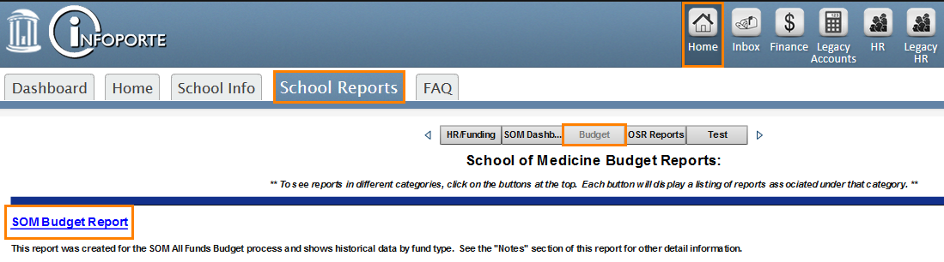

FY21 Budget Assumptions

Budgets should be constructed based on the following assumptions:

Salary & Salary Increases

In doing your 2020-2021 forecasts, assume for budgeting purposes a **Legislative Salary Increase of 2%** for both EHRA non-faculty and SHRA employees. Follow the policies and procedures set forth in your department’s compensation plan for Faculty increases. At this time we have no information regarding increases, however, for budgeting it is prudent to anticipate some increase due to compensation plans.

If you anticipate more than a 2% salary increase, please include comments in the FY21 Budget Comments template (accompanying these instructions), along with the source of the funds for the raises. This estimate is based on the assumptions that:

* the State does not allocate funds for raises, and
* departments are allowed to give raises based on their compensation plan

**To note: please be prepared to provide employee level detail by fund type to support your personnel budget. There is no predetermined template so you may provide whatever format you already use as part of your budgeting process. SOM may be required to provide this data as part of the University budget submission.**

Service Center Rates

Beginning in FY21, please budget using the new IT bill amount. For HR and Finance Service Center rates please budget similar to what you budgeted in FY20. If you have specific questions, please contact Tara Coble-Herring ([tara_coble-herring@med.unc.edu](mailto:tara_coble-herring@med.unc.edu)) for the HR service center, and Holly Rudicil ([holly_rudicil@med.unc.edu](mailto:holly_rudicil@med.unc.edu)) for the Finance service center.

Contracts and Grants

Awards issued **on/after** January 6, 2019 are subject to the exec level II salary cap of $192,300. Should the cap change during the budget process please use the new salary cap.

UNCFP Supplemental Benefits

Remember that UNCFP supplemental benefits (employee portion) are automatically charged to all fund sources (with the exception of State funds) based on payroll distribution.

Instructions

As we are requesting you project the remainder of FY20 we have set the templates to “yes” to prorate your revenue and expenses.

Overview

Departments will need to update the revenue and expenses for each fund type, which are broken out into separate tabs in the budget template. Once all applicable fund types/tabs are complete, the data entered will automatically roll up to the “Future” tab in the budget template.

* Input fields are indicated by grayed cells
* Please create one template per Department and Division (if applicable)
* Revenues should be entered as a positive number, and expenses should be entered as a negative number

Steps

1. **Navigate to *Infoporte > Home > School Reports > Budget > SOM Budget Report > Alternate Summary tab*.**
2. **Clear the *Fiscal_Year* filter so that all FY’s are selected.**
3. **Select your Department.**
4. **Export the data from the detailed table at the bottom of the report.**

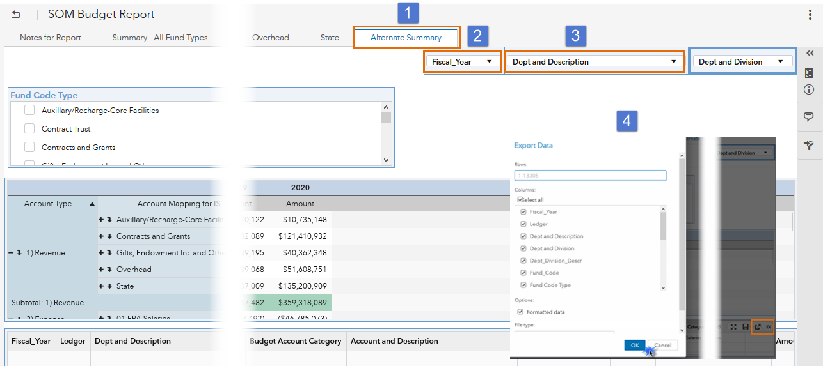

1. **Copy the exported data from the SAS Report starting in cell A4, and paste in cell A2 on the “Data” tab within the *FY21 Budget Template*.**

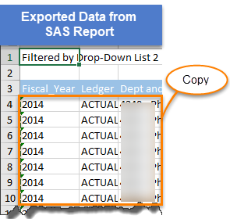

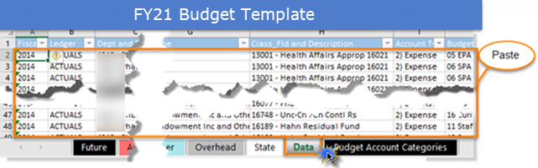

1. **Input your Department/Division ID on the “Future” tab. This is the only input you will need to do on this tab, as all other numbers will feed from your input on the individual fund type tabs. Then complete all applicable fund types/tabs for your department/** **division.**

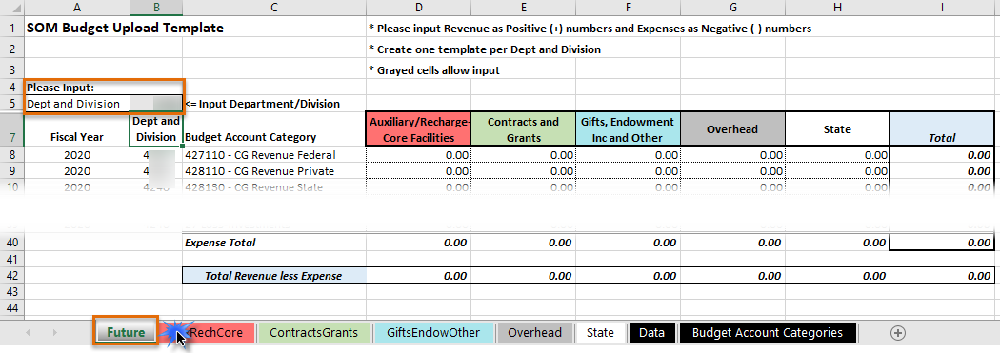

**FY20 Projections/Prorates**

**Prorating the revenue and expenses will double the revenue/expense based on the revenues/expenses incurred July 1, 2019 – December 31, 2019. This allows you to see what the potential budget would look like if you knew the budget would double exactly.**

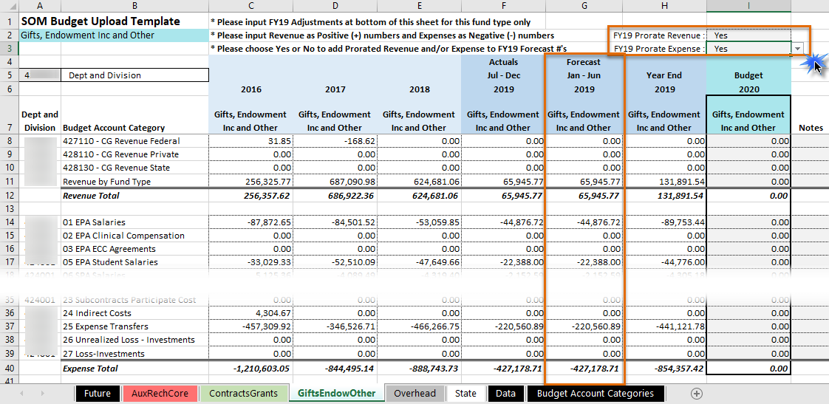

**We realize that it’s not likely that your budget will double exactly, so there is an adjustments section at the bottom of each fund type/tab to adjust the FY20 projected budget. Enter your FY20 adjustments here.**

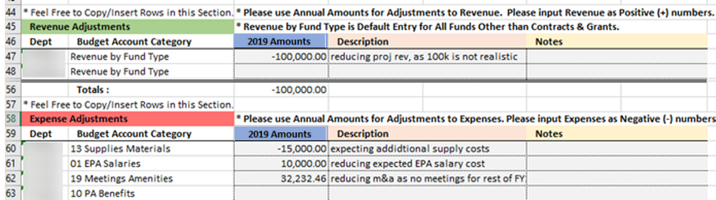

**Result:** *this will adjust the “Forecast Jan – Jun 2020” and “Year End 2020” columns, so that your full year FY20 budget is more accurate.*

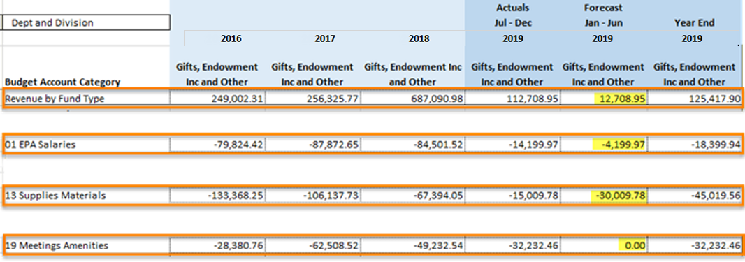

**Once the prorates and adjustments are made for FY20 you could potentially use the “Year End 2020” numbers as the baseline budget for your FY21 budget.**

**Benefit Estimates**

**There is a fringe benefit forecast calculation for each fund type/tab. Once your department data is downloaded from the “Alternate Summary” tab in the Budget report and pasted into the “Data” tab in the FY21 Budget Template the formula calculates the fringe percentages based on spend history. You could use these percentage estimates when calculating the benefits for your FY21 budget.**

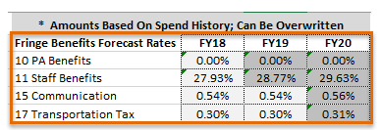

**Please note:** *the cells in dark gray have been inflated by 3% to allow for potential benefit increases.*

FAQ’s

**Q**: **Should I include carry forward in any of my fund types?**

**A**: No, please do not include carry forward in any of your fund types EXCEPT for your Overhead funds.

**Q: Is CHMED data included in the FY21 SOM budget process?**

**A**: No, we have not included any CHMED data in our historic data, and we are not requesting that you include it in your FY20 projections or your FY21 budget. However, if you have a source where funds were transferred from the CHMED business unit to the UNCCH business unit this information will be included in the historic data, and you will need to budget for this in FY20 projections and FY21 budget (if applicable).

**Q: Should I include benefit amounts to my State budget?**

**A**: Yes, please include your benefit estimates when completing your State budget. This goes for the revenue and expense lines.

**Q: Do I need to complete a full-year projection for FY20?**

**A**: Yes, we are requesting that you complete and return a projected full-year budget for FY20.