TarHeel Reports

Faculty Productivity – Current
  - General Notes

Data
- Data refresh, at a minimum, will take place shortly after the month-end close
- The data is for current Fiscal Year only.
- The data sources for this report include HR/Payroll, Revenue Cycle, AAMC, FPSC, and MGMA.
- Data nuances: there have been occurrences where the degree data is not in ConnectCarolina; therefore it is not pulled into this report.

  - Report Navigation

Navigate to TarHeel Reports > SOM > HR/Funding Reports > Faculty Productivity - Current

  - 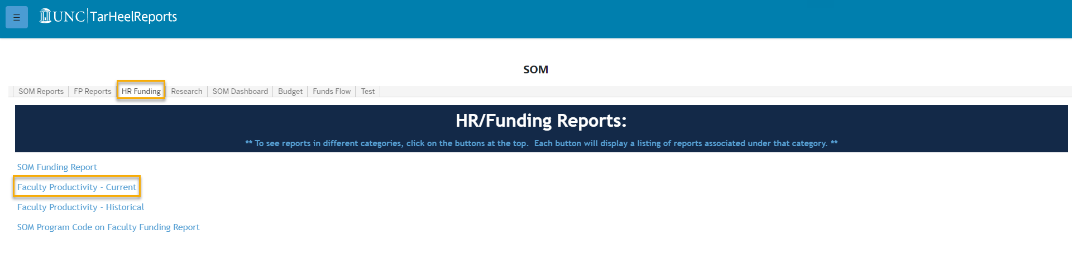

  - Default Filters

These filters apply to all tabs in this report. For example when you make a certain selection for the “Detail Data” tab it will carry over to the “Dashboard AAMC and FPSC” tab.
- Exclude PY PAAT Trans: allows you to include PY PAAT Transactions or only show the PY PAAT Transactions
- Rank: this filter includes the ranks that can be queried (e.g., Associate Professor, Professor, etc.)
- Payroll Status: this filter shows the payroll status. It is automatically set to Active (A) employees, but the following are additional payroll statuses:

  - A – Active
  - D – Deceased
  - L – Leave of Absence
  - P – Leave with Pay
  - T – Terminated

- Type of Faculty: this filter shows the type of Faculty. It can be changed to Clinical, Adjunct, Other, Research, or the filter can be cleared.
- Degree_Type: this filter shows you all degree types possible
- Degree Control: this filter is preselected to MD or PHD, but “Other” can be selected as well
- Dept and Description: this is where you can select your four-digit department ID.
- Department and Description: this is where you can select your six-digit division ID

