SOM Funding Report in School Reports
  - Items to consider:
- All short term retro tool actions were loaded in Period 4 of FY16, so you would not get an accurate funding history prior to October 2015. November 2015 – present is accurate.
- The view in this report is a financial impact view, meaning, PAATs will post to the Accounting Period in which they are processed (for PAATs processed after October 2015). Therefore, to see the impact of PAATs you will need to pull Fiscal YTD (all Accounting Periods to date).
- Multiple departments cannot be pulled on the detail tabs due to data size.
  - SOM Payroll – SUMMARY
Displays payroll data broken out by the major fund groups (State, Overhead, Clinical, etc.) by amount and percentage.

  - SOM Payroll – Detail
This report shows the net of the original transaction, the PAAT adjustment, and the new funding. This view will allow you to view how a person/group of people/project ID/source/etc. was paid for a given payroll run ID. This report includes wage, fringe, and tax, and also includes a “Payroll Detail for Export” tab, which includes additional information such as the full chartfield string, payroll run ID, etc.
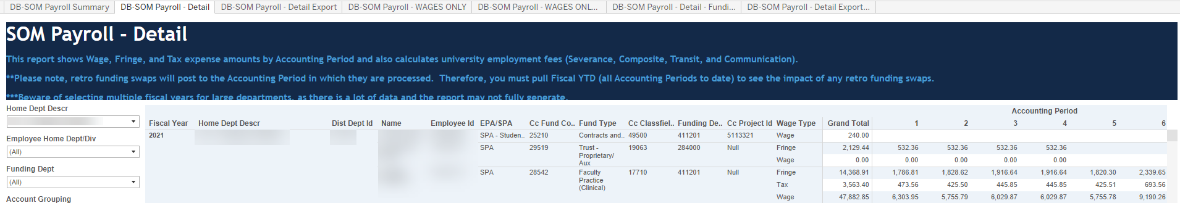

  - SOM Payroll – WAGES ONLY
This report shows the net of the original transaction, the PAAT adjustment, and the new funding. This view will allow you to view how a person/group of people/project ID/source/etc. was paid for a given payroll run ID. This report only includes the wage portion of payroll, and also includes a “Payroll Detail for Export” tab, which includes additional information such as the full chartfield string, payroll run ID, etc.
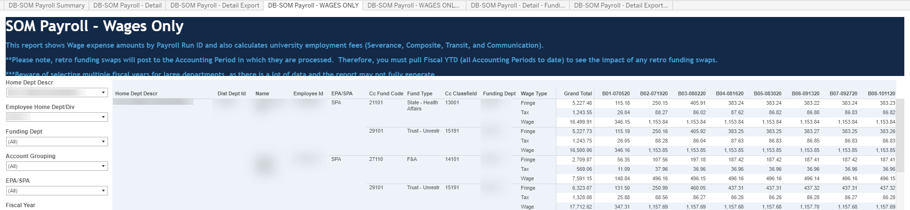

  - SOM Payroll – Detail by Funding Department
This report shows wage, fringe, and tax expense amounts by accounting period and also calculates university employment fees. This view will allow you to view how a person/group of people/project ID/source/etc. was paid for a given payroll run ID. This report only includes the wage portion of payroll, and also includes a “Payroll Detail for Export” tab, which includes additional information such as the full chartfield string, payroll run ID, etc.
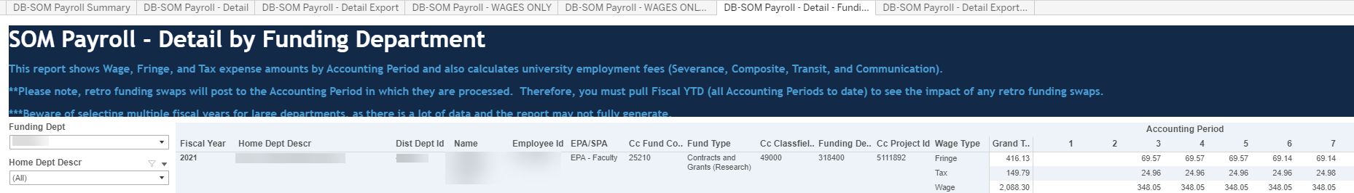

  - Understanding the filters
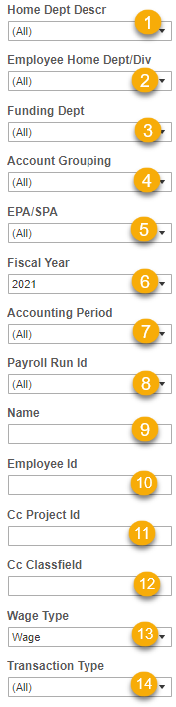
- Home Dept: select home department to view employee’s funding for a given home department
- Employee Home Dept/Div: select individual divisions to view the funding for given division(s).
- Funding Dept: select funding department when you want to see the funding department vs. the home department for a given department
- Account Grouping: currently this filter is preselected to show all payroll accounts. Further selections can be made:
  - Show Base and Supplemental Accounts
  - Show one Time Payment Accounts Only: will limit the accounts to 511330, 511340, and 558410
- EPA/SPA Selection: select employee type to see different groups of employees (e.g., all EHRA-Faculty, or SHRA)
- Fiscal Year: selection is current FY, but can select one fiscal year, or multiple fiscal years depending on what you need to see
- Accounting Period: select the accounting period(s) for which you want to see
Note: PAATs will post to the Accounting Period in which they are processed
- Payroll Run ID: select a particular payroll run ID, or if you want to see all payroll run ID’s no selection is necessary
- Name: input a name to look at one specific person
- Employee ID: input a PID to look at one specific person
- Cc Project ID: input a specific project ID to look at the payroll funding for this project ID
- Cc Classfield: input a specific source to look at the payroll funding for this source
- Wage Type: select the wage type(s) to see a specific portion of the wages.
- Transaction type:
  - Original Payroll: how the pay was originally distributed
  - Payment From Adjustment: the PAAT action submitted to change the funding
  - Payroll To Adju stment: the result of the submitted PAAT – how the funding should have been distributed
Note: if you do not check any of the boxes the report will automatically pull all three types

