Table of Contents

1. Startup 2
2. BD FACSDiva Software 2
3. Setting Up Your Experiment 3
4. Shutdown 6
5. Troubleshooting 6
6. References 6
7. Quality Control – Cytometer Setup & Tracking (CST) 6
8. Working with BD FACSDiva Software 10
9. Revisions 11

Startup

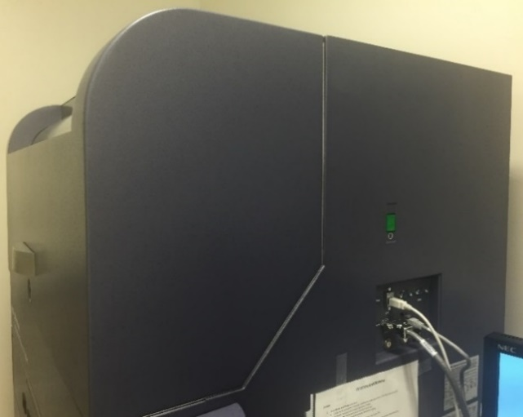
- Check Sheath and Waste containers:
- Empty Waste container in the sink – Add bleach to the black mark (~10% final concentration).
- Fill Sheath container with Sheath Solution (1X PBS).
- Turn on Cytometer – Green button on the right-hand side.
- Check Sheath filter for air, bleed if necessary. Bleed side tubing.
- Log in to Windows (Onyen + password).
- Turn on necessary lasers using Coherent Connection 3, click ‘Laser START’.
- Close Coherent Connection 3.
- Launch BD FACSDiva Software (Username + password).

Wait for the computer to establish a connection with the cytometer
If the connection fails, restart the cytometer (green button) or alternatively power down the cytometer and the computer and then restart them both.

BD FACSDiva Software
Menus Overview

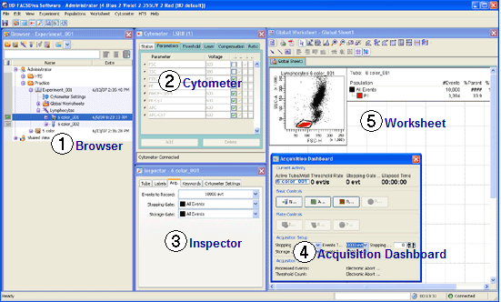

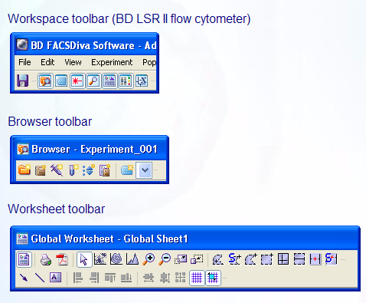

Setting Up Your Experiment

Adjusting Baseline Voltages
- Click ‘New Experiment’ (2nd icon in the Browser toolbar) OR Recall a saved Experiment Template (Experiment menu>New Experiment…).
- Rename the Experiment (R-click>Rename).
- Click on Cytometer Settings and delete unused parameters in the Inspector window.
- Check the Height (H), Width (W), or both for FSC, SSC, or both to perform doublet discrimination.
- Check the Log box and the Area (A) box for all fluorescent parameters if running a phenotypic experiment.
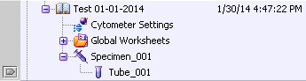
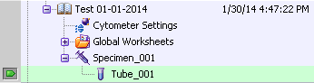
- Click on the Experiment (in Browser) and create a New Specimen (3rd icon in the Browser toolbar) then place the tube pointer on Tube_001 (Green arrow).
NOTE: If running compensation move on to the next section, if not follow the steps
below
- In the worksheet add an SSC-A vs FSC-A dot plot, and histogram plots for all of your parameters being used.
- The Acquisition Dashboard becomes available.
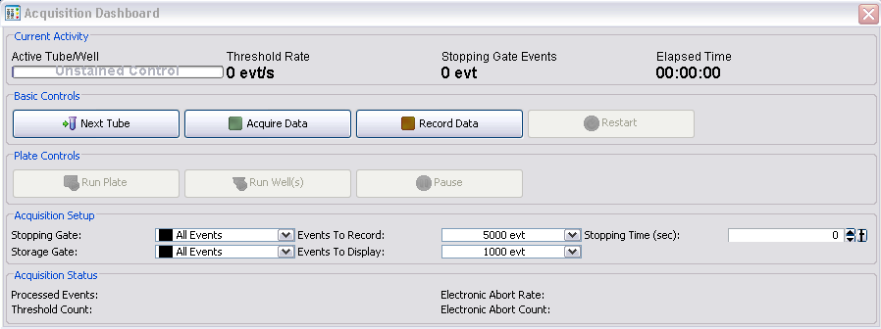

- Filter your samples prior to running on the instrument
- Load your unstained control on the cytometer.
- Click Acquire on the Acquisition Dashboard.
- Adjust FSC-A and SSC-A PMT voltages, as well as the threshold if needed.

- Run a fully-stained sample to make sure all fluorescent parameters are on scale.

Compensation Set up
- Go to Experiment menu>Compensation Setup>Create Compensation Controls.
- If using an unstained control, check the “Include separate unstained control tube/well” box.
- Click OK.
- A Specimen called “Compensation Controls” is created. Open it by clicking on the “+”
Compensation
- Place your tube pointer (Green arrow) on your unstained control
- Load your full-stained control or sample
- Click Acquire on the Acquisition Dashboard.
- Adjust FSC-A and SSC-A PMT voltages, as well as set all fluorescent parameters on scale
- Unload sample
- Load the corresponding sample on the cytometer.
- Click Acquire (adjust P1 if necessary – you can R-click on the P1 to “Apply to All Compensation Controls”).
- Click Record (5000 events are automatically recorded).
- Click Next Tube.
- Load then Acquire/Record your next single-stained control.
- Once all have been recorded, review/adjust the placement of the “snap-to gate” P2 for each control.
Note: If not using an unstained control, you will have to manually create a gate around
the negative population of all your single-stained controls.
- Go to Experiment menu> Compensation Setup>Calculate Compensation…
- Select ‘Apply Only’ and click OK.
- Toggle back to the “Global Worksheet” (Worksheet View button).
- Review and Enable Compensation

Running Samples
- Place the tube pointer on Tube_001.
- While Tube_001 is selected, go to the Inspector window>label tab and input the names of your antibodies.

Note: If naming multiple tubes simultaneously, use the Experiment Layout (Experiment menu> Experiment Layout…).

- Rename Tube_001.
- Create Plots & Gates in the Global Worksheet.

Note: Apply a gate to a plot by R-clicking a plot and selecting Show Populations>”Name of the Gate” or by using the Inspector window (plot tab).

- Set the ‘Events To Record’ and the ‘Stopping Gate’ on the Acquisition Dashboard or in the Experiment Layout (Acquisition tab).

Note: To display the name of the applied gate on the header of a plot: click on a plot, go to the Inspector window (title tab) and check the ‘Populations’ box.

- R-click on any of your plot and select Show Population hierarchy to visualize simple statistics.

Note: To display data using Biexponential display: click on a plot, go to the Inspector window (plot tab) and check the Biexponential X and Y boxes.

- Load then Acquire/Record your samples (FMOs, biological controls, and experimental samples).

Exporting Data
- Close your experiment (double-click on header)
- R-click Experiment>Export>FCS files… [FCS 3.0]
- Select Location (path)
- R-click Experiment>Export>Experiment Template… (if desired add information pertaining to your experiment)
- R-click Experiment>Delete

Shutdown

Be considerate of others, start cleaning ~12 minutes before the end of your scheduled time

- Install a tube with 3mL of 1% Contrad with support arm to the side for 1 minute
- Put support arm under the tube and RUN on HI for 3 minutes
- Install a tube with 3mL of FACSClean with support arm to the side for 1 minute
- Put support arm under the tube and RUN on HI for 3 minutes
- Install a tube with 3mL of Deionized Water (diH₂O) with support arm to the side for 1 minute
- Put support arm under tube and RUN on HI for 3 minutes
- Leave a tube with ~1ml of diH₂O with support arm under
- Switch cytometer to STANDBY mode
- Log off FACSDiva then Quit
- Turn off lasers
- Log out of Windows

Last user turn off cytometer & FACSFlow Supply System

Troubleshooting

- Coherent Connection not visible
Alt + Space, Maximize
- Coherent Connection not displaying all lasers – [also occurs to first-time users]
Tools > Serial Settings… > Scan Ports or turn the cytometer off then on
- Cytometer not connected
Turn the cytometer off then on
- No cells being detected
Cracked tube / Wrong tube (must be polystyrene)

References

- BD FACSDiva 6 Online Course
- BD Training & eLearning

Quality Control – Cytometer Setup & Tracking (CST)

CST beads are used to optimize each PMT. This ensures that the ratio of signal to noise is the highest, and the CVs of the positive peak are the smallest.

Launching the CST Workspace
Select Cytometer Menu > CST
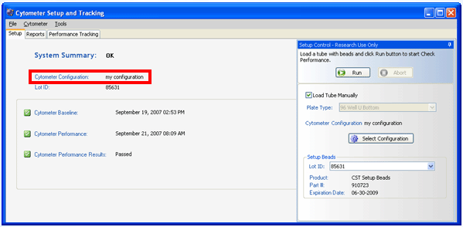

CST Workspace Overview

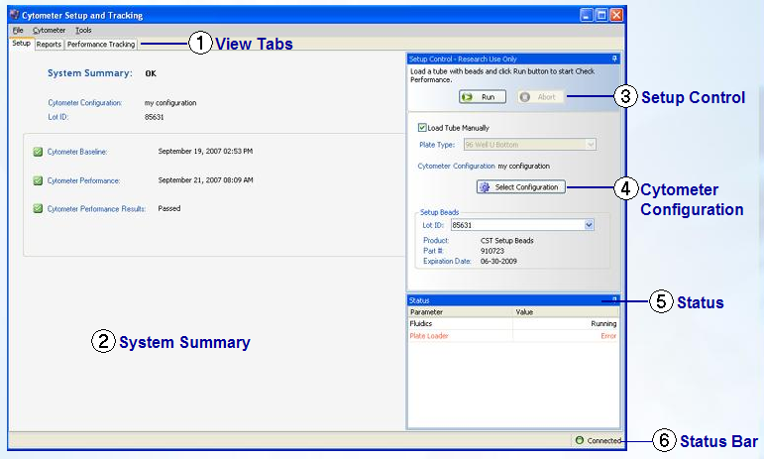
Instrument Configuration
Select the Configuration that matches the optical bench layout (filters & mirror installed on the cytometer).
Within the Cytometer Configuration windows, select a configuration from the left-hand side menu and click Set Configuration. Click OK to close the Window. Close CST Workspace.
Note: If necessary change filters & mirror to accommodate your experimental staining panel.
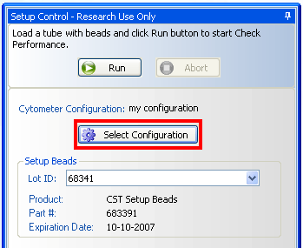

Running CST (Performance Check)
- Prepare the CST beads (1 drop in 350µL of PBS)
- Verify the bead Lot ID is correct
- Select Run mode and Low on the fluidics control panel of the cytometer.
- Click Run in CST Workspace

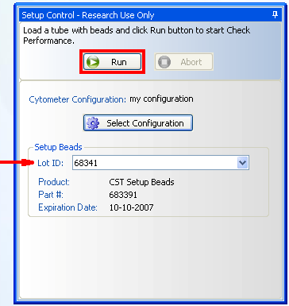

CST Results
Under System Summary, check the system’s status.
If the status is ‘Requires Attention!’, you must run a Performance Check for that configuration.
If the status is ‘OK’, proceed with setting up your experiment.

Click the Report and troubleshoot any warnings or failures.
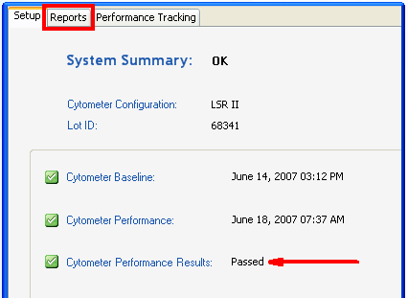

Working with BD FACSDiva Software

Worksheets are where you create plots, gates, population hierarchies, statistic views, and custom text.
There are 2 types of worksheets between which you can toggle (Worksheet View button):
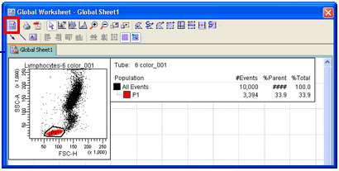
Worksheet View button

Global:
- Displays data from one tube at a time.
- Uses the same set of plots/gates to analyze any tube in an experiment.
- Used to record data using the Loader or HTS options.
- Used to perform batch data analysis.
Normal:
- Used to perform compensation.
- Displays data from several tubes simultaneously.
- Uses different gating strategies (on the same worksheet) for tubes within an experiment.

Data displayed in a Global Worksheet changes when the current tube pointer is moved to another tube.

Data displayed in a Normal Worksheet is not dependent on where the current tube pointer is set.
For example, the plots in the graphics to the right display data from tubes 001 and 002.
Additionally, you can use different gates and gating strategies for each tubes. Here, the P1 gates in the plots are different.

Revisions

SOP version # | Date | Tracked Changes | Primary Reviewer | Secondary Reviewer
UT SOP 003.2 | 04.06.2023 | Rearranged set up for training purposes. Moved around pictures. Added additional steps for all around training. | Roman Bandy

