Submitting Barcodes to HTSF
If you are submitting prepared libraries or pools of prepared libraries, please read these instructions for listing your index (barcode) sequence.
The HTSF sequences many different types of samples with various bioinformatics pipelines. In order to simplify processing, we ask that you always submit barcodes as if they are running on the HiSeq 2500, even if you are requesting a different sequencing platform. We will internally modify them, if needed, for your specific workflow. Please also submit the full length index sequence.

For example, follow Illumina’s guidelines for entering the i7 index. If sequencing a dual-indexed library, list the i7 index as index 1.
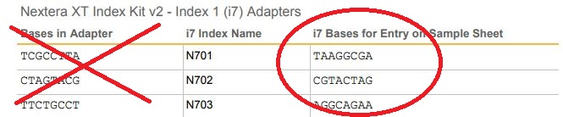

If sequencing a dual-indexed library, list the i5 index as index 2. Do NOT use Illumina’s guidelines for HiSeq 3000/4000 runs. Submit barcodes as if you are running on HiSeq 2500 or MiSeq.

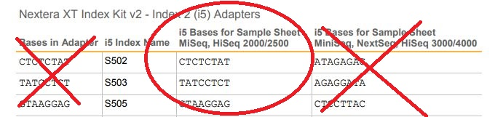

Please use the following reference tables to help you determine how to submit your barcode sequence. If you have used custom barcodes, or a library prep kit that is not listed here, please contact HTSF about how to submit your barcodes.

For single-indexed Illumina (TruSeq LT or ChIP kits) or Kapa Biosystems libraries:
i7 Index Name | i7 Bases for Sample Sheet
Index 1 | ATCACGA
Index 2 | CGATGTA
Index 3 | TTAGGCA
Index 4 | TGACCAA
Index 5 | ACAGTGA
Index 6 | GCCAATA
Index 7 | CAGATCA
Index 8 | ACTTGAA
Index 9 | GATCAGA
Index 10 | TAGCTTA
Index 11 | GGCTACA
Index 12 | CTTGTAA
Index 13 | AGTCAAC
Index 14 | AGTTCCG
Index 15 | ATGTCAG
Index 16 | CCGTCCC
Index 18 | GTCCGCA
Index 19 | GTGAAAC
Index 20 | GTGGCCT
Index 21 | GTTTCGG
Index 22 | CGTACGT
Index 23 | GAGTGGA
Index 25 | ACTGATA
Index 27 | ATTCCTT

For dual-indexed Illumina (TruSeq HT kits) or Kapa Biosystems libraries:
i7 Index Name | i7 Bases for Sample Sheet |  | i5 Index Name | i5 Bases for Sample Sheet
D701 | ATTACTCG |  | D501 | TATAGCCT
D702 | TCCGGAGA |  | D502 | ATAGAGGC
D703 | CGCTCATT |  | D503 | CCTATCCT
D704 | GAGATTCC |  | D504 | GGCTCTGA
D705 | ATTCAGAA |  | D505 | AGGCGAAG
D706 | GAATTCGT |  | D506 | TAATCTTA
D707 | CTGAAGCT |  | D507 | CAGGACGT
D708 | TAATGCGC |  | D508 | GTACTGAC
D709 | CGGCTATG
D710 | TCCGCGAA
D711 | TCTCGCGC
D712 | AGCGATAG

For Illumina TruSeq Small RNA or BIOO Scientific NEXTflex™ Small RNA libraries:
i7 Index Name | i7 Bases for Sample Sheet
RPI1 | ATCACG
RPI2 | CGATGT
RPI3 | TTAGGC
RPI4 | TGACCA
RPI5 | ACAGTG
RPI6 | GCCAAT
RPI7 | CAGATC
RPI8 | ACTTGA
RPI9 | GATCAG
RPI10 | TAGCTT
RPI11 | GGCTAC
RPI12 | CTTGTA
RPI13 | AGTCAA
RPI14 | AGTTCC
RPI15 | ATGTCA
RPI16 | CCGTCC
RPI17 | GTAGAG
RPI18 | GTCCGC
RPI19 | GTGAAA
RPI20 | GTGGCC
RPI21 | GTTTCG
RPI22 | CGTACG
RPI23 | GAGTGG
RPI24 | GGTAGC
RPI25 | ACTGAT
RPI26 | ATGAGC
RPI27 | ATTCCT
RPI28 | CAAAAG
RPI29 | CAACTA
RPI30 | CACCGG
RPI31 | CACGAT
RPI32 | CACTCA
RPI33 | CAGGCG
RPI34 | CATGGC
RPI35 | CATTTT
RPI36 | CCAACA
RPI37 | CGGAAT
RPI38 | CTAGCT
RPI39 | CTATAC
RPI40 | CTCAGA
RPI41 | GACGAC
RPI42 | TAATCG
RPI43 | TACAGC
RPI44 | TATAAT
RPI45 | TCATTC
RPI46 | TCCCGA
RPI47 | TCGAAG
RPI48 | TCGGCA

For Illumina Nextera libraries (Nextera DNA, Nextera XT, and Nextera Rapid Capture kits)*:
The i5 index names vary for different Nextera products as follows:
• N50x—Nextera DNA
• S50x—Nextera XT
• E50x—Nextera Rapid Capture

*Please note: The i5 index adapter [N/S/E]501 has been discontinued and replaced with [N/S/E]517. Be careful to note which index you have in your kit.
i7 Index Name | i7 Bases for Sample Sheet |  | i5 Index Name | i5 Bases for Sample Sheet
N701 | TAAGGCGA |  | [N/S/E]501 | TAGATCGC
N702 | CGTACTAG |  | [N/S/E]502 | CTCTCTAT
N703 | AGGCAGAA |  | [N/S/E]503 | TATCCTCT
N704 | TCCTGAGC |  | [N/S/E]504 | AGAGTAGA
N705 | GGACTCCT |  | [N/S/E]505 | GTAAGGAG
N706 | TAGGCATG |  | [N/S/E]506 | ACTGCATA
N707 | CTCTCTAC |  | [N/S/E]507 | AAGGAGTA
N708 | CAGAGAGG |  | [N/S/E]508 | CTAAGCCT
N709 | GCTACGCT |  | [N/S/E]517 | GCGTAAGA
N710 | CGAGGCTG
N711 | AAGAGGCA
N712 | GTAGAGGA

An Excel file with common Illumina barcodes is available for download here.
Link to Illumina Barcode list 2017.xlsx

