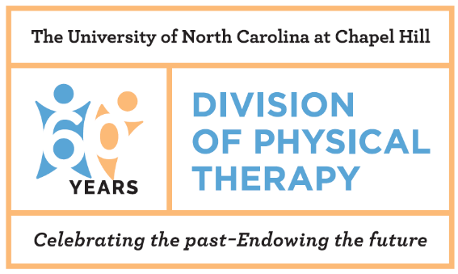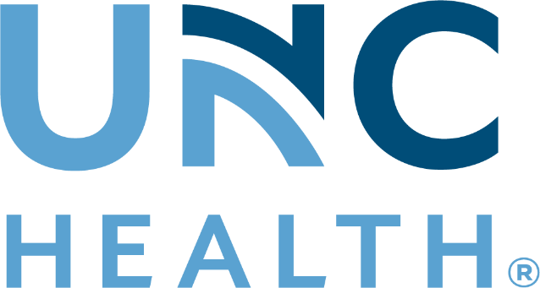

ORTHOPEDIC PHYSICAL THERAPY RESIDENCY

FACT SHEET

PROGRAM PURPOSE:

Our Mission

The mission of the UNC School of Medicine Department of Allied Health Sciences and UNC Hospitals Rehabilitation Services Residency Programs is to provide a superior, comprehensive specialist training and mentorship to licensed physical therapists to meet the health and wellness needs of the people of North Carolina and beyond. For the UNC Orthopedic Physical Therapy residency, this mission is applied to physical therapists and their work with patients with musculoskeletal conditions.

Resident Program Philosophy
The faculty and staff of the Division of Physical Therapy and UNC Hospitals are committed to developing residents who are recognized leaders within orthopedic physical therapy. Residents will develop excellence in examination, diagnosis, intervention, consultation, teaching and the integration of best evidence into the patient care they provide. They will develop as a resource for the community in orthopedics and will contribute to the profession through teaching, writing, and leadership. Graduates of the residency program will be prepared to sit for the ABPTS Orthopedic Certified Specialist (OCS) examination.

CURRICULUM:
The program’s curriculum is designed in modules that address each area of the Description of Specialty Practice. The core components of the residency program include outpatient clinical practice, mentored clinical practice, didactic activities, written patient case reports and professional community service.

Most modules focus on a specific body region such as spine or hip and knee. Other modules focus on associated topics such as clinical reasoning, pain science, pharmacology, imaging, and teaching/learning. The didactic work is administered through a combination of independent study and face-to-face instruction.

RESIDENT SCHEDULE:
Residents will practice in an outpatient clinic for 30 hours per week. The resident will also have mentored clinical work and didactic learning activities each week. Given the scope of residency learning opportunities, residents should expect to spend additional time each week outside of patient care while completing program activities.

MENTORSHIP:
Clinical mentorship is a core component of the UNC Residency Program. You will have the opportunity to learn from various mentors who are experts in orthopedic physical therapy with a variety of specialty certifications. During mentored time, the resident evaluates and treats patients in the clinic with a mentor. Individualized instruction and feedback is provided during each mentored session. The resident’s mentor rotates periodically during the duration of the program to provide a variety of perspectives and expertise. The current mentors include:

Clinical Mentors
Evan Adler PT, DPT
Board Certified Clinical Specialist in Orthopedic Physical Therapy (OCS)
Geert Audiens, PT
Board Certified Clinical Specialist in Orthopedic Physical Therapy (OCS)
Certified in Mechanical Diagnosis and Therapy (Cert MDT)
Certified in Orthopedic Manual Therapy (COMT)

Jennifer Cooke, PT, DPT
Kyle Cooper, PT, DPT
Board Certified Clinical Specialist in Orthopedic Physical Therapy (OCS)
Quinn Curtis, PT, DPT
Board Certified Clinical Specialist in Orthopedic Physical Therapy (OCS)
Fellow of the American Academy of Orthopedic Manual Physical Therapy (FAAOMPT)
Corey Drvol, PT, DPT
Board Certified Clinical Specialist in Orthopedic Physical Therapy (OCS)
Catherine Duncan, PT, DPT
Athletic trainer certified (ATC)
Board Certified Clinical Specialist in Sports (SCS)

Nicole Dickson, PT, DPT
Board Certified Clinical Specialist in Sports (SCS)
Bria Dunn, PT, DPT
Board Certified Clinical Specialist in Orthopedic Physical Therapy (OCS)
Michael Gross, PT, PhD
Catherine Worthingham Fellow of APTA (FAPTA)
Jyotsna Gupta, PT, PhD
Eric Hartmann, PT, DPT
Certified in Mechanical Diagnosis and Therapy (Cert MDT)
Stephanie Milosovic, PT, DPT
Board Certified Clinical Specialist in Orthopedic Physical Therapy (OCS)
Reuben (RJ) Myer, PT, DPT
Board Certified Clinical Specialist in Orthopedic Physical Therapy (OCS)
Jeffrey O’Laughlin, PT, DPT, Program Director
Board Certified Clinical Specialist in Orthopedic Physical Therapy (OCS)
Fellow of the American Academy of Orthopedic Manual Physical Therapy (FAAOMPT)
Emile Olsen, PT, DPT
Board Certified Clinical Specialist in Orthopedic Physical Therapy (OCS)
Brian Trabulsi, PT, MPT
Certified in Orthopedic Manual Therapy (COMT)
Josh Torrey, PT, DPT
Board Certified Clinical Specialist in Orthopedic Physical Therapy (OCS)
Sarah Van der Horst, PT, DPT
Board Certified Clinical Specialist in Orthopedic Physical Therapy (OCS)
Nicole Zimmerman, PT, DPT
Board Certified Clinical Specialist in Orthopedic Physical Therapy (OCS)

Additional Residency Faculty
Carla Hill PT, DPT
Board Certified Clinical Specialist in Orthopedic Physical Therapy (OCS)
Certified in Mechanical Diagnosis and Therapy (Cert MDT)
Deborah Givens, PT, PhD, DPT
Catherine Worthingham Fellow of APTA (FAPTA)
Lisa Johnston, PT, MS, DPT
Kristel Maes, PT, DPT, Program Coordinator
Diplomate in Mechanical Diagnosis and Therapy (Dip MDT)

SALARY, TUITION AND BENEFITS:
Residents are paid an annual salary of $47,500, the equivalent of a new graduate salary for 30 hours of clinic work per week at UNC. Residents are eligible for full time benefits including health insurance and dental insurance. Residents also receive Paid Time Off to allow for vacation, sick and holiday time off from clinic work. There is no tuition associated with the program. The resident is expected to be an APTA member and member of the Academy of Orthopedic PT. There are fees associated with the didactic learning material.

ELIGIBILITY:
Must be U.S. citizen and licensed to practice PT in North Carolina – new graduates are encouraged to apply but must successfully complete licensure by August 1st (in NC, take exam in July at latest) to enter the program in mid-September. Completion of immunization requirements, HIPAA, OSHA, and CPR training prior to matriculation is required.

APPLICATION AND ENROLLMENT:

Application deadline: December 31st, 2022

Application available via RF-PTCAS at http://www.abptrfe.org/RFPTCAS/

On campus interviews for selected candidates: February 2023
Program Start Date: early September each year, and lasting 55 weeks.

For more information visit: https://www.uncmedicalcenter.org/uncmc/professional-education-and-services/rehabilitation-clinical-education/

