Instructions for Creating Med School Email Account

- Go to onyen.unc.edu

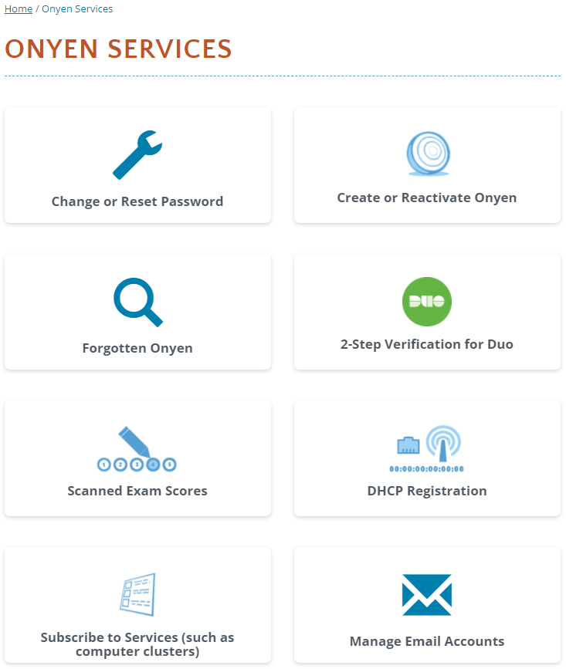

- Click on “Email & Calendar”
- Login using your onyen and password
- Click on “My Aliases” 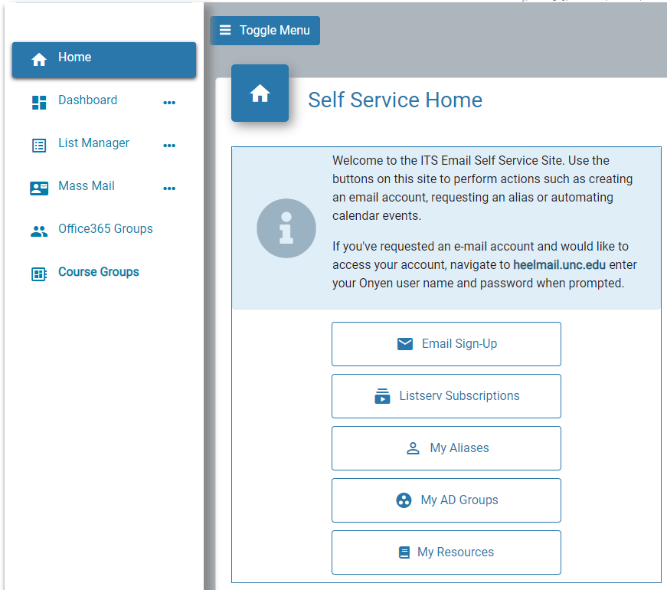
- In the “Add New Alias” section,
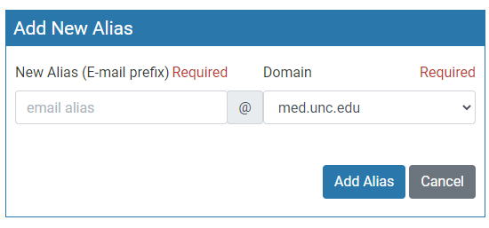

Complete the new email alias prefix using the following standard:

firstname_lastname, i.e. “jane_doe”

Within the Domain dropdown: be sure to select “med.unc.edu” as shown above.

Making Your Med Email Your Primary Account

- Go to connectcarolina.unc.edu and login to your Student Center

- Select the “Self Service” option from the dropdown menu located within the dark blue menu bar at the top of your screen.
- Select “Personal Information”
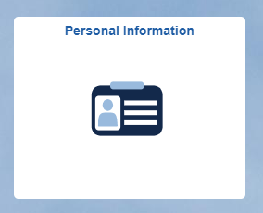

- Select “Email Addresses” from the left-hand menu options.
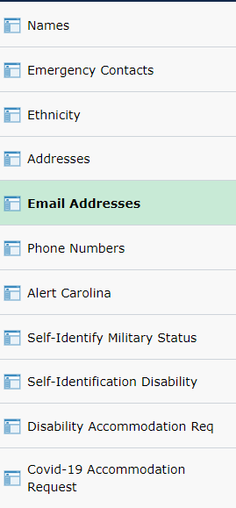

- Modify any existing “Business Email Address and Domain” reflects your @med.unc.edu email address.

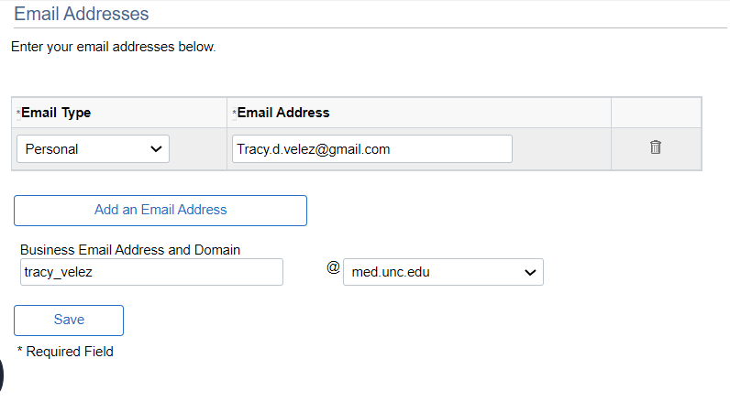
- Click Save to Activate Changes

