Preceptors of the Year
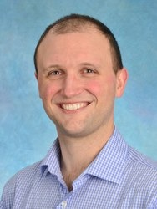  Jonathon Heath, MD  Department of Medicine  UNC Medical Center  2017 | 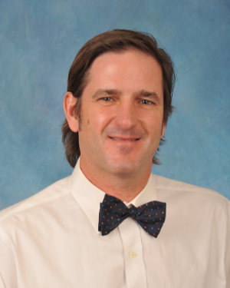  William Mills Jr., MD, MPH  Department of Pediatrics  UNC Medical Center  2018 | 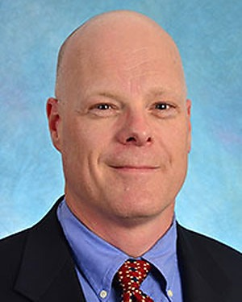  David Wayne Overby, MD  Department of Surgery  UNC Medical Center  2019
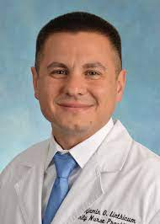  Benjamin Linthicum, DNP, FNP  Department of Emergency Medicine  UNC Medical Center  2020 | 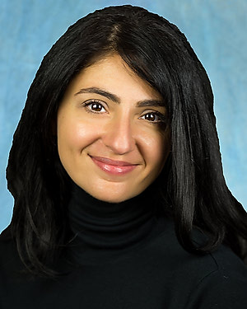  Jessica Curcio, MPAS, PA-C, FSVM  Department of Surgery  UNC Medical Center  2021

