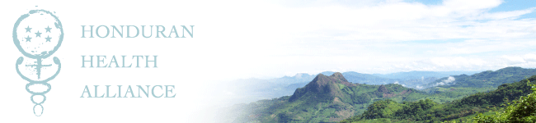

HHA Preceptor Guide

Introduction
Thank you for your interest in precepting medical students through the Honduran Health Alliance (HHA). HHA is a unique organization that provides invaluable experiences for all who are involved. As a preceptor, you will experience rural healthcare delivery in a resource-poor setting, community living in a small Honduran town, and an opportunity to work with UNC health professional students who are motivated to make a difference in health inequities in Honduras as well as in the US.

I. HHA Project Summary AND REVIEW OF PRECEPTOR ROLE
The Honduran Health Alliance (HHA) is an alliance between UNC health professional students and rural Honduran communities. Founded by UNC medical students in 2003, this UNC student-led alliance is committed to providing sustainable, community-driven public health programs, health education, and clinic based care for rural Hondurans. HHA is centered upon an annual month of activity based in El Corpus, Honduras, during which a group of UNC health professional students and preceptors dedicate themselves to health educational workshops and clinical care for rural Hondurans. Multiple Honduran partners are involved in the operation of HHA, and include Comunidades Unidas (the six communities of Espabeles, Guanacaste, Los Torreros, Potreritos, Papalon, and Guasaule as well as their governing body), ASHONPLAFA (International Affiliate of Planned Parenthood), the Honduran Ministry of Health, and Peace Corps volunteers.
During the six clinical days in Honduras, HHA members are dedicated to the delivery of health care for the women of the 6 communities that comprise Comunidades Unidas (CU), a locally formed NGO that unites communities for economic development independent of HHA’s activities. More specifically, HHA clinics focus on family planning and delivery of contraception (IUD, Depo, OCPs, natural family planning), STI prevention and treatment, preventive medicine (PAP smears, breast exams), and one-on-one nutrition counseling. Following the six days of clinic, each patient receives personal follow-up (one-on-one) in their respective community for PAP results and post-test counseling. HHA preceptors are responsible for overseeing student administration of clinical care during the six days of clinic in Honduras, as well as guiding clinical follow-up counseling while in Honduras the week after clinics occur. Two preceptors should be present at all times during the six days of clinic, and at least one preceptor should remain in Honduras for mentoring students on results counseling the week following clinics.

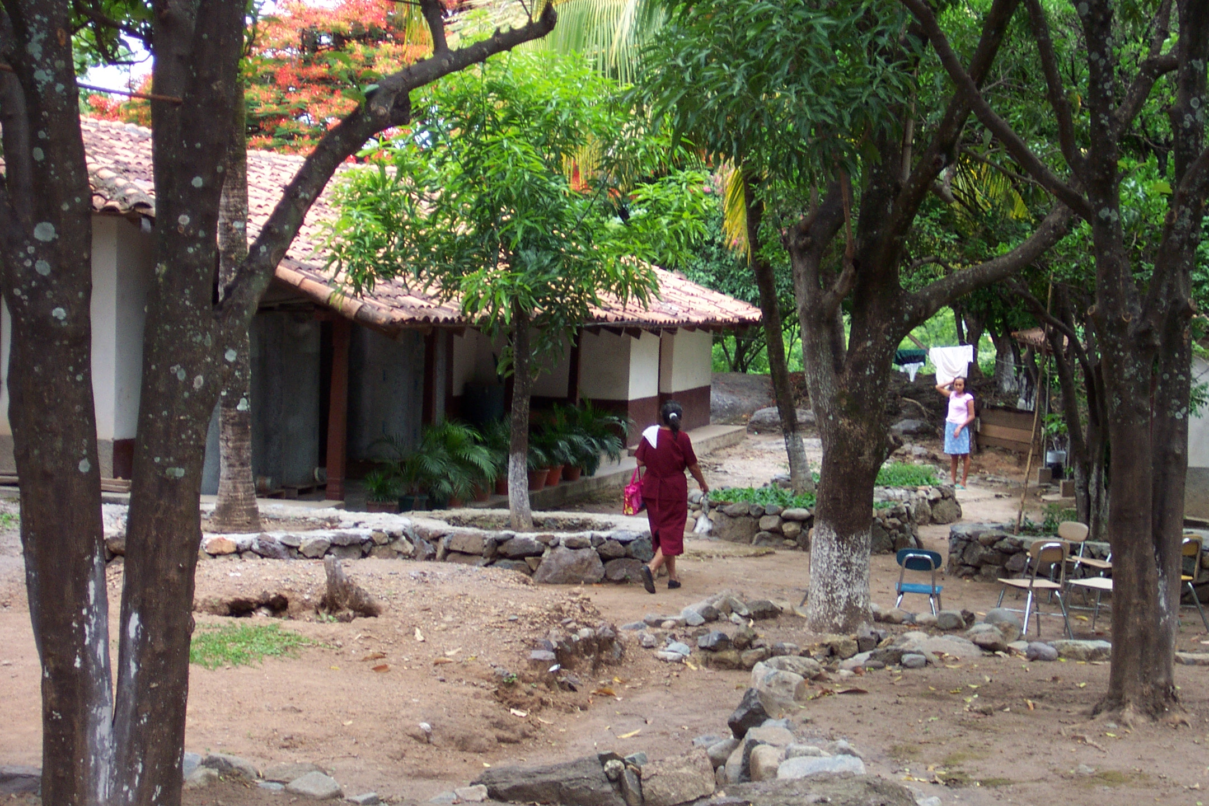
Clinic site in Madrigales, Honduras

Patient education and public health seminars (called “charlas”) are an equally significant component of HHA activities in Honduras. Charla topics are community-directed, and in the past have focused on nutrition, hygiene/disease prevention, reproductive health, HIV/STI prevention, and family planning. These charlas are given for 3-4 days by pairs of MS2/MS4 medical students in each of the six member communities of Comunidades Unidas before the 6 days of clinic based care, and women are required to attend charlas in order to receive clinical care. Preceptors are invited to join medical students in the outlying communities for homestays and administering charlas should the preceptors’ time permit.
Medical student teaching is also an important aspect of Honduran Health Alliance. In the spring prior to traveling to Honduras, students participate in a lecture series to discuss important historical and sociological aspects of medical and public health intervention in developing countries. For participating in this lecture series and traveling to Honduras, students receive medical school elective credit for the course FMME ??? called “Honduran Health Alliance”. Typically, participating students are rising 2nd and 4th year medical students. A non-medical public health student participates in HHA as one of the HHA co-directors, and receives practicum credit through the School of Public Health. Preceptors themselves have the opportunity to teach and review GYN exams, OB/GYN topics, microbiology, pharmacology, and pathophysiology, but also should encourage MS4s to precept MS2s.
Several other important educational experiences are gleaned by participants of HHA. Being immersed in Spanish-speaking only communities in rural Honduras provides an excellent opportunity for practice of medical and conversational Spanish. Additionally, spending time in communities without electricity and many of the comforts of home is an excellent opportunity for cultural exchange. Taking part in the process of community feedback through surveys/conversations is an excellent experience for HHA members to incorporate into future projects as well.

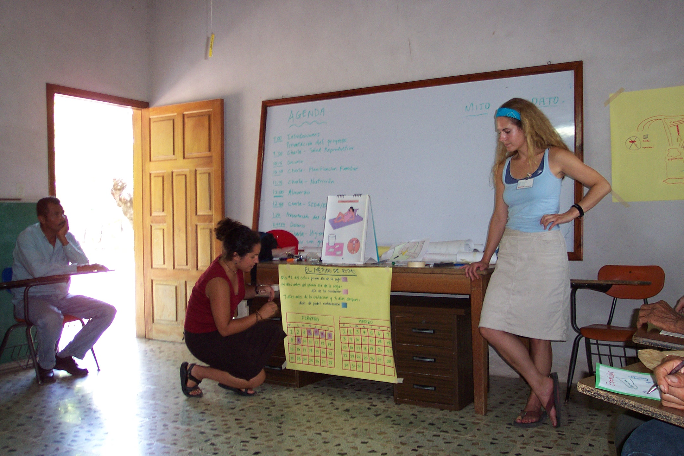
HHA students teaching charla to health promoters in Madrigales, Honduras

II. SAMPLE SCHEDULE

SUNDAY | MONDAY | TUESDAY | WEDNESDAY | THURSDAY | FRIDAY | SATURDAY
¹ | ² | ³ | ⁴ | ⁵ | ⁶ | ⁷  Tegucigalpa
⁸  Valle | ⁹  Valle | ¹⁰  El Corpus | ¹¹  Off to the Communities | ¹²  Charlas | ¹³  Charlas | ¹⁴  Charlas; return to El Corpus
¹⁵  Sunday | ¹⁶  Clinic | ¹⁷  Clinic | ¹⁸  Clinic | ¹⁹  Clinic | ²⁰  Clinic | ²¹  Clinic
²²  Sunday  Funday  (Choluteca) | ²³  Tour Choluteca | ²⁴  Women’s  Health  Conference | ²⁵  Lay Health  Advisor Training | ²⁶  Health Promoter  Training | ²⁷  RESULTS  (PAPs) to Communities | ²⁸  Charlas
²⁹  Farewell  Dinner | ³⁰  Leave El  Corpus | ³¹  Leave Honduras

Tegucigalpa – Tegucigalpa is the point of entry/exit to Honduras for most HHA participants. The day spent here is typically laid back, as the group awaits all members arriving at different times. In the past, the group has stayed at Hotel Maya; very nice, good food, swimming pool, gym, $10 half-hour massages.

El Valle – A site just outside of Valle de Angeles serves as the retreat and planning center for HHA in-country educational activities. The center has running water & electricity, but is in the countryside/more rural; it is a 45 minute walk from Valle de Angeles, the only good place to get souvenirs in Honduras (art work, T-shirts, etc.); the training for the “Charlas” takes place here (where HHA students practice giving the public health seminars); thus a typical day here includes crafting educational materials and practicing charlas, with one afternoon of leisure time and evenings without obligations. The time here is ideal for reviewing female gyn exams with the students (review cervical dysplasia guidelines, pelvic organ prolapse, normal variants of gyn exams), as this will make your clinic week go more smoothly.

El Corpus – El Corpus is very rural, in the mountains, but also has running water & electricity; has an internet café (but rain often knocks out the connection); this is the “headquarters” or central location for everything; Juana & Pedro are the liaisons for us in Honduras (Juana’s sister, Sandra, lives in Carrboro) & they live in El Corpus; they will arrange housing for everyone (usually two students staying with a family; the families are paid to provide food); there are two pool halls where you can go for beers, music, & pool; not much else in town. Full days spent here are usually for regrouping/relaxing, but many evenings are spent here during clinic week and in transition from site to site.

The Communities – Many communities are speckled across the rural countryside of southwestern Honduras, but the six communities that comprise Comunidades Unidas (CU) are pertinent to HHA. Two to three students will go to each of the six communities to conduct “charlas” (chats, conversations), which are public health seminars about various topics (there are many to choose from, but most people start off with the ones that were practiced in Valle, since they are fresh on everyone’s mind). Also, here students reinvite the women of the communities to the clinic the following week (each community will have their own day for clinic). A typical day in the communities consists of breakfast with the family, tying together last minute charla materials, providing one charla in the morning, lunch, one charla in the afternoon, and spending time with host families in the late afternoon/evening. the attending has the choice of whether or not they want to go to the communities (they have the option of staying in El Corpus or traveling/sightseeing); the communities are very rural, no running water/no electricity; bucket baths available; will be sleeping in a hammock; may have pigs/chickens frequently roaming through homes; some people don’t bathe/shower at all while in the communities because they don’t like the outdoor bucket bathing

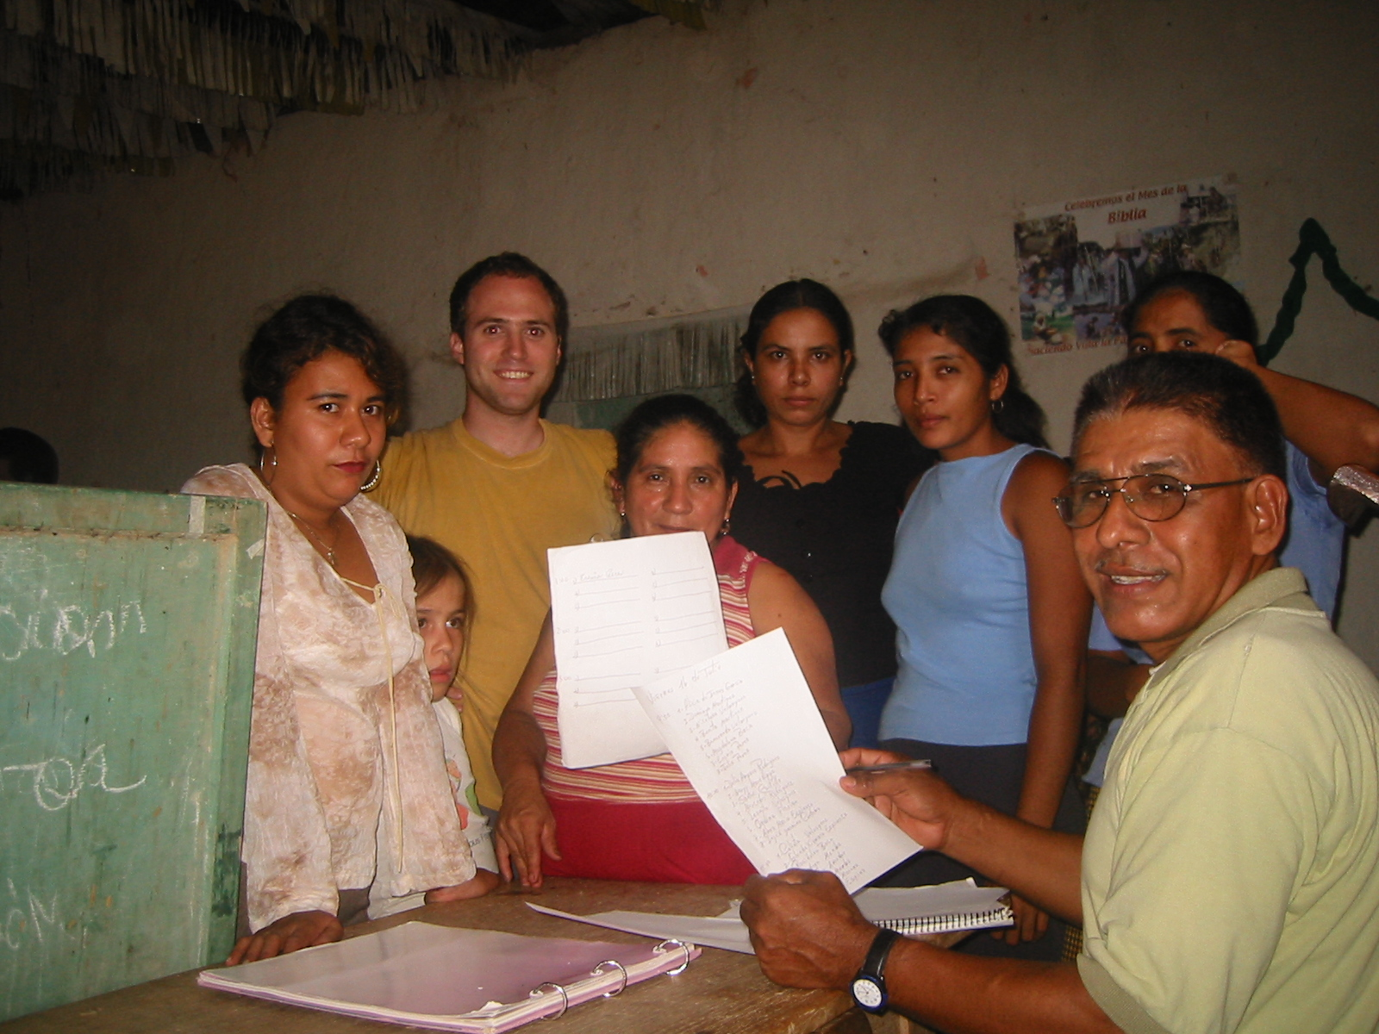
HHA student and community members of Espabeles

Clinic – Each of the six communities has their own community clinic day, which occurs in Madrigales, a multipurpose complex of buildings 30 minutes drive from El Corpus. Clinic days occur Mon-Sat after returning from giving charlas in the communities. Everyone returns to El Corpus each night after clinic; the families you are staying with in El Corpus will pack a lunch for you; the clinic week is when the attending is absolutely needed. A typical day for an attending at clinic involves assisting the rest of the HHA team with proper clinic set-up, accompanying students to the physical exam at random as well as for specific questions, and providing any pertinent clinical advice.

Choluteca – In addition to housing many of the partners that comprise HHA, Choluteca serves as a place of respite for the UNC students/preceptors at various times throughout the month in Honduras. HHA members stay at a motel with swimming pool; not as nice as Hotel Maya, but okay; can catch cab to the market; very nice/reliable internet café very close to the hotel; during tour of Choluteca, will tour Ashonplafa, the local STI clinic, & the public hospital.

Results – Following all clinic days and processing of slides by ASHONPLAFA, UNC students/preceptors return to all six communities to give the results of pap smears to each woman one-on-one. At least one attending should be present for result reading and creation of each patient’s clinical plan (very chaotic to do it over the phone), but the attending does not need to return to each community individually.

III. Grading
Most students receive course credit for the trip, so they will need grades (grades are pass/fail). It is most important to focus on comments for each individual; don’t worry about assigning an actual grade. Even for students not receiving grades, it is extremely important to give a summary of their performances for their dean’s letters. It is best to jot down each student’s name as well as notes about their performance during the trip; this will make it easier and quicker to turn in grades for them after you return. Give constructive feedback, but try to focus on the positives. It is essential to return each students’ comments immediately upon return from Honduras, as residency applications are submitted early in the fall semester.

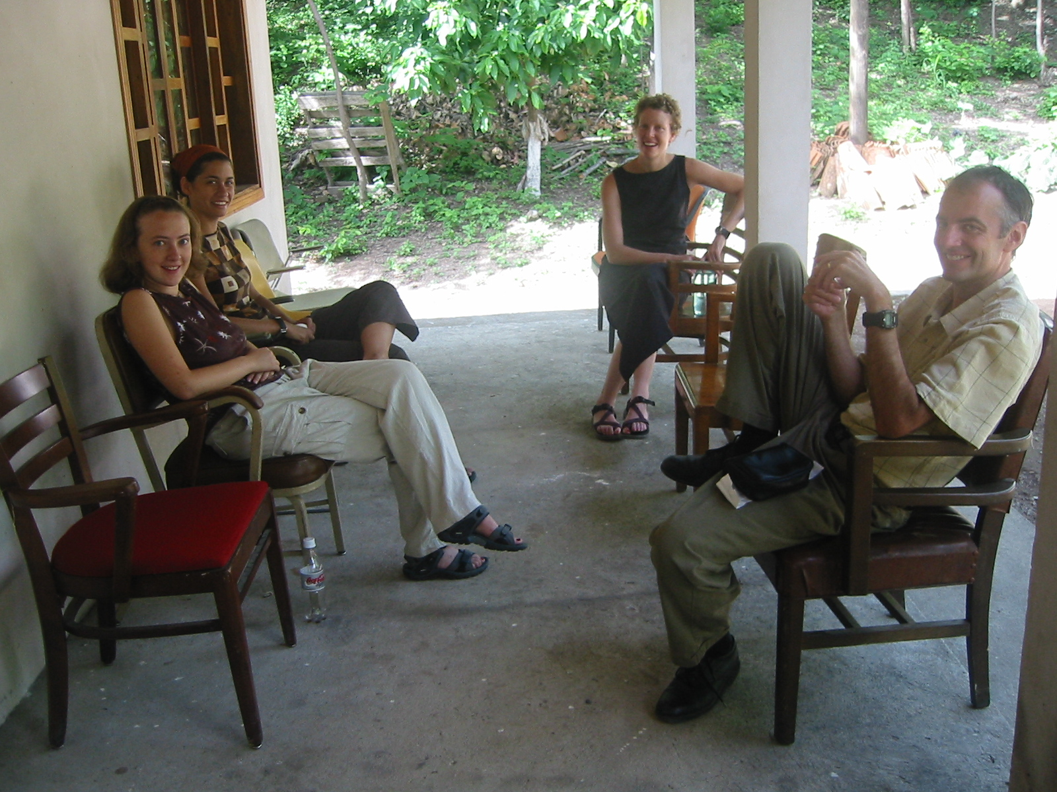
Students and preceptor Dr. Beat Steiner during a break at clinic site in Madrigales, Honduras

**If interested in serving as a preceptor, please contact the current HHA co-directors at hha@listserv.med.unc.edu**

