Teamwork occurs when patient care teams coordinate their interdependent activities to achieve a common goal.
Interprofessional teams provide safe and effective patient care in routine and unexpected patient care events when they:
- engage the right people
- communicate with each other
- share a common understanding of goals
- build teamwork and communication into the process
- organize resources to achieve goals
- adapt to changing circumstances
- know their responsibilities and their teammates’ responsibilities
- feel responsible for helping each other
- look out for one another and catch each others’ mistakes
- regularly reflect on team performance
TeamSTEPPS (Team Strategies and Tools to Enhance Performance and Patient Safety) provides a framework for improving communication and teamwork skills.
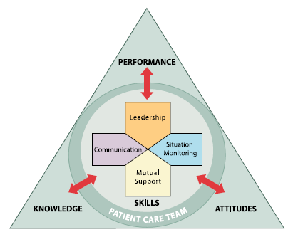
Leadership
- Designated and situational leadership
- Effective team leader skills
- Briefs, huddles, and debriefs
Communication
- Structured communication practices
- Callouts provide important information to all team members simultaneously
- Checkbacks verify information
Situation Monitoring
- Continuous assessment to identify and address changes in the situation
- Maintain a shared understanding of the situation and team goals
- Team members catch and correct each other’s mistakes
Mutual Support
- Offer and receive task assistance to ensure safe patient care
- Empower team members to speak up and advocate for patient safety
- Use CUS words (concerned, uncomfortable, safety issue) to safely express concerns
- Two challenge rule allows team members to “stop the line”

