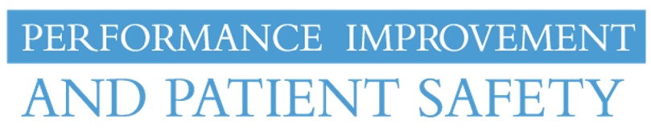

Quality Improvement
Continuing Education

Interested in Quality Improvement or data analysis?
Performance Improvement & Patient Safety (PIPS) is offering 5 sessions over the next year on a range of topics from data visualization to team building. See below for the list of courses and when they will be offered; flip this flyer over for a more detailed explanation of the courses. For more information or to sign up, please contact George Guthrie by email (George.Guthrie@unchealth.unc.edu) or at 984-974-2669. We hope you can join us!
12/17/19*  Data Visualization | 2/18/20*  Methodologies  in QI | 3/17/20*  Team Building Techniques | 5/19/20*  Users’ Choice from last year’s courses | 6/16/20*  QI Macros Walkthrough

*Courses will be offered on the 3rd Tuesday of the month from 11-12:30, location TBD

Earn the IHI Basic Certificate in Quality & Safety
The Basic Certificate in Quality and Safety is a series of 13 online courses offered by the Institute of Healthcare Improvement (IHI) that cover a wide variety of topics to enhance your knowledge and skill. Some topics include: learning models of improvement, PDSA cycles, interpreting data, and leading quality improvement projects.
These courses are offered through Performance Improvement & Patient Safety, and are FREE for UNC staff! IHI also offers continuing education credits for completing Open School courses online – up to 35 credits are available. Contact Therese Paratory for your free enrollment info; therese.paratory@unchealth.unc.edu

Performance Improvement & Patient Safety (PIPS)
Continuing Education Offerings

Date | Topic
12/17/19* | Data Visualization – How to Use Data to Tell Your Story  Learn the concepts that go into creating visually efficient charts, dashboards and presentations
2/18/20* | Methodologies in Quality Improvement – When to Use What  An overview of various quality improvement methodologies – similarities/differences and when they are most appropriately used.
3/17/20* | Team Building Techniques – Using StrengthsFinder & Myers Briggs to Enhance Team Dynamics  A facilitator’s seminar on how to utilize the Myers Briggs Personality Inventory and StrengthsFinder to evaluate and promote team building.
5/19/20* | Users’ Choice from last year’s courses  Options to choose from include: Basic Statistics, Surveying Techniques, Sampling, Dashboard Creation, and Excel Charts & Pivot Tables.
6/16/20* | QI Macros Walkthrough – Explore What QI Macros Has to Offer  Find out the different tools/templates that are available in Microsoft’s Excel: QI Macros
*courses will be offered on the 3rd Tuesday of the month from 11-12:30, location TBD

