Creating Control Charts with QI Macros 2016

- Select data you would like to use in control chart

- Click on QI Macros 2016 tab in ribbon

- Click on Control Chart Wizard

- Input Chart Title, X and Y axis Labels if necessary and click OK after each – you will have to do this twice (once for moving range chart and the individuals chart)

- Individuals chart displays on top, moving range chart displays on bottom
Data markers will change color to indicate out of control points and data trends

- To show process change, isolate data point where process change occurred

- Click QIMacros Chart in ribbon
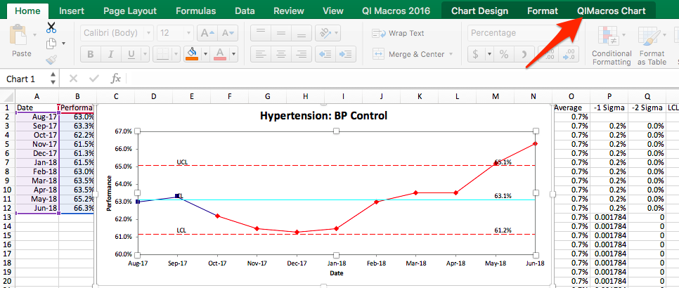

- Click Show Process Change

- Control chart will recalculate your limits at that point

- Another option for showing a process change in a data set is to add a blank row in your raw data before creating your chart

- Follow Steps 2-4 to create your control chart

- Control chart displays a break in data at your process change and limits are recalculated automatically

Additional help with QI Macros:
https://www.qimacros.com/training/qi-macros-webinar/qi-macros-for-excel/

