Project:
Ramp:

What are we trying to accomplish?
How will we know that a change is an improvement?
What change can we make that will result in improvement?

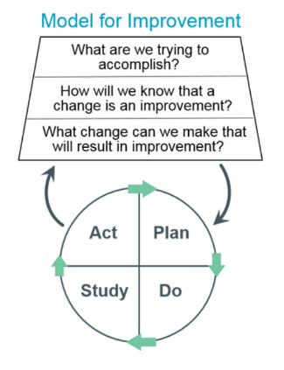

Date | Plan  What is our prediction? | Do  (Who, what, where, when, how) | Study  What did we learn? | Act  (Adopt/Adapt/Abandon) | Comments

