How to Gain EPIC Access for Quality Improvement Professionals

- Complete the EPIC Clinical & Revenue Cycle Read Only Modules in LMS. Search for code in LMS: EPIC17_NEO_ROREVCLIN_CURR

- Once the modules are complete, then you must take the EPIC Clinical & Revenue Cycle Read Only Assessment. Search for Code in LMS: EPIC_NEO_ROREVCLIN_TST

- Once the assessment is complete and you have made at least 80%, you can then request EPIC Access from ISD. https://unchc.service-now.com/sp?id=sc_home

- Once you click on the ISD service site, you can then click on the service catalog and then click on “Unblock Epic Access – Required Training Completed”
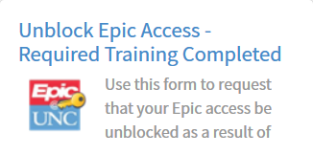

- Once your request has been approved, MySupport@UNC will send you an email granting that your access is unblocked and will let you know what your username/password is for EPIC@UNC.

- To ensure you have access to both inpatient and outpatient facilities at UNC, visit the Access Request Center (ARC) website. https://iam.unch.unc.edu/CourionARMS/AspxCommon/PortalHome.aspx

- Submit a request to get UNCHCS View Only Access (T2109902). An email will be sent to you to let you know that your access has been granted.

- For additional reporting access, you must complete the EPIC@ UNC Reporting class and then request in ARC the Sub-High Needs Reporting template to get additional reporting access. Registration for additional classes can be completed via LMS.
Additional EPIC courses to consider:
- EPIC@UNC Reporting (in person)
- Business Objectives New User (in person)
If you have any questions or concerns, please reach out to Candice Hunt at Candice.Hunt@unchealth.unc.edu or (910) 674 – 0063.

