
Faculty Workload Plan
Faculty Guide
As part of the UNC SOM Policy on Faculty Workload, the SOM must submit faculty work plans for each upcoming academic year for each individual faculty member. This Policy applies to all full-time faculty members (1.0 FTE) appointed in the UNC SOM for a term longer than one year, including tenured, tenure-track, and fixed-term faculty members.
The Faculty Workload portal can be accessed at:
https://apexo.oasis.unc.edu/ords/r/som_prod/cas-forms/faculty-workload-plan
If you are off campus, you will need to use the University VPN to access this system. After logging in, you will be directed to your home page, as shown below.

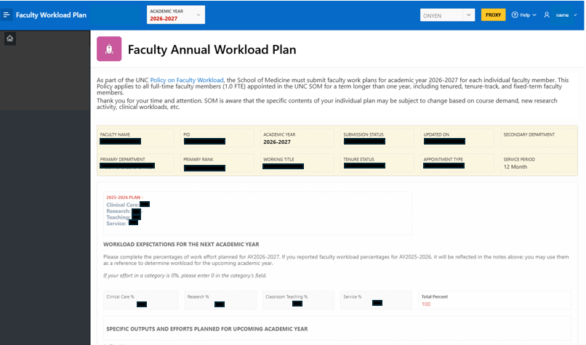
The Faculty Workload documentation captures teaching planned by faculty for the next academic year. In the SOM, its faculty teach a wide range of learners in a wide range of settings, including in the classroom, laboratory, and clinic. In addition to classroom teaching, UNC SOM faculty teaching includes supporting learners outside the classroom through advising, research mentoring, practical experience, and other academic activities.

Steps to complete:
Section 1: Workload Expectations Section
  - Complete the percentages for each section: Clinical Care, Research, Classroom Teaching, Service
    - If workload percentages were provided for 2025-2026, that information will be provided for reference above. You may use the same percentages, or adjust as needed to reflect plan for the next academic year.
    - If you have a category that is not applicable, please fill in 0%
    - For each category with a percentage given, you will provide some additional information in the next section, Specific Outputs and Efforts.
  - Total must equal 100%
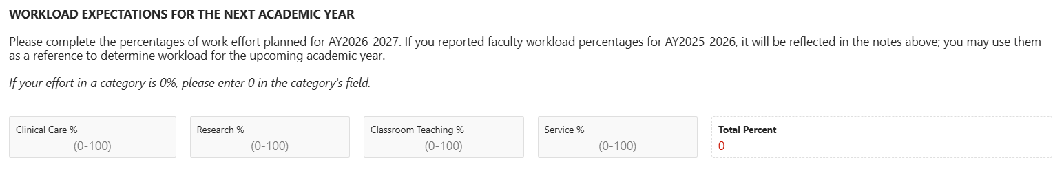

Section 2: Specific Outputs and Efforts Planned for Upcoming Academic Year
- Complete each section that has been reflected as a percentage of your work above – all categories may not be applicable.
  - Teaching REQUIRED FOR ALL FACULTY
    - Please make sure you provide class name/prefix for any course you are assigned in AY26-27 in this section.
    - The SOM Faculty Workload policy expands the definition of teaching including in the classroom, laboratory, and clinic. In addition to classroom teaching, UNC SOM faculty teaching includes supporting learners outside the classroom through advising, research mentoring, practical experience, and other academic activities. Learners include health science students, medical students, graduate students, residents, fellows, and post-doctoral fellows, in a wide range of settings, including classroom, laboratory, and clinic. Briefly describe those activities here. If you do not anticipate working with learners in any capacity this year, please note “Not applicable”.
  - Clinical
    - Provide a brief, high-level description of your planned activity for the next academic year – a few sentences or bullet points. This may include: Inpatient/Outpatient planned activity, patient care delivery goals, etc.
  - Research
    - Provide a brief, high-level description of your planned activity for the next academic year – a few sentences or bullet points. This may include: Publication activity, grant/funding activity, details about your research activity.
  - Service
    - Provide a brief, high-level description of your planned activity for the next academic year – a few sentences or bullet points. This may include: serving on key committees, administrative commitments (such as Director, Division Chief, Chair roles), service to your discipline at or outside of UNC.

Section 3: Acknowledging Teaching Effort Outside the Classroom
In addition to classroom teaching captured in the workload percentages, we want to highlight that our faculty teach a wide range of learners, including health science students, medical students, graduate students, residents, fellows, and post-doctoral fellows, in a wide range of settings, including classroom, laboratory, and clinic. In addition to classroom teaching, UNC SOM faculty teaching includes supporting these learners outside the classroom through advising, research mentoring, practical experience, and other academic activities.
To reflect clinical-based and research-based teaching, please estimate:
What percentage of your clinical care workload will be spent with learners in AY26-27?
and/or
What percentage of your research workload will be spent with learners in AY26-27?
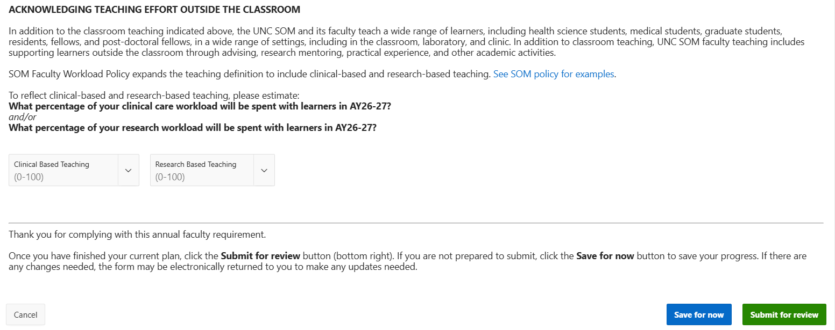

Submit your Plan
Once you have finished your current plan, click the Submit for review button (bottom right). If you are not prepared to submit, click the Save for now button to save your progress. If there are any changes needed, the form may be electronically returned to you to make any updates needed.

Technical issues with the portal? Please submit a ticket to SOM-IT, note “Faculty Workload Portal”
https://tdx.unc.edu/TDClient/33/Portal/Requests/TicketRequests/NewForm?ID=no~URb~kpWM_&RequestorType=ServiceOffering

