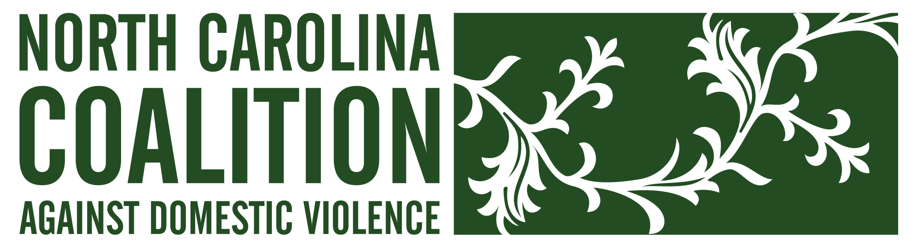

NORTH CAROLINA COALITION AGAINST DOMESTIC VIOLENCE

Mission Statement

The mission of the North Carolina Coalition Against Domestic Violence (NCCADV) is to create social change through the elimination of the institutional, cultural, and individual oppressions that contribute to domestic violence.

What is the North Carolina Coalition Against Domestic Violence?
NCCADV is a statewide non-profit membership organization providing support services to local domestic violence agencies and allied professionals. Our purpose is to strengthen the network of people working to end domestic violence in NC.

Programs and Services

- Technical Assistance
Provides information, referrals and support for survivors, member programs and the general public regarding domestic violence and available resources.

- Training Institute
Provides workshops, on-site training, and conferences for domestic violence advocates and allied professionals throughout the state. Supports statewide survivor’s speakers’ bureau.

- Public Policy
Advocates to improve statewide policies and legislation to positively impact the lives of survivors of domestic violence and their children.

- Public Awareness
Keeps the issue of domestic violence in the public eye through special events and partnerships with the media. Promotes the Silent Witness initiative, a traveling memorial honoring those who were murdered as a result of domestic violence.

- Resource Library
Provides a broad collection of books, journals, research materials, videos and curricula about domestic violence and related topics.

www.nccadv.org 123 W. Main Street, #700, Durham, NC 1.888.232.9124
Domestic Violence in North Carolina
Fact Sheet
- At least 550 women, children, and men have been murdered as a result of domestic violence in NC since January 2002, according to information collected by NCCADV.

- NC ranks 13th in the nation for the number of per capita homicides committed by men against women in our state in 2006, according to the Violence Policy Center.

- Approximately 90 domestic violence programs in the state provide crisis intervention services for all 100 counties, including shelter, crisis counseling, court advocacy and support groups.

- Local domestic violence programs responded to over 119,000 crisis line calls and served over 47,000 victims in person in FY 2006, according to the Council for Women/Domestic Violence Commission.

- Over 31,000 domestic violence protective orders were filed in NC courts in FY 2006.

- The North Carolina Coalition Against Domestic Violence is a statewide non-profit membership organization that supports all of the local domestic violence programs and allied professionals across the state.

For more information, please contact the North Carolina Coalition Against Domestic Violence at 888.232.9124 or visit our website at www.nccadv.org.

