PowerPoint 2010 File Compression Tips

When creating a presentation:

- Scan and save images for use in PowerPoint as .jpg or .gif format at 72-100dpi
- Size your images in a graphics program (such as Adobe Photoshop or Microsoft Image Editor), not in PowerPoint
- Add graphics or images using the Insert tab (versus the copy, paste or drag function). On the Insert tab, click Picture and browse to your file.

To reduce the file size of an existing presentation:

- Open your presentation, click on any image, and choose the Picture Tools tab which will appear to the right of all other formatting tabs (1).
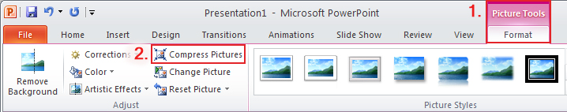
- From here, select Compress Pictures (2).

- Choose the options below, then select OK and save your presentation.

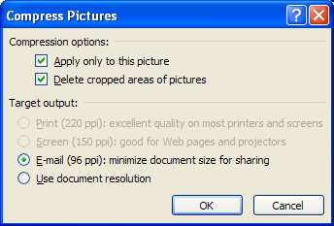

To reduce the file size of a presentation with audio/video files:

- After you’ve inserted a video, select the File menu.
- Select Compress Media.

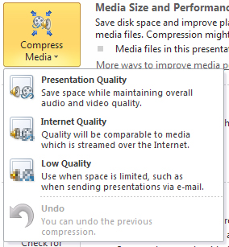

- Choose Internet Quality if your presentation will be distributed via the internet, or Low Quality if your presentation will be emailed.

