Measuring your blood pressure at home
Follow these steps to make sure that you are measuring your blood pressure accurately.
Before you take your blood pressure:
- Do not measure your blood pressure within 30 minutes of smoking, drinking alcohol, eating, or vigorous exercise. Do not take decongestants for 30 minutes before you take your blood pressure.
- Sit comfortably in a chair with your arm resting on a counter top or table at about the level of your heart.
- Sit with your back supported while keeping your feet flat on the floor.
- Use the bathroom if you need to before taking your blood pressure
- Remove clothing from the arm before applying the cuff.
- Rest for 5 minutes
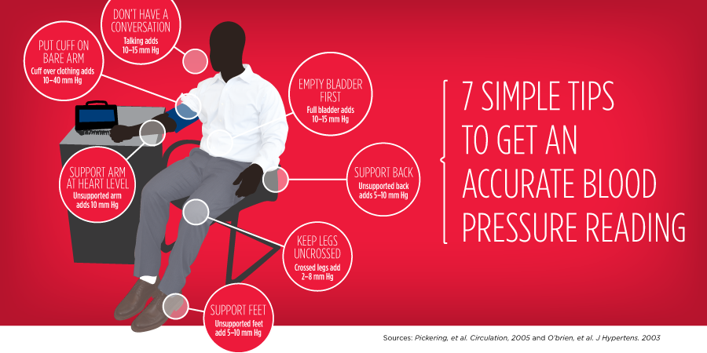
When you are ready to take your blood pressure:
- Continue to sit with your back supported, your legs uncrossed, and your feet flat on the floor.
- Follow the instructions for your device. Put the cuff on by wrapping it around your bare arm above your elbow. Face the palm of your hand up to relax your arm muscles.
- Rest your arm on a table or another flat surface at the level of your heart. Keep it stretched out and relaxed. Sit still.
- Do not talk while taking your blood pressure.
- Following the directions of the monitor you are using, press the button to start the machine. The cuff will inflate and slowly deflate by itself.

Recording your blood pressure:
- The machine will display two numbers. Write down both numbers, and the data and time of the measurement if the machine does not store that information automatically. If there is a pulse recorded on the display, write that down too. Record every measurement (even if you think it is incorrect!).
- Wait one minute and then repeat the steps. You should always check at least two measurements one minute apart and write them down. This is one set of blood pressure readings.
- Make one set of blood pressure readings in the morning before taking your medications and another in the late afternoon before supper. Do this every day during the week prior to your clinic visit.

Remember to bring your record of blood pressure readings and your monitor to your clinic appointment.

