High Throughput Sequencing
16S rRNA Amplicon Sequencing

Sequencing of targeted variable regions (V3-V4) in the 16S ribosomal gene allows to determine the bacterial components of microbial complex communities. Data provided include relative abundance of taxa at the genus/species-level, alpha and beta diversity calculations and basic analysis of significantly over or underrepresented groups.

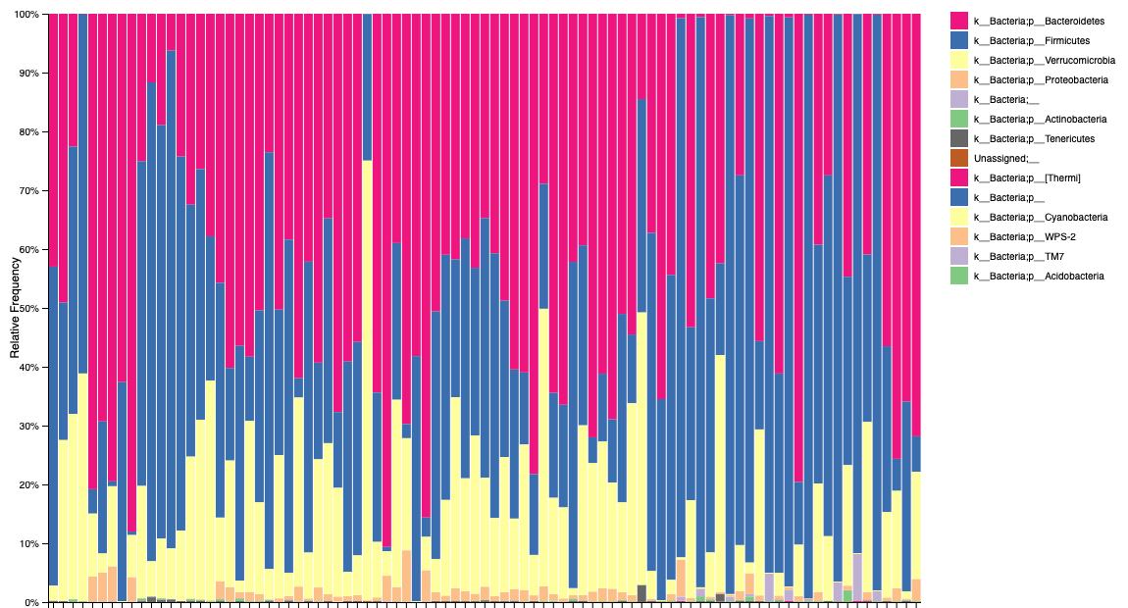
Whole Genome Shotgun (WGS) Sequencing

WGS sequencing generates high depth sequence data (>10M sequences per sample) of entire microbial communities for higher resolution taxonomic characterization compared to 16S rRNA sequencing, providing species/strain-level information and community functional potential (enzymatic pathways and gene families). WGS can also be applied to isolated microbial strains to generate genomic sequencing data.

RNA Sequencing

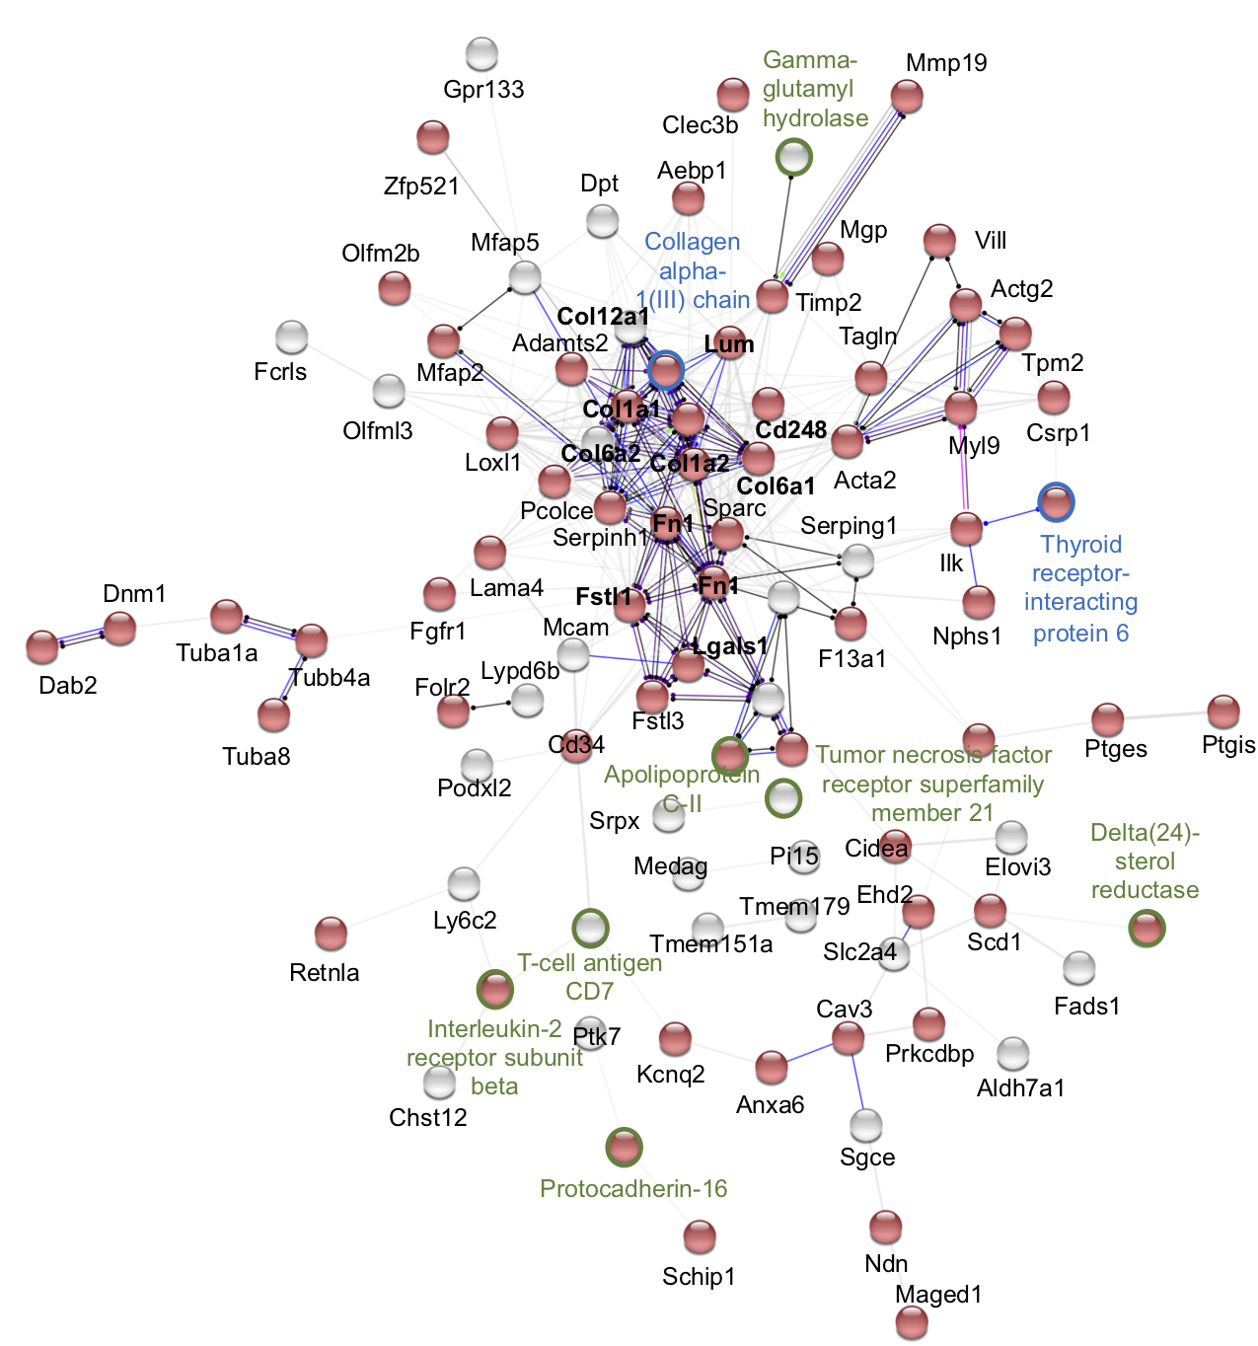
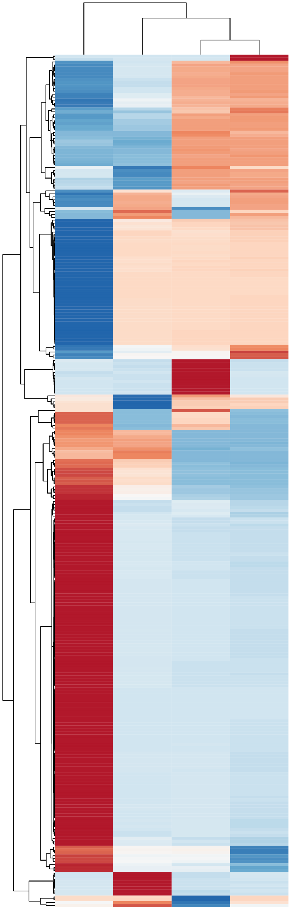
Total community meta transcriptomics generates sequencing data from genes being actively expressed across community members. RNA sequencing can also be used to target host-specific factors, or to characterize changes in expression of individual bacterial strains in culture.

Shallow WGS Sequencing

Whole Genome Shotgun (WGS) sequencing performed at lower sequencing depth (>1M reads per sample) is a cost-effective method to acquire species/strain-level taxonomic characterization of the more abundant members of complex microbial communities. By sequencing at a lower depth, the cost of sequencing is reduced, however this will reduce the ability to accurately assess the identity or potential function of low-abundance community members. This approach is offered as a lower-cost alternative to WGS sequencing while providing higher taxonomic depth than standard 16S rRNA amplicon sequencing.

