Dear Neuroscience Retreaters-

Well, time flies and our third annual UNC Pierre Morrell Neuroscience Retreat is this week! All of us on the retreat planning committee are super excited, and are looking forward to hearing about great science and hanging out with everyone in a fun and new setting. Before we pack up and head to the Haw River State Park, there are a few details regarding the event that I would like to share with you.

Location:
Haw River State Park
339 Conference Center Drive
Browns Summit, NC 27214
Phone: 336-342-6163
haw.river@ncparks.gov
Latitude: 36.250646
Longitude: -79.756360

Time:
Events and Talks start at 10:00 AM on Thursday May 17th. The retreat ends after lunch on Friday May 18th.

Getting there:
As stated above we will be staying at the Haw River State Park Conference Center. The easiest way to get to the venue from UNC is here and printable directions are attached separately as a PDF to this email. If you have not yet arranged transportation to the retreat, please contact the retreat committee ASAP.

Arriving:
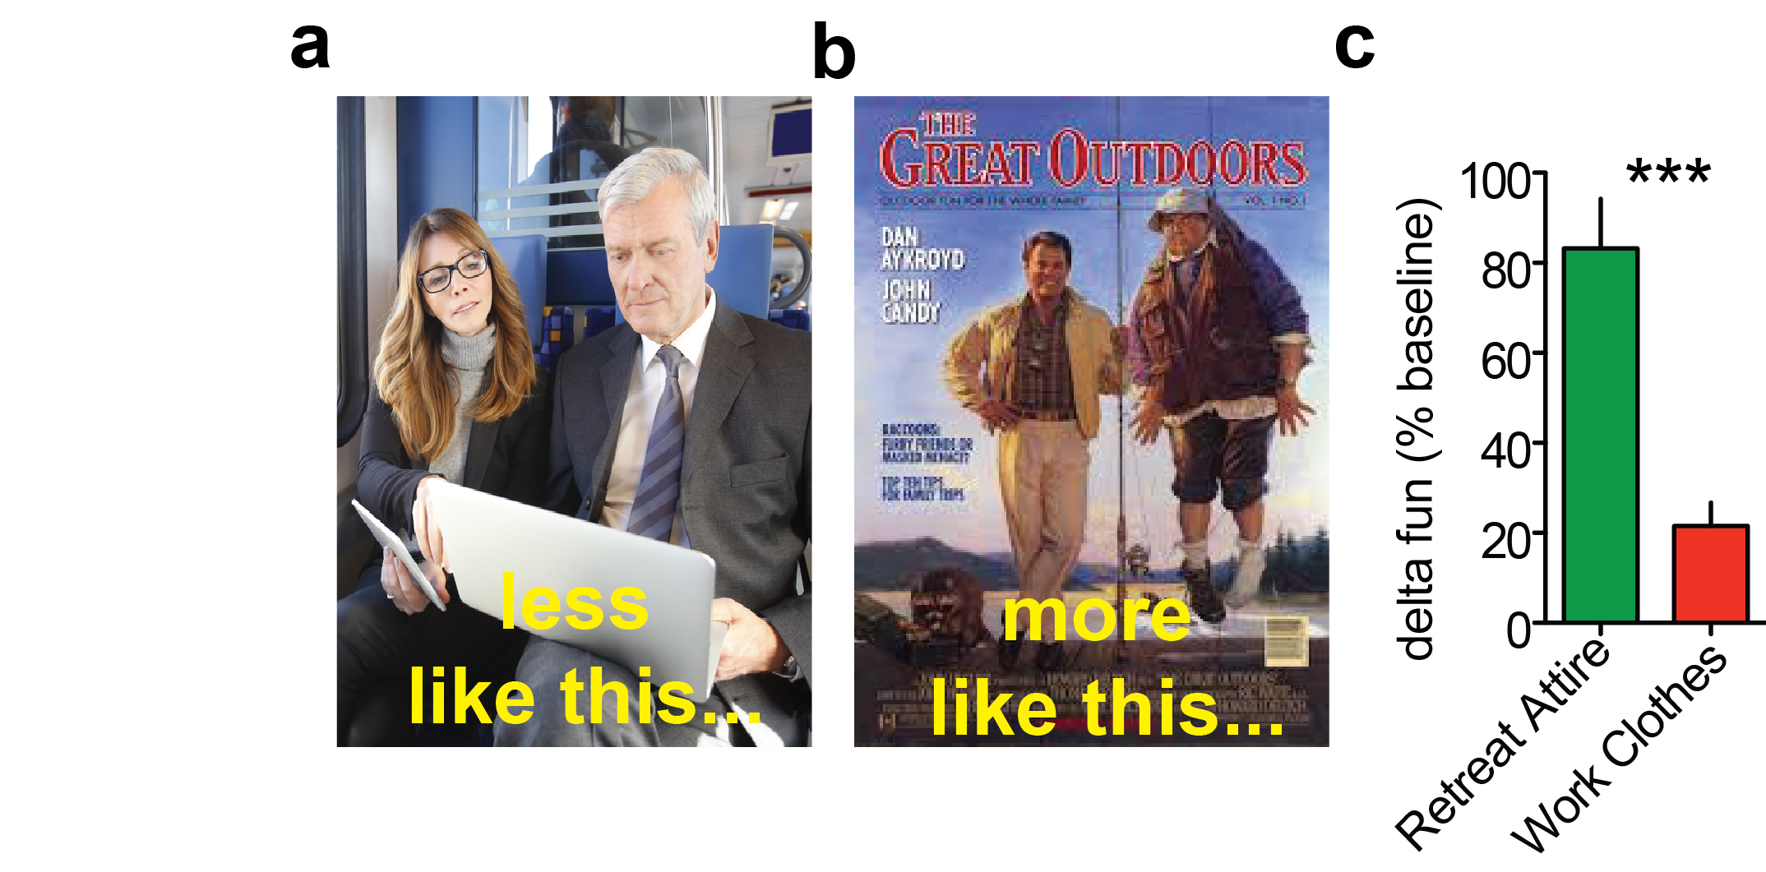
There is plenty of parking at the conference center, park anywhere and walk into the main building which includes the lobby and main conference room. All of the talks and presentations will be in the Grove Auditorium and all of the meals will be in the Cafeteria. Check in will be from 3-3:30pm so please leave your bags in the car until it is time to check in.
Figure 1: Suggested retreat attire. a. Less like this b. more like this. c. Significantly more fun has previously been had wearing retreat attire compared to work clothes.

Accommodations:
You should by now have your roommate buddy assignments. Please treat them nicely! You can get your key at the front desk in the main building. The rooms are motel style with two double beds and a bath. Linens are provided. One of the employees there said some people choose to bring their own sleeping bags, but this is optional. The accommodations should be perfect for the event, but don’t expect the Carolina Inn! This is a retreat after all, think of it more like nerd summer camp.

Attire:
We recommend you bring clothes fit for whatever the weather conditions permit, and you air on the side of ‘rustic adventurer’ instead of ‘business casual’. You should also bring clothes for any outdoors activities you may want to participate in (see below). Please see Fig. 1 for additional details.

Activities:
We have awesome activities planned – a first year student data blitz, two scientific sessions, a plenary lecture, meals, and much more! There will be a few free hours to hike the retreat grounds, canoe, play frisbee, or participate in an organized soccer match (teams to be determined). There will be a sign up sheet for soccer and canoeing at lunch on Thursday.

Appropriate conduct at the retreat:
The purpose of the retreat is to hang out and learn more about each other and our science. We are 98.2% sure fun will be had, but remember, this is still a UNC-related event. All retreat attendees are expected to maintain the same level of respect for their colleagues and peers as they would show in the lab, office, or classroom.

Meals:
Coffee and water will be available ad libitum throughout the retreat.
PLEASE NOTE: the vegetarian options will be specifically for those who indicated vegetarian preferences in the survey.
Thursday Morning | Assorted Pastries
Thursday Lunch | Cheesesburger/Boca Burger  Fries, pasta salad, salad bar
Thursday Dinner | Baked Ziti/Vegetarian Baked Ziti  Sautéed fresh veggies, dinner rolls, salad bar, apple crisp
Thursday Poster Session | Beer, Wine, and Snacks
Friday Breakfast | Scrambled Eggs & Pancakes  Sausage patties, yogurt, cereal, milk, fresh fruit
Friday Lunch | BBQ Pulled Pork/Veggie BBQ Platter  Mac & cheese, cole slaw, corn bread, salad bar

Agenda:
Thursday, May 17, 2017:
10:00 AM - 11:50 AM -- 1st Year Data Blitz
11:50 AM - 12:00 PM -- Certificate: Mentor of the Year
12:00 PM - 1:00 PM -- Lunch
1:00 PM - 4:30 PM -- Free Time
4:30 PM - 6:00 PM -- 1st Oral Session
- Maria Luisa Torruella Suarez
- Mark Rossi, PhD
- 10 min. Break
- Henry Tseng, PhD
6:00 PM - 7:00 PM -- Dinner
7:00 PM - 8:00 PM -- Plenary Session feat. Dr. Dayu Lin, PhD
8:00 PM - 10:00 PM -- Poster Session
10:00 PM+ -- Campfire
Friday, May 18, 2017:
8:00 AM - 9:00 AM -- Breakfast
9:00 AM - 10:30 AM -- Checkout
10:30 AM - 12:00 PM -- 2nd Oral Session
- Sally Kim
- Natale Sciolino, PhD
- 10 min. Break
- Toshi Hige, PhD
12:00 PM - 1:00 PM -- Lunch

