Plan Do Study Act (PDSA) Form

Cycle #:
Start Date: End Date:
Project Title:
University/Organization Name:
Health System Sponsor Name:

Objectives of this Cycle:
Test a Change
Implement a Change
Spread a Change

Short objective of cycle:
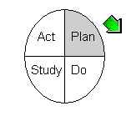

PLAN

Test/Implementation Plan:

What change will be tested or implemented?

How will the change be tested or implementation be conducted (consider small scale early)?

Who will run the test or implementation?

Where will the test or implementation take place?

When will the test or implementation take place?

Predictions:
1.
2.
3.
4.

Data Collection Plan:

What information is important to collect?

Why is it important?

Who will collect the data?

Who will analyze the data prior to Study?

Where will data be collected?

When will the collection of data take place?

How will the data (measures or observations) be collected?
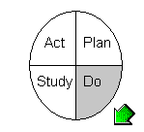

DO

Observations:

Record observations not part of the plan:

Did you need to tweak the original Plan?

Begin analysis of data (graph of the data, picture):
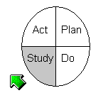

STUDY

Questions: Copy and paste Questions and Predictions from Plan above and evaluate learning. Complete analysis of the data. Insert graphic analysis whenever possible.
- Prediction:
Learning (Comparison of questions, predictions, and analysis of data):

- Prediction:
Learning (Comparison of questions, predictions, and analysis of data):

- Prediction:
Learning (Comparison of questions, predictions, and analysis of data):

- Prediction:
Learning (Comparison of questions, predictions, and analysis of data):

Summary (Look at your data. Did the change lead to improvement? Why or why not?):

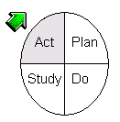
ACT

Describe next PDSA Cycle: Based on the learning in “Study,” what is your next test?

