RECRUITMENT AND RETENTION PLAN TO ENHANCE DIVERSITY
Diversity Efforts for Underrepresented (UR) Groups and Students from Disadvantaged Backgrounds. The University of North Carolina at Chapel Hill is committed to a diverse scientific workforce that is representative of the US population and that every student with the motivation for a research career has the opportunity and resources to thrive as a scientist. In her role as Associate Dean for Graduate Education, Dr. Jean Cook serves as the head of OGE. In addition to overseeing recruitment to the umbrella PhD first year program, BBSP, the OGE is responsible for coordinating recruitment and retention efforts for individuals from underrepresented groups (URs) and students from disadvantaged backgrounds. At the post-undergraduate level, these groups are groups A and B as defined by NIH: Individuals from racial and ethnic groups underrepresented in health-related sciences on a national basis and individuals with disabilities. (Per NIH policy, individuals from disadvantaged backgrounds are not targeted for funding, though the OGE emphasizes such groups in our science outreach efforts and in our partnerships with undergraduate science training programs.)
Dr. Ashalla Freeman, full-time Director of Diversity Initiatives and the Program Coordinator for the UNC Initiative for Maximizing Student Diversity (IMSD) is a member of the Science Training and Diversity team in the Office of Graduate Education. Dr. Freeman provides leadership for the recruitment and support of UR students in the biomedical and biological sciences. She is joined by Dr. Jessica Harrell, Director of Academic Excellence and summer undergraduate research programs, Dr. Joshua Hall, Director of UNC’s post-baccalaureate program, and OGE staff in both student recruitment and retention activities. Their efforts are supported by generous institutional resources from the School of Medicine, the UNC Lineberger Comprehensive Cancer Center, and other UNC schools that participate in the BBSP program (the College of Arts and Sciences, the Eshelman School of Pharmacy, and the UNC School of Dentistry), plus NIH educational grants.
History of Achievements. The creation of the umbrella BBSP program in 2008 coincided with the creation of the Office of Graduate Education and has greatly advanced diversity goals in the life sciences at UNC. After concerted OGE effort, the percentage of training grant eligible UR students entering graduate school in the biomedical sciences at UNC increased dramatically compared to typical years pre-BBSP. Before 2008, the individual program efforts sustained much smaller numbers of UR students (~6%), whereas the combined efforts have led to substantial increases (see table below). Notably, the 2015 thru 2017 BBSP classes are >21% UR students, and this number exceeds the percentages of URs in the BBSP applicant pool for these years. In the 2015-2017 recruitment seasons, 21-24% of domestic BBSP applicants were from UR applicants and 24-26% of the total admissions offers were issued to UR recruits.
Underrepresented Student Recruitment Summary
Recruiting Year | 2006 | 2007 | 2008* | 2009 | 2010 | 2011 | 2012 | 2013 | 2014** | 2015 | 2016 | 2017
Number of UR students/total students  (% of Class) | 6  (~6%) | 10 (12%) | 23/121  (19%) | 19/84 (23%) | 17/76 (23%) | 11/83 (13%) | 12/85 (14%) | 16/90 (18%) | 7/64 (11%) | 20/78  (26%) | 17/79  (22%) | 23/91 (25%)
* Data from 2006 and 2007 are the combined data from BBSP-participating programs prior to the initiation of BBSP in 2008. **The 2014 BBSP class (n=64) was deliberately set smaller than the typical class size, which is 75-85.

Underrepresented Student Retention and Graduation Summary
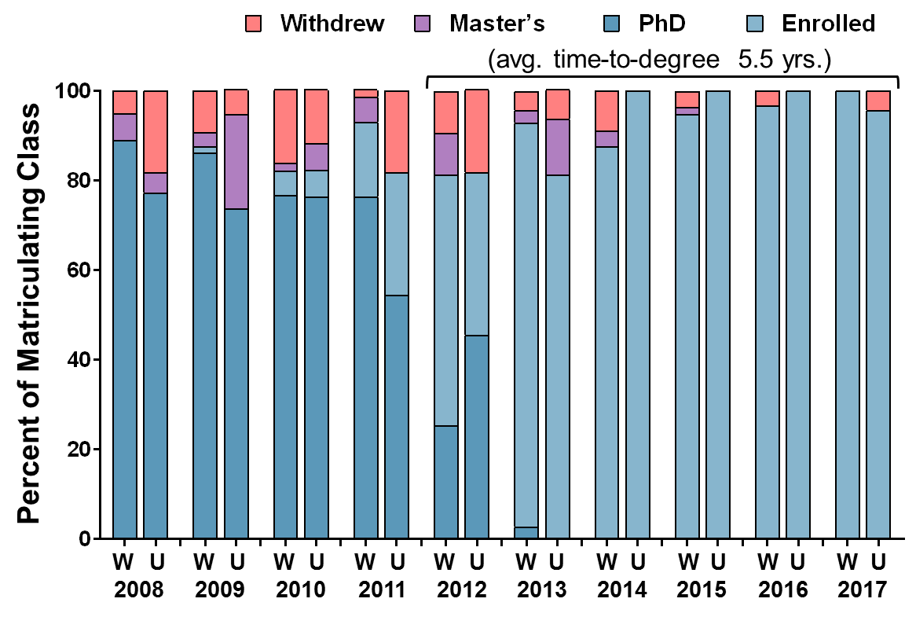
The OGE closely monitors UR student progress. Gratifyingly, soon after the institution of OGE and the IMSD, UR student success rapidly matched non-UR students (see graph below). Moreover, the overall UNC student success rates for both UR and non-UR students (>85%) – measured by the percentage of the matriculating class that has graduated with a PhD or is still on-track to graduate – are substantially higher than recently reported national averages. According to reports from the Council of Graduate Schools, “Doctoral Initiative on Minority Attrition and Completion,” which analyzed STEM doctoral students who matriculated between 1992/1993 and 2011/2012, the 7-year completion rate for all UR life science students was just 50-58%. The 2008 PhD Completion Project report indicates that the degree completion rate for all life sciences students is 59-69%. The vast majority of UNC PhD students complete their degrees, UR students complete at close to the same rate as their non-UR peers, and most BBSP-affiliated PhD programs require at least one first-authored publication in press by the time of graduation. In fact, Diverse Issues in Higher Education recently (December 2017) ranked UNC Chapel Hill 1st nationally for PhD completion by African-American scholars in the biological and biomedical sciences and 5th nationally for total minority PhD completion in the biological and biomedical sciences (http://diverseeducation.com/top100/pages/GraduateDegreeProducers2017.php?dtsearch=&dtdegree=&dtrace=&dtmajor=Biological%20and%20Biomedical%20Sciences&dtschool=&dtstate=&dtpage=0).
Enrollment and Graduation Outcomes for UNC well-represented (W) and under-represented (U)
Biomedical PhD Students (2008-17)
Moreover, the time-to-degree for all BBSP-entered students is currently ~5.5 years.

Proposed plans for Recruitment
Though the substantial increase in UR recruitment is encouraging, the process of establishing the best UR recruitment for the sciences is an ongoing one. The philosophy at UNC is that outstanding UR recruitment is built from the ground up through multi-faceted development of individual, community, and outreach relationships. Notably, many of the training faculty in “XXXXX” and their students are involved in these activities. The programs developed so far include OGE-coordinated outreach by graduate students to high school students and the community, summer research programs, a Postbaccalaureate (PREP) Program, and the SPIRE fellowship program which places UNC postdoctoral fellows in North Carolina Minority Serving Institutions (MSIs). The OGE maintains a database tracking UR recruitment, applicant competitiveness and the undergraduate institutions applicants attended which is analyzed to determine how recruitment efforts are working. A few examples of these programs are the following.
- North Carolina DNA Day. This science outreach program is held annually in April to coincide with National DNA Day. UNC graduate students and postdoctoral scholars visit high schools across the state of North Carolina to conduct engaging, hands-on scientific activities highlighting genetics and genomics and sharing their passion for science and information about science careers. In 2017, approximately 9,000 high school students in 132 high schools were reached by over 170 graduate students and postdoc scientist “ambassadors". Since the program was established in 2007, NC DNA Day has reached 502 unique high schools and >90,000 high school students. For most of the high school participants, it was their first interaction with a career scientist. Students in the laboratories of our training faculty are regular participants in this important event. In addition, as part of UNC’s DNA Day CONNECT initiative, a subset of trainees are paired with NC high school science teachers at the start of the school year to be available as a “guest scientist” by Skype throughout the year. This culminates with the scientist visiting the classroom in person on DNA Day.
- SURE and SOLAR. These summer research programs host visiting undergraduates from other institutions where there are few opportunities to participate in internationally-competitive research. Over the years, many of these students have been hosted by faculty in our training program. Typically 50% of the NSF-funded SURE participants are URs. SOLAR is a program exclusively for URs that is organized and directed by the OGE (funded by intramural sources). BBSP has a high rate of recruitment from these programs.
- Postbaccalaureate Research Education Program (PREP). The OGE has administered an NIH-funded Postbaccalaureate Research Education Program (PREP) for UR scholars since 2010 (R25 PI, Dr. Jean Cook). UNC PREP provides one year of stipend/tuition support for UR scholars who plan to apply to biomedical Ph.D. programs. Besides working full-time in research labs during their year in the program, UNC PREP scholars receive extensive professional development in areas important to their growth as scientists such as scientific writing, presentation skills, critical analysis, and time management. Since 2010, UNC PREP has transitioned 57 UR scholars (90.4%) into top-tier biomedical doctoral programs with a retention rate of 94%. UNC PREP outcomes and a detailed program description were recently published (Hall et al., 2016). BBSP has a high rate of recruitment from this UR pool, with 34.5% (22/64) of PREP scholars transitioning directly to BBSP.
- UNC SPIRE program. The SPIRE program is a NIH-funded program for postdoctoral training in research and education. SPIRE postdoctoral fellows teach at North Carolina MSIs, and they work with the OGE to identify candidate UR undergraduates for research opportunities at UNC. Nine previous SPIRE fellows are now faculty at NC MSIs
- OGE-sponsored visits. The OGE hosts campus visits for undergraduates from MSIs. This program is being extended to include North Carolina undergraduates from schools with high percentages of 1st generation college students. The OGE has developed strong relationships with the University of Puerto Rico at Cayey and the University of the Virgin Islands, two MSIs outside the continental US with very limited research infrastructure and few research opportunities for students. Each year, the OGE sends graduate students to these universities to lead laboratory skills workshops and present their research. As evidence for interconnections between UNC recruitment programs is that several undergraduates from UPR Cayey and UVI have participated in the OGE SOLAR and PREP programs, and successfully matriculated through BBSP.
- Faculty participation at conferences. The OGE sponsors faculty and student attendance at conferences for UR students interested in biomedical research careers including SACNAS (Society for the Advancement of Chicanos and Native Americans in Science) and ABRCMS (Annual Biomedical Research Conference for Minority Students). Additionally, the OGE provides recruitment materials and training for faculty attending targeted UR recruitment events at society meetings including the ENDURE session at the Society for Neuroscience National Meeting and the Society for Toxicology Annual Meeting.
- BBSP Preview Weekend. Beginning in 2014, UNC hosts 15-20 prospective BBSP applicants from underrepresented groups for an all-expenses-paid two-day campus visit each Fall. Participants receive individual guidance from faculty about crafting competitive graduate school applications and the interview and admissions process at UNC. Participants meet faculty and current PhD students to learn more about the research opportunities and diverse community at UNC.
- Recruitment Ambassadors. IMSD students serve as ambassadors who are points-of-contact for UR BBSP applicants, and they reach-out to recruits to share a student perspective about IMSD, BBSP and Chapel Hill. Ambassadors attend a Meet-and-Greet event hosted by Drs. Freeman and Cook at the start of each interview weekend to introduce recruits to the IMSD community.

Retention. UNC hosts an NIH-funded R25 Initiative for Maximizing Student Diversity (IMSD, 5R25GM055336) to enhance the training of UR students in biomedical graduate education. Dr. Cook serves as the PI on this grant and Dr. Freeman as the Program Coordinator. The IMSD program provides activities and support services that are available to all UR students from admissions through post-graduation. This program also provides a supportive community along with continuous assessment and response to an individual student’s needs.
- IMSD meets with UR applicants during their preview and interview visits to address their unique questions and introduce them to the broader IMSD community of scholars.
- IMSD seamlessly integrates all first year IMSD students into the BBSP program and provides them with extensive professional development training in presentation and writing skills and life coaching/career counseling to aid their transition to graduate school.
- IMSD assesses the needs of each student and addresses issues they are having. IMSD organizes academic coaches for students having difficulty in their graduate classes, needing to strengthen their critical analysis skills and scientific background in a new discipline, or for students needing help in preparing for written or oral qualifying exams.
- IMSD generates Individual Development Plans (IDPs) for all program participants. These collaborations between IMSD staff, IMSD students, and their research mentors involve assessment of the student’s skills by the student and mentor. These cooperative efforts foster collaboration among the research mentor, student, and research mentors welcome the continued support of IMSD programming and services for their students
- IMSD programming includes monthly community-wide social gatherings and specialized group meetings: Topics for discussion have included the “The Culture of Science Versus Your Own Culture” and “Dealing with Failure”. Two series provide a venue for IMSD students to present their research within the community (Student Research Talks series) and expose the IMSD community to successful UR scientists in a variety of career paths (Diversity Mentor series). Through the Career Advancement Breakfasts, IMSD leaders provide one-on-one career guidance and advice to IMSD students. Monthly meetings with the first year IMSD students enable IMSD staff to closely monitor student progress in courses and labs and provide personalized advisement and support to augment student success.
- Additional annual programming includes the IMSD Biomedical Research Symposium which showcases IMSD student research to the UNC community through oral and poster presentations. The Holiday Dinner celebrates the year’s successes and student achievement while encouraging networking and strengthening intra-community ties. Finally, the IMSD Retreat provides unique professional development training that enhances the progress and competitiveness of IMSD scholars.
The IMSD program is not only an important part of our retention plan, but it also facilitates the development of IMSD students into outstanding training grant students. In fact, IMSD has partnered with several T32 training grants to create discipline-specific Diversity Fellowships to recruit outstanding UR students to UNC. These competitive fellowships provide at least 2 years of NIH-funded stipend support and travel funds for scientific presentations, in addition to the T32- and IMSD-specific programming. This is optional and should be included by participating T32 programs

Evaluation. In addition to internal evaluation of our programming, the OGE contracts with Dawayne Whittington of Strategic Evaluations, Inc., as an external evaluator. Mr. Whittington has developed a comprehensive evaluation plan to track the academic success and experience of UR graduate students. The evaluation includes interviews with the students, their mentors and documentation of their publications, grades, awards and future career success.
Specific efforts of the “XXXXX”. You should highlight here how your faculty, students, etc have participated in the above programs/events. If you have other events or programs that you do on your own you should describe them here. This is extremely important. The review committee is looking for specific involvement by your training faculty rather than simply leaving these activities to OGE to take care of.
Plan for Predoctoral Students with Disabilities. While UNC is prohibited from asking about disabilities in our admission process, we do not discriminate against students with disabilities for admissions, and active recruitment of students with disabilities is an integral part of the BBSP recruitment strategy. The OGE reaches out to accessibility services offices at all major undergraduate institutions in North Carolina and many others in the Southeast. This effort involves yearly emails and letters to the heads of accessibility services offices at the 16 UNC system schools, 17 private liberal arts colleges and 6 private universities in NC, as well as a dozen other regional colleges and universities in the Southeast. These communications emphasize our commitment to enrolling and actively supporting students with disabilities in the 14 PhD-granting programs associated with the BBSP, summer undergraduate research programs, and the Postbaccalaureate Research Experience Program (PREP). Faculty and students also recruit at undergraduate research conferences for students from under-represented groups, e.g. the annual ABRCMS and SACNAS events, where many students living with disabilities present their research. We make a concerted effort at these events to demonstrate UNC’s commitment to inclusion and diversity for students of all ability levels.

The OGE also extends our outreach efforts to the high school level. Dr. Patrick Brandt, Director of Career Development and Training in the OGE, has served on the planning committee since 2012 for an annual STEM diversity event sponsored by the local statistics software development company, SAS. This annual STEM Career Showcase is a joint effort between SAS, the NC Museum of Natural Sciences, UNC, and Duke University. Over 100 middle and high school children with a variety of mobility and cognitive disabilities meet at the NC Museum of Natural Sciences to hear an encouraging and practical keynote address by a nationally recognized scientist, engineer, or mathematician who is living with disability. Each year, UNC graduate students living with disabilities have participated as panelists and mentors to the attendees. The event has not yet resulted in applications to our PhD programs, but it has served as motivation and affirmation to over 200 students with disabilities that their skills and abilities can and should be applied to STEM careers such as life science research.

Once a student self-identifies as having a disability, we commit to providing academic and community support through IMSD, the OGE, and in conjunction with the Office of Accessibility Resources & Service (ARS), which works to ensure that the programs and facilities of the University are accessible to all students. Additionally, ARS determines reasonable accommodations, including resources and services to provide students with disabilities with equal access to the opportunities available to them at UNC to help them be as independent as possible. For example, ARS worked with the OGE to have a door installed in the BBSP office that would be accessible to current students who use a wheelchair. Additionally, in 2015, the OGE worked with ARS and BBSP faculty to implement classroom and laboratory accommodations for a BBSP student who is blind. Students may also have learning disabilities, anxiety and eating disorders, and other mental health issues. The entire OGE staff is certified in Mental Health First Aid, a national program that teaches the skills to respond to the signs of mental illness and substance abuse. Anna O’Connell, Director of Student Affairs for BBSP, and other OGE Directors often meet with students who are having difficulties. These individuals are extremely knowledgeable about the various resources on campus for students with mental health issues including UNC’s Counseling and Psychological Services (CAPS) which is available through Campus Health Services and free to all registered students. Additionally, the OGE recently hired a Wellness Counselor to help support the mental and emotional health of biomedical graduate students. Off-campus professionals are also available to meet with students who prefer not to utilize on-campus resources.

