Physician Opportunities in Whiteriver AZ
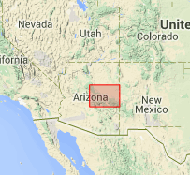
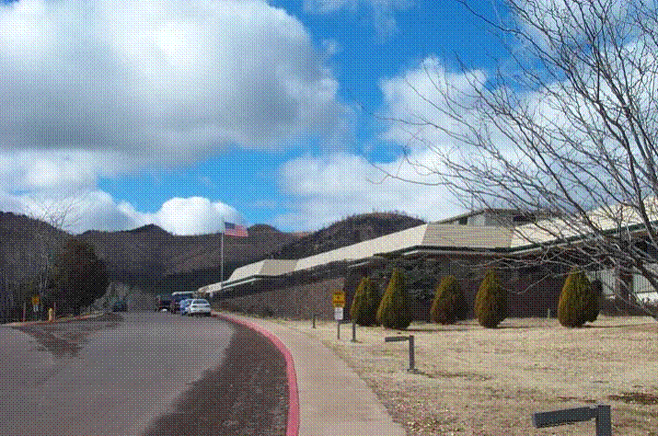
The Whiteriver USPHS Indian Hospital is a Joint Commission accredited 40 bed acute care hospital which includes all-ages Family Care, Emergency Services, OB and Ambulatory Surgery. The hospital is located on the Fort Apache Indian Reservation about three miles north of the town of Whiteriver, Arizona, and serves approximately 18,000 tribal members and other Native American communities around the area. Residents to the southwest are served through the Cibecue Health Center, located fifty miles from Whiteriver.
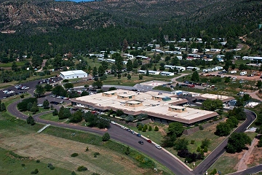
Whiteriver Hospital has also been designated as Baby Friendly. It is staffed by approximately 25 primary care physicians, including Family Medicine, Internal Medicine, Pediatrics, and Internal Medicine/Pediatric physicians, as well as 9 Nurse Practitioners, 4 Physician Assistants, 1 podiatrist, 1 orthopedist, 1 general surgeon, 2 optometrists, 5 dentists and 79 nursing staff members. We see approximately 177,000 outpatient visits, 40,000 ER visits and have approximately 1700 admission annually. We have an active teaching program which includes medical students and residents, pharmacy students and residents, as well as nurse practitioner, physician assistant, optometry, dental, and physical therapy students. We can schedule a site visit to meet our Medical Staff and explore all we have to offer. Thanks so much for your interest in serving our Native American communities.

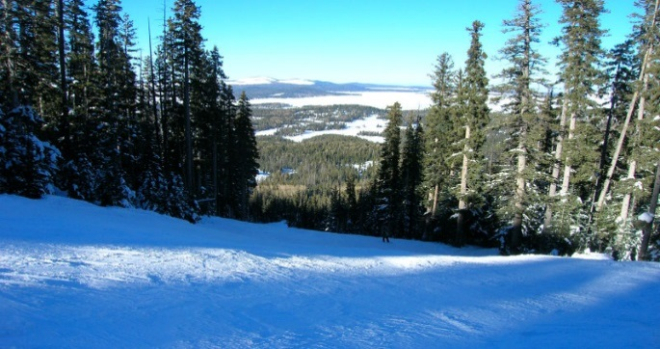
Whiteriver is located within 20 to 30 miles from the resort towns of Pinetop, Lakeside and Show Low. Ranging from mid-desert in the lower elevations to more than 11,000 feet in the mountains, this region offers a four-season climate. Whiteriver and Cibecue are above 5,000 feet, and maintain pleasant 75 to 95 degree temperatures in the summer and 40 to 55 degrees in the winter. This climate puts the best of Arizona right at your doorstep. Take the family to a different campsite every weekend. Drive the twisting roads of the Salt River Canyon. Marvel at the Mogollon Rim, a vast geological fault. Cast your line in a lake that mirrors the pines. Golfing is primo throughout the region in the warmer months, and in the winter you can’t beat a quick trip to the Sunrise Ski Resort which is only 45 minutes from the hospital and offers night skiing (http://sunriseskiparkaz.com/).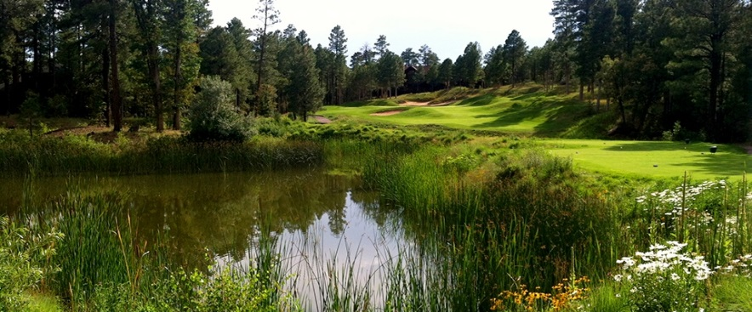
Pinetop-Lakeside Chamber of Commerce: http://www.pinetoplakesidechamber.com/pages/Home
For more information about physician opportunities, please contact: Kevin Long, Health Profession Recruiter at
602-364-5178 or kevin.long@ihs.gov

