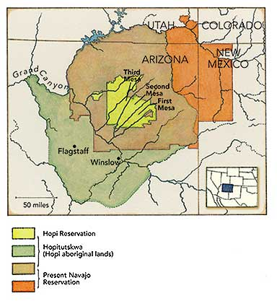
Hopi Health Care Center (HHCC) Physician Opportunities
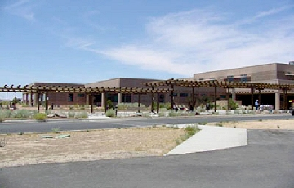
HHCC offers a very unique, challenging and rewarding rural practice setting, and is located in Polacca, AZ, on the Hopi Reservation. The above map of northern Arizona shows the Hopi Reservation surrounded by the larger Navajo Reservation, placing HHCC in the unique position of being at the heart of two Native American cultures rich in history, language, arts, and religion. HHCC serves approximately 8000 Hopi Tribal members as well as at least as many Navajo members, covering approximately 2500 square miles.
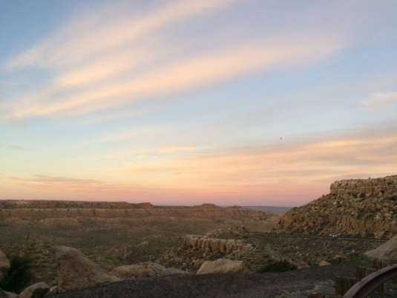
Where in the world is Polacca, AZ? We are located just east of the intersection of Hwy 87 and Hwy 264 in northern Arizona in an area called First Mesa. The Hopi people settled into this land in the area where three mesas stand side by side, dotted with quaint reservation villages scattered throughout the three mesas. Each mesa and each village has its own history and a surprising variation in traditions. The village of Polacca has a convenience store with an ATM, a post office (zip code 86042), as well as a few other small stores, mostly selling arts and crafts. The village of Keams Canyon, approximately 11 miles to the east, has a small grocery store/restaurant/trading post, a post office, a gas station, and a few small stores. Larger towns such as Flagstaff, AZ (1.7 hour drive), Winslow, AZ (1 hour drive), Gallup, NM (1½ hour drive), and Dilkon, AZ (45 min. drive) offer a wider selection of shopping and entertainment. The Southwest region has many other attractions such as hiking, camping, mountain biking, rafting/canoeing, fishing, skiing/snowboarding, and dozens of state and national parks in the surrounding Arizona, Utah, and New Mexico and Colorado areas. While many of these activities are a bit of a drive (between 1-4 hours for most), there are often local groups traveling from the reservation to the cities or on outdoor adventure trips on the weekends.

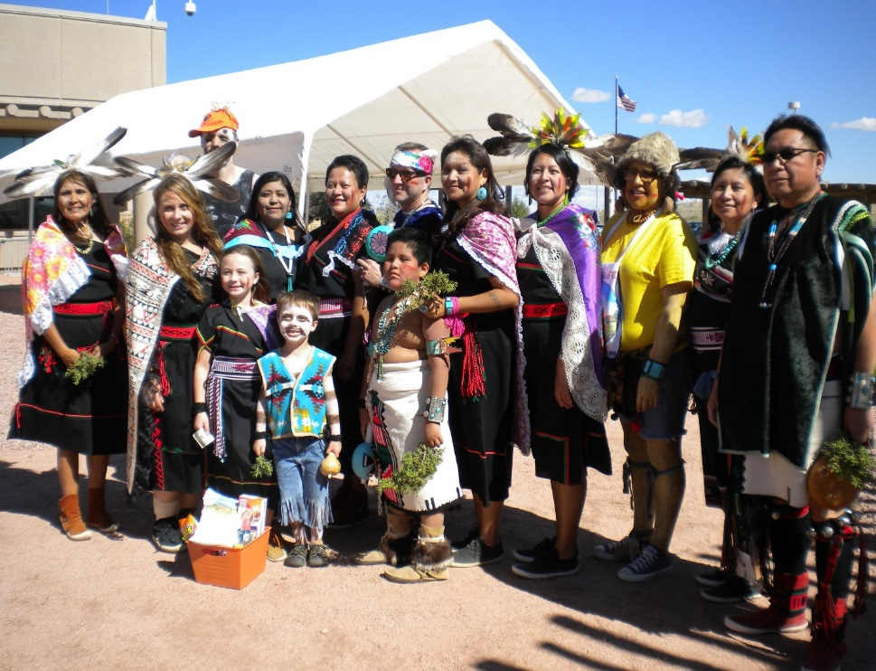
Experience a rich culture: The Hopi reservation and the Three Mesas area offer many opportunities to observe Hopi culture and traditions, including arts and crafts galleries, village tours, festivals and dances. Throughout the year, there are dances in the villages on the weekend, and hospital employees frequently receive invitations from patients, visitors, and co-workers to observe the festivities and learn about the Hopi culture. There are many opportunities to purchase authentic Native American arts and crafts, jewelry, and other items.
Picture: HHCC Staff/Family Indian Day
About the hospital: HHCC is a small, 6-bed critical access Indian Health Service hospital with a large ambulatory clinic with medical, urgent care, OB/GYN, pediatrics, emergency, optometry, dental, specialty clinics (rheumatology, cardiology, nephrology, acupuncture, etc.), physical therapy, social services, and behavior health services.
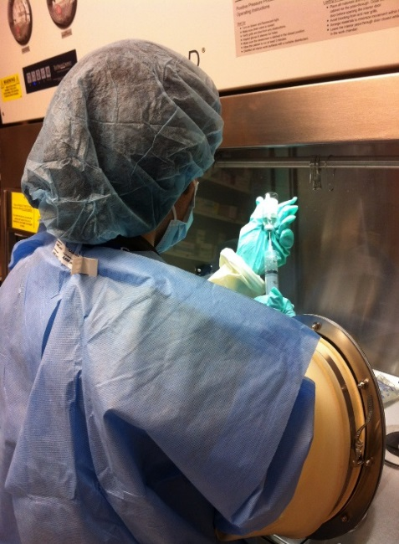
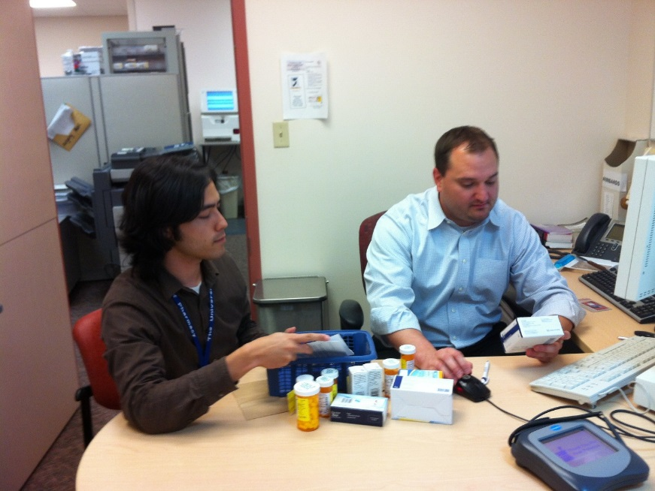
As a member of a JC accredited Critical Access Hospital and certified Primary Medical Home , you can take pride in providing innovative health care services. Our ambulatory care setting offers primary and preventative medical services; with the facility offering a 2-bed birthing unit, a 4-bed Med/Surg, adult/peds unit supported by a staff of 12 physicians and 6 APNs and PA-Cs . We provide general family medical care, surgical follow-up, pediatric and obstetric services with 70,000 visits a year on average. An eye clinic, staffed by 2 optometrists, provides refraction and general clinical eye care. 7 dentists stationed at the HHCC provide wide ranging dental services. Major trauma, acute surgical emergencies and high-risk obstetric patients are stabilized in our ED, then transported to regional hospitals with whom we have great network partnerships developed.
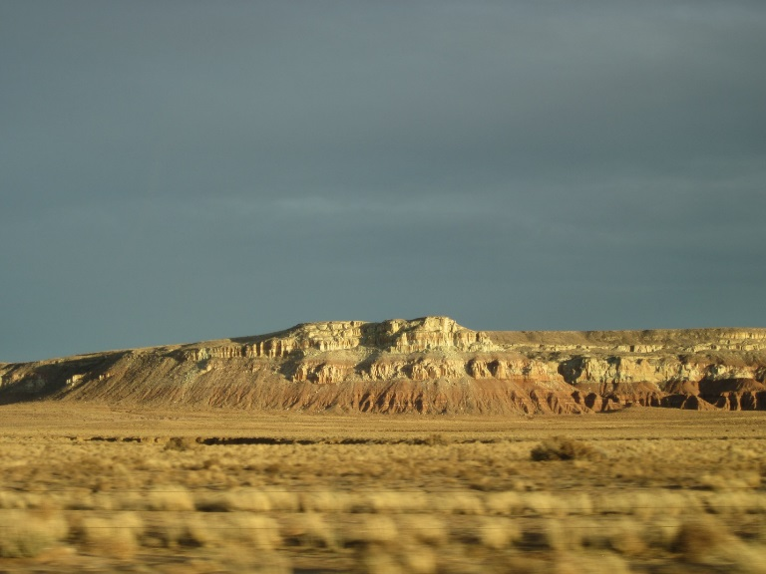
Find the adventurer in you!
We can schedule a site visit to meet our Medical Staff and explore all we have to offer. If you are looking for a challenging and fulfilling medical practice with ample opportunities to improve clinical skills, want to be an instrumental member in developing new clinical services, and are interested in experiencing two unique and rich Native American cultures, all within a day trip of numerous outdoor and urban activities, the Hopi Health Care Center has a position for you!
For more information about the Hopi Provider Opportunities, please contact:
Kevin Long, Health Profession Recruiter at 602-364-5178 or kevin.long@ihs.gov

